Coordinates and Design
1. Use the grid below to answer the following questions.
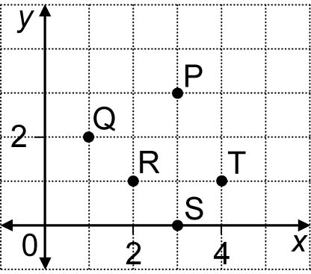
a) Which point has the coordinates (2, 1)?
b) What are the coordinates of P?
c) What is the vertical distance between points P and S?
d) What is the horizontal distance between R and T?

2. Use the grid below to answer the following questions.
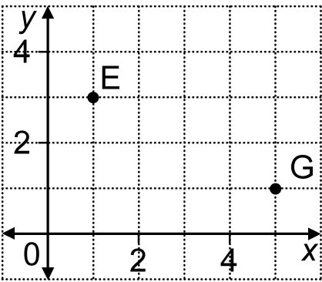
a) Draw a rectangle, EFGH, that has vertical and horizontal sides.
b) What are the coordinates for points F and H?
c) What are the length and width of the sides of rectangle EFGH?

3. Use the grid below to answer the following questions.
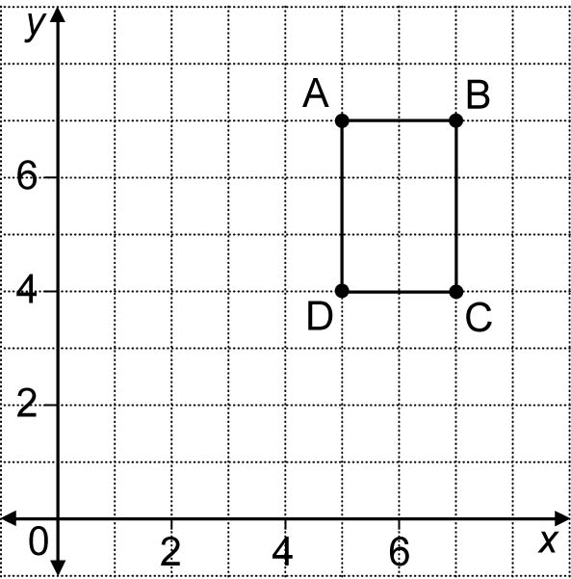
a) Rotate rectangle ABCD 180° about point D.
b) What are the coordinates of point B'?

