Section 1.1 Extra Practice
1. Identify the letter that matches each of the following ordered pairs.

a) ___ (3, 1), ___ (2, 8)  These points are in quadrant ___.  b) ___ (−4, 4), ___ (−2, 2)  These points are in quadrant ___.  c) ___ (−4, −4), ___ (−2, −6)  These points are in quadrant ___.  d) ___ (2, −4), ___ (4, −10)  These points are in quadrant ___.  e) ___ (−3, 0)  This point is on the ___ -axis.  f) ___ (0, −9)  This point is on the ___ -axis.  g) ___ (0, 0)  This point is at the ________. | 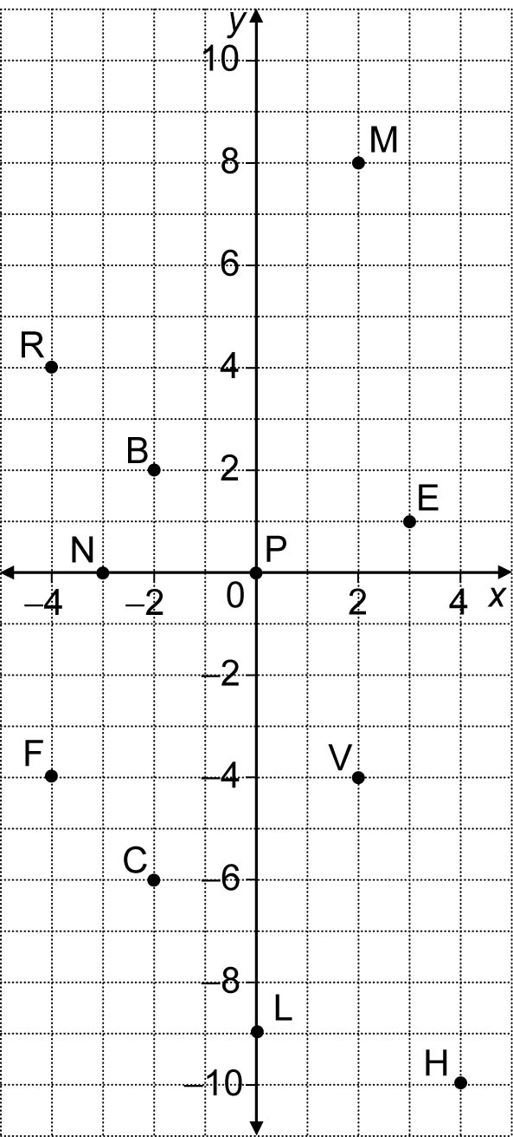

2. Follow the instructions.

• Label the origin.  • Number the x-axis and y-axis by 2s.  • Plot and name the following points:  A(−2, 1), B(4, 1), C(4, −3), D(−2, −3).  • Connect the points in alphabetical order. Connect D to A.  a) The length of line segment AB is _____________ units.  b) The length of line segment BC is _____________ units.  c) ABCD forms a _____________.  d) The area of this shape is _____________ square units. | 