Section 1.1 Math Link
This worksheet will help you with the Math Link on page 11.

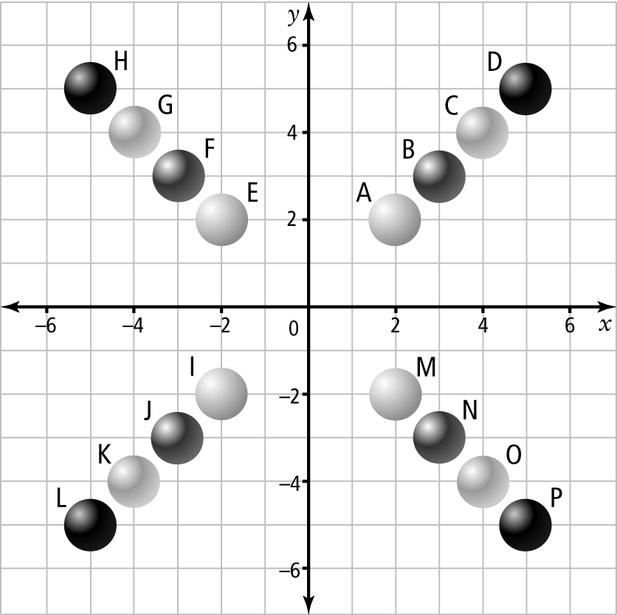

1. Identify the coordinates of the beads in each quadrant. The table will help you to organize your work.

Quadrant __ | Quadrant __ | Quadrant __ | Quadrant __
A( __, __ ) | E( __, __ ) | I( __, __ ) | M( __, __ )
B( __, __ ) | F( __, __ ) | J( __, __ ) | N( __, __ )
C( __, __ ) | G( __, __ ) | K( __, __ ) | O( __, __ )
D( __, __ ) | H( __, __ ) | L( __, __ ) | P( __, __ )

2. Study the table. What patterns do you notice when you look at the coordinates in each quadrant?
______________________________________________________________
______________________________________________________________
______________________________________________________________

