Section 1.2 Extra Practice
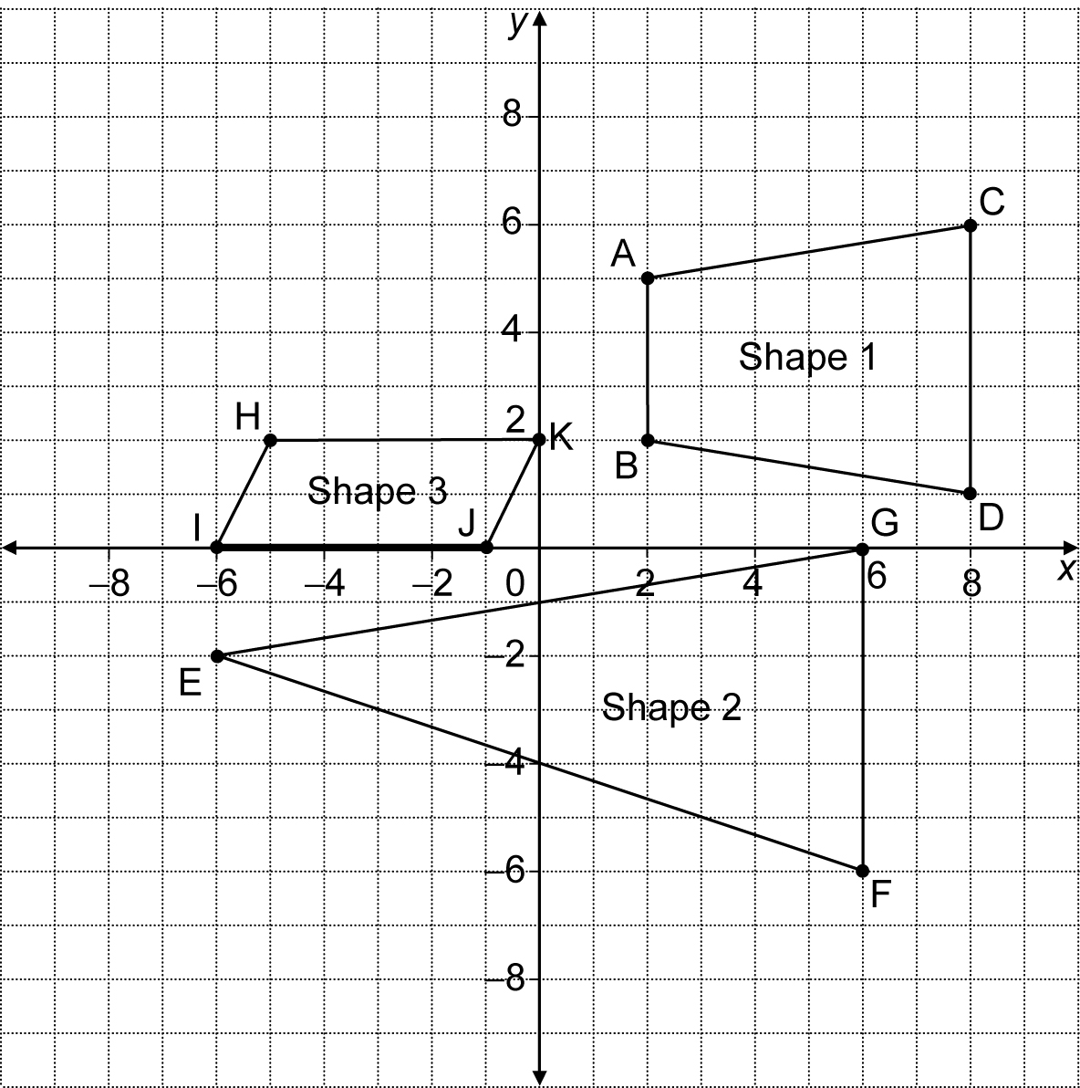

1. Write the coordinates of the vertices for the shapes on the coordinate grid.

Shape 1: A____ B____ C____ D____
Shape 2: E____ F____ G____
Shape 3: H____ I____ J____ K____

2. Name the shapes.

Shape 1: ________________
Shape 2: ________________
Shape 3: ________________

