Section 1.2 Math Link
This worksheet will help you with the Math Link on page 17.

1. Study the Math Link on page 17 of the student resource. Copy the bead design onto the coordinate grid below.

a) What quadrant is the design in? Explain how you know.  ___________________________________  ___________________________________  ___________________________________  ___________________________________  ___________________________________  ___________________________________ | 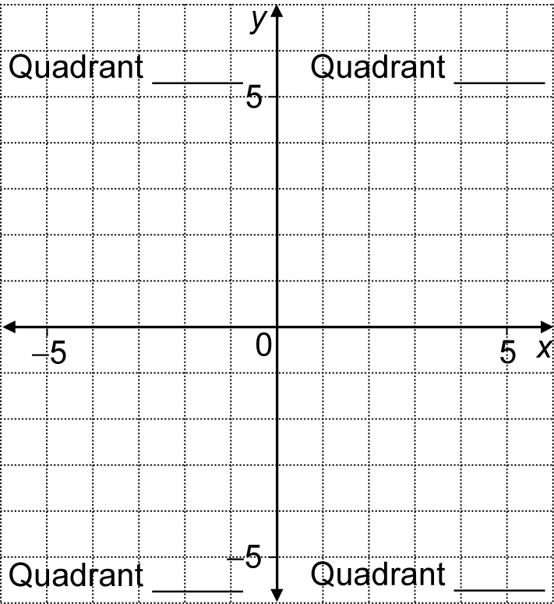

b) Look at the Math Link on page 17 again. For each line of the design, describe what colours are used, from left to right. The first one has been done for you.  A red, black, black, black, red_____________  B ___________________________________  C ___________________________________  D ___________________________________  E ___________________________________ | 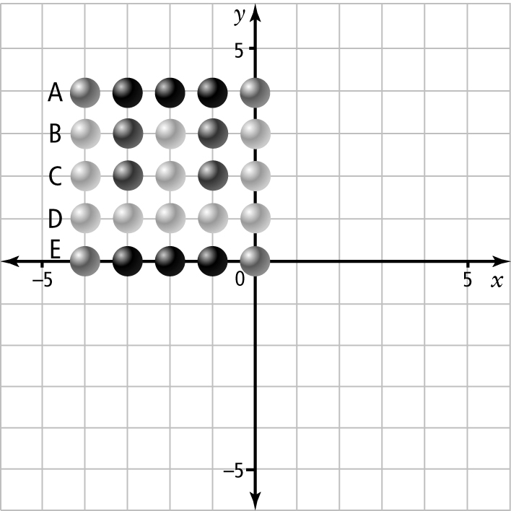

2. Repeat the same design in quadrants I, III, and IV of your grid at the top of this page. The design in each quadrant should have one edge along the
x-axis and one edge along the y-axis.
a) Look at the design in quadrants I, III, and IV. Is part of the design in these quadrants shared with the design in quadrant II? YES NO
b) Explain. ____________________________________________________
___________________________________________________________
___________________________________________________________

