Section 1.3 Extra Practice
Draw a line to match each rotation in #1 to #3 with the correct description.

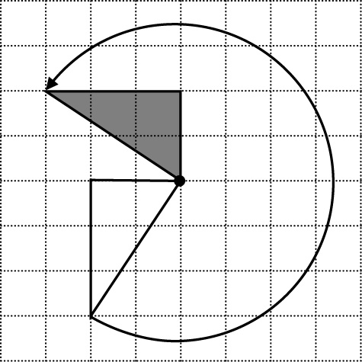  1. | A 90° counterclockwise  B 270° clockwise  C 180° clockwise  D 90° clockwise  E 180° counterclockwise  F 270° counterclockwise
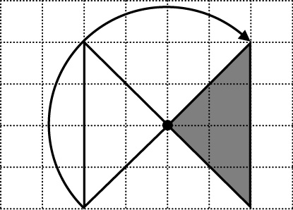
2.

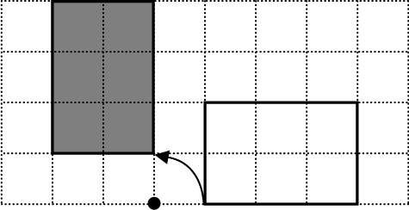
3.

4. Describe the translations shown by the arrows.

Example:

_1_ unit _right_  _2_ units _up_ | 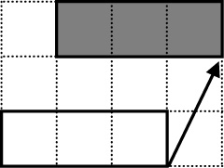

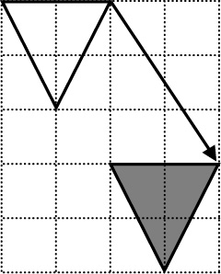  a) ___ units _______  ___ units _______ |  | b) ___ units _______  ___ units _______ | 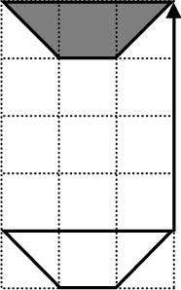

c) ___ units _______  ___ unit _______ | 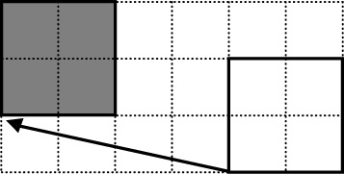 | d) ___ units _______  ___ units _______ | 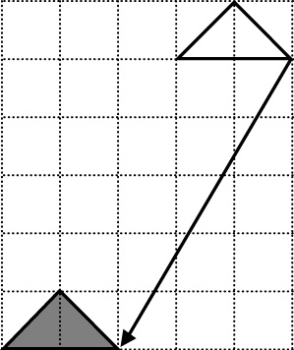

5. a) Draw the reflection image on each grid to complete the figure.

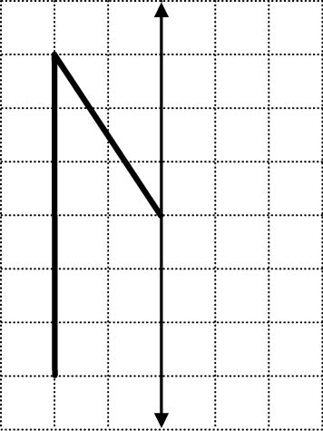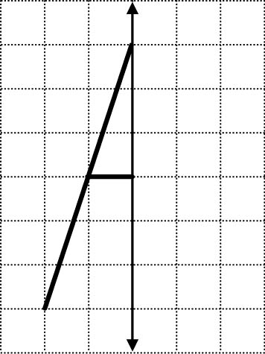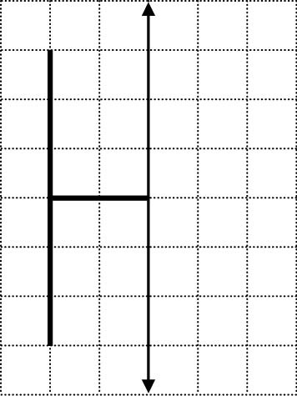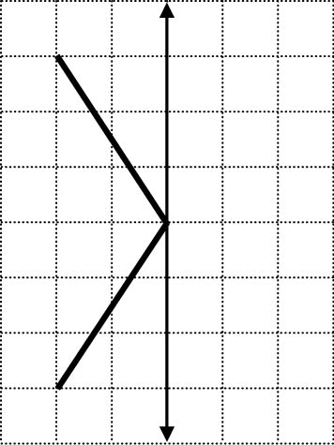
Grid A Grid B Grid C Grid D

b) Identify each figure.
Grid A ____________________ Grid B ____________________
Grid C ____________________ Grid D ____________________

c) Each of the letters has a vertical line of reflection. For which of the
letters can you draw a horizontal line of reflection so that the letter reflects onto itself? _________________

Draw these horizontal lines of reflection on the grids above.

