Section 1.4 Extra Practice
1. Write the coordinates for each point after the given translation.

Example:
D(3, 2): 3 units horizontally right, 2 units vertically down D'(6, 0)

a) C(5, 2): 5 units vertically up ______
b) F(–2, 6): 3 units horizontally left ______
c) M(−8, −4): 5 units horizontally right, 4 units vertically down ______
d) S(7, −3): 1 unit horizontally left, 2 units vertically up ______

2. Describe each translation.

Example:
T(–1, 4) → T'(0, 2)
1 unit horizontally right, 2 units vertically down _______________________

a) B(3, 10) → B'(5, 10)
___________________________________________________________
b) C(0, 6) → C'(0, −2)
___________________________________________________________
c) N(3, 3) → N'(–1, 4)
___________________________________________________________
d) R(−4, −2) → R'(5, 10)
___________________________________________________________

3. On the coordinate grid below, draw and label a triangle with vertices
R(−8, 4), S(−4, 4), and T(−6, 0).

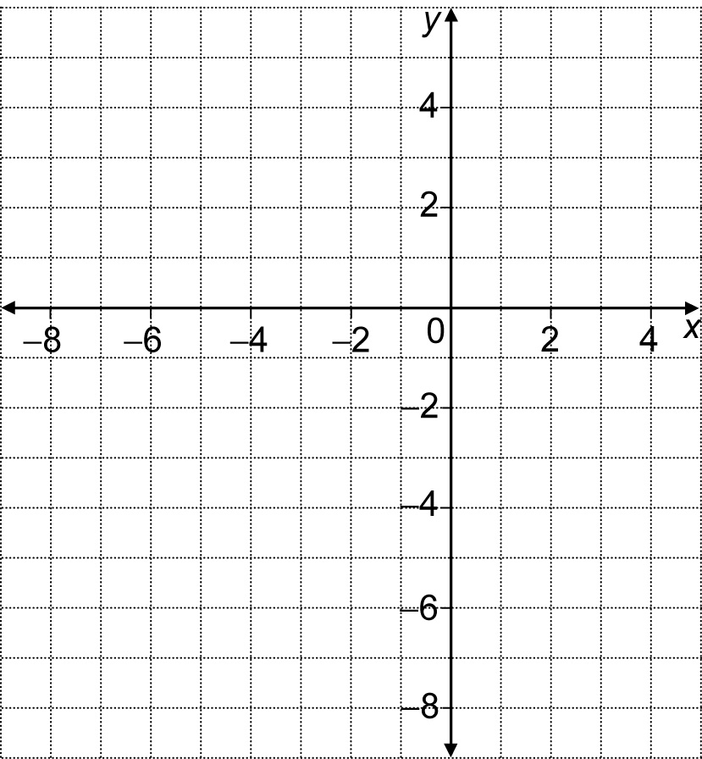

a) Draw ∆R'S'T' after a reflection in the x-axis.
What are the coordinates of the vertices of ∆R'S'T'?
R'_____, S'_____, T'_____

b) Draw ∆R"S"T" after a 180º clockwise rotation about S'.
What are the coordinates of the vertices of ∆R"S"T"?
R"_____, S"_____, T"_____

c) Draw ∆R'''S'''T''' after a reflection in the y-axis.
What are the coordinates of the vertices of ∆R'''S'''T'''?
R'''_____, S'''_____, T'''_____

d) What single transformation would have the same result as the three transformations in a), b), and c)?
_____________________________________________________________

