Chapter 1 Test
For #1 to #8, match letters on the coordinate grid to the descriptions.
Each letter may be used more than once.

1. _____ x-axis  2. _____ quadrant I  3. _____ origin  4. _____ quadrant IV  5. _____ horizontal axis  6. _____ the possible location of a point with signs (–, +)  7. _____ vertical axis  8. _____ the quadrant point M' would be in if M(3, –4) is reflected in the y-axis | 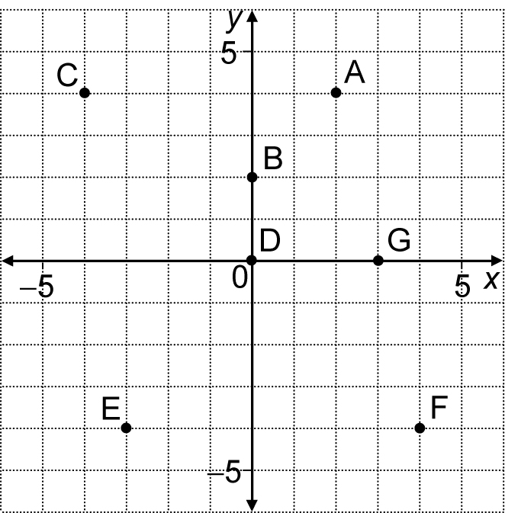

For #9 and #10, circle the best answer.
9. To plot the ordered pair (0, 5), you would move
A right 5 B up 5 C left 5 D down 5

10. Figure PQR is reflected in line n.  What are the coordinates of Q'?  A (1, 0) B (−4, −1)  C (0, 1) D (4, 1) | 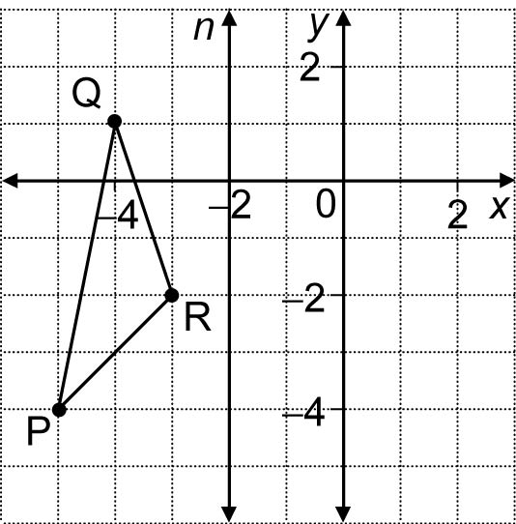
Short Answer
11. Look at the grid. What are the coordinates of each letter?  M __________________________  N __________________________  P __________________________  Q __________________________  R __________________________ | 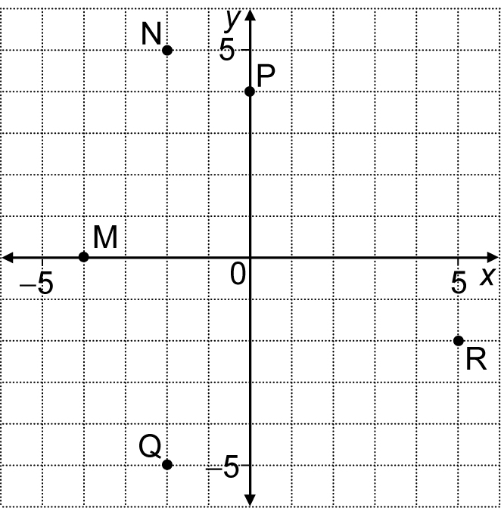

12. a) On the grid, draw and label an x-axis and  a y-axis from −5 to 5.  b) Plot and label each of the following  points:  A (−3, 5), B (0, −4),  C (4, −2), D (−4, −5),  E (5, 0) | 

13. Use the coordinate grid shown to do the following:
a) Rotate figure STV 90° in a clockwise  direction about centre of rotation T.  b) Translate figure S'T'V' 4 units left and  1 unit down.  c) What are the coordinates of V''? _______ | 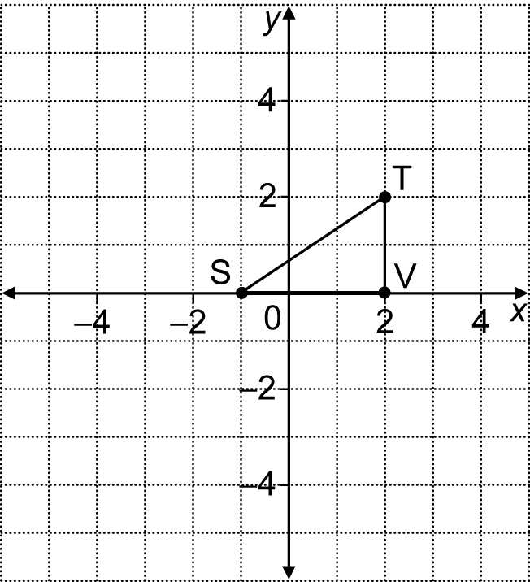
Extended Response
14. Choose any one of the following letters: A E H M K
Draw the letter on the grid below. The letter must extend into all four quadrants. Write instructions to create the letter.

              

