Chapter 1 MathLinks 7
Student Resource Answers

1.1 The Cartesian Plane, pages 9–11
5. A(3, 6), B(7, 0), C(1, −2), D(0, 0),
E(−2, −3), F(−3, 4)
6. G(3, 4), H(0, 7), I(−5, 2), J(−5, −2),
K(4, −6), L(−7, 0)
7. a) T b) X c) U d) W e) Y f) V
8. a) E b) A c) F d) B e) C f) D
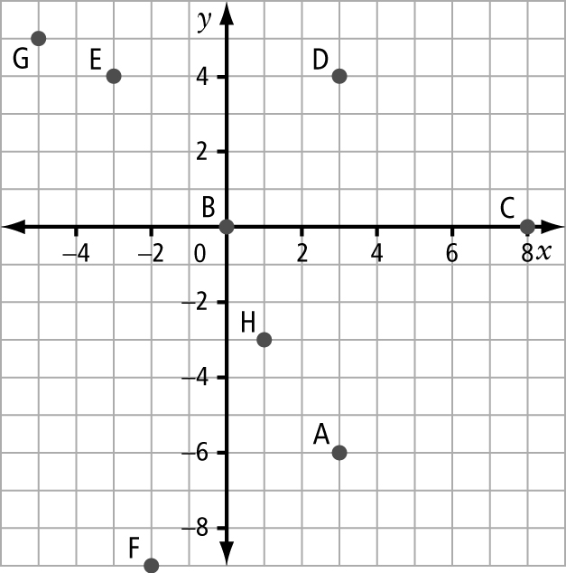
9.

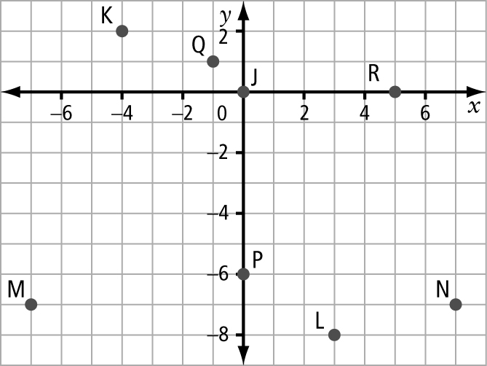
10.

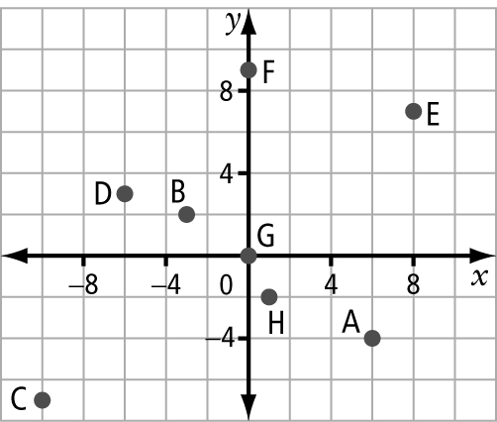
11. a), b)

c) Answers may vary, depending on the accuracy of the predictions.
d) F, G. Point F lies on the y-axis, and
G lies on the origin.
12. a) They form a vertical dotted line.
b) The x-coordinate of each point is −7.
c) Answers may vary. For example,
(−7, −2), (−7, −4)

13. a) square b) quadrant I c) 4 units
d) A and B have the same x-coordinate,
C and D have the same x-coordinate, and A and D have the same y-coordinate.
14. 12 square units. The rectangle is 4 units by 3 units. Area = length × width = 4 × 3 = 12 square units
15. a) 20 times (assumes that they do not cross diagonally) b) Yes c) Yes, W
16. a) No b) M c) M(0, −3)
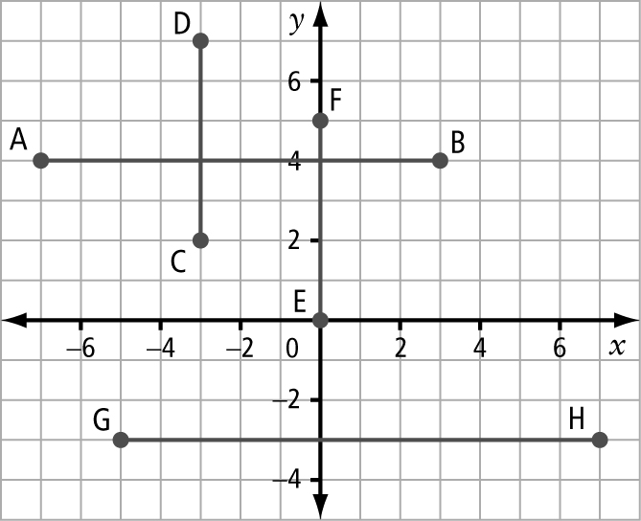
17. a)
b) AB: 10 units; CD: 5 units; EF: 5 units; GH: 12 units
18. a) (−80, 26) b) (−88, 26) c) (−89, 33)

1.2 Create Designs, pages 15–17
3. P: (2, 0), (4, 4), (0, 4); Q: (−1, −2),
(−1, −6), (3, −2), (3,−6); R: (−2, −3),
(−6, −3), (−8, −1), (−4, −1); S: (−3, −1), (−1, 1), (−6, 2), (−4, 4)
4. A: (3, 2), (3, 5), (−2, 5); B: (4, −1),
(1, −4), (5, −7), (8, −4); C: (−3, −3),
(−3, −5), (−1, −5), (3, −1), (1, −1), (1, 1);
D: (0, 2), (−1, 4), (−4, 3), (−2, 0)
5. a) A(−7, −3), B(−8, −5), C(−6, −7),
D(−5, −5), E(2, −1), F(3, −5), G(4, −3)
b) Connect A to B to C to D, connect A to E to G to D to A, connect C to F to G.
6. Answers may vary. Design A: Connect
(1, 0) to (3, 1) to (5, 0), connect (6, 1) to (4, 2) to (6, 3), connect (5, 4) to (3, 3) to (1, 4), connect (0, 3) to (2, 2) to (0, 1); colour the triangles. Design B: Connect
(0, 3) to (−3, 3) to (−6, 3) to (−6, −1) to (−3, −1) to (0, −1) to (−1, 1) to (0, 3), connect (−3, 3) to (−3, −1); colour the right side of the design. Design C: Plot and connect all 8 vertices around the outside edge of the design. Connect (−3, −2) to (−3, −6), connect (−5, −2) to (−5, −6); colour the left and right rectangles.
Design D: Connect (0, −3) to (0, −7) to
(3, −7) to (6, −7) to (6, −3) to (3, −3) to (0, −3); colour the rectangle on the right.
7. math
8. a) Answers may vary. For example, the word BOAT.
B: Connect (2, 6) to (2, 2) to (8, 2) to (5, 4) to (8, 6) to (2, 6).
O: Connect (−2, 2) to (−2, 6) to (−8, 6) to (−8, 2) to (−2, 2), and connect (−8, 6)
to (−2, 2).
A: Connect (−2, −2) to (−8, −2) to
(−8, −6) to (−2, −6) to (−3, −4) to
(−2, −2), and connect (−5, −2) to
(−5, −6).
T: Connect (2, −2) to (8, −2) to (8, −6) to (2, −6) to (2, −2), connect (4, −2) to (4, −6), and connect (6, −2) to (6, −6).
b) Answers may vary.
9. Answers may vary. For example, plot and join the following points in order: (1, 6), (2, 6), (2, 4), (3, 4), (3, 6), (4, 6), (4, 4), (5, 4), (5, 3), (4, 3), (4, 1), (3, 1), (3, 3), (1, 3). Join (1, 3) to (1, 6).
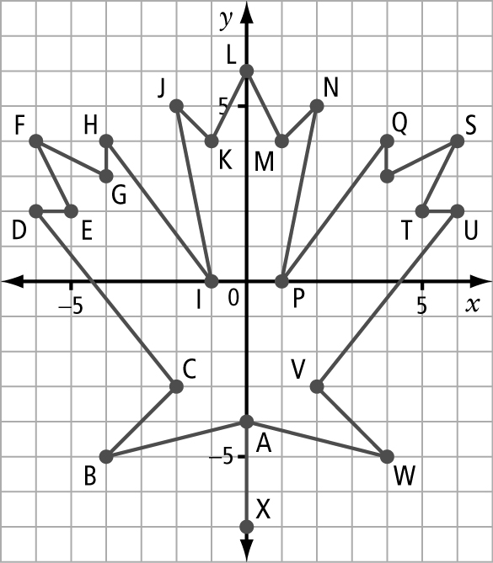
10. a)
b) a maple leaf
11. a) (21, −27) b) (28, −15) c) (59, 8)
d) (37, −5)
12. a), b) (l, w): (1, 17), (2, 16), (3, 15),
(4, 14), (5, 13), (6, 12), (7, 11),
(8, 10), (9, 9)
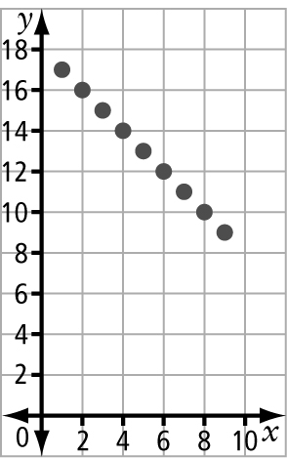  c) | d) Quadrant I. Length and width are always positive values.

13. a), b) (0, 6) and (5, 0), (0, 5) and (6, 0), (0, 4) and (7, 0), (0, 3) and (8, 0), (0, 2) and (9, 0), (0, 1) and (10, 0) | 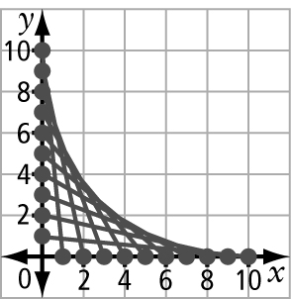
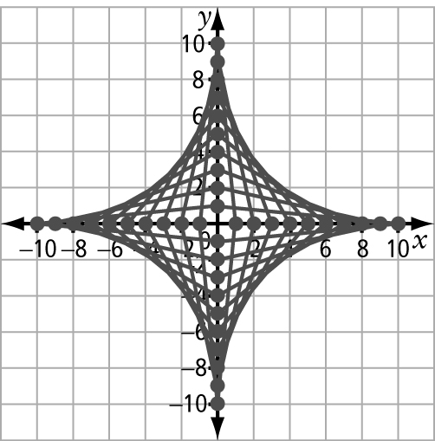
14. a)

b) The ordered pairs on the y-axis for the shapes in quadrant I and III have the same x-values and opposite y-values. The ordered pairs on the x-axis for
the shapes in quadrants I and III have opposite x-values and the same
y-values.
c) a 4-point star shape with concave sides

1.3 Transformations, pages 24–29
3. a) 8 units right, 2 units down
b) 1 unit left, 6 units up
4. a) 6 units right, 5 units up
b) 6 units left, 4 units up
5. a), b) P′(7, 4), Q′(7, −2), R′(6, 1), S′(5, 2)
c) translation: 3 units right, 6 units down
6. a), b) W′(−1, 0), X′(1, −2), Y′(−2, −3), Z′(−4, −1)
c) translation: 6 units left, 3 units down
7. No. Each vertex is not the same distance from the line of reflection, l, as its reflected vertex.
8. Yes. Each vertex is the same distance from the line of reflection, n, as its reflected vertex.
9. The line of reflection is the vertical line that crosses the x-axis at 1.
10. The line of reflection is the horizontal line that crosses the y-axis at 1.
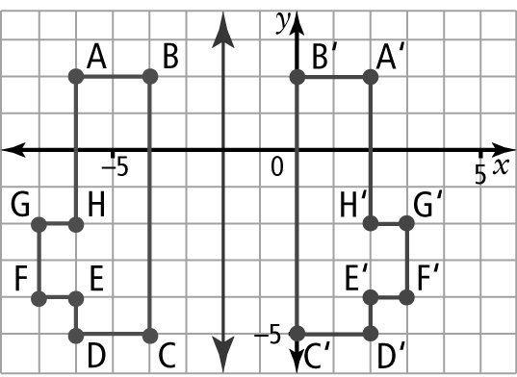
11. a)

b) A′(2, 2), B′(0, 2), C′(0, −5), D′(2, −5), E′(2, −4), F′(3, −4), G′(3, −2), H′(2, −2)
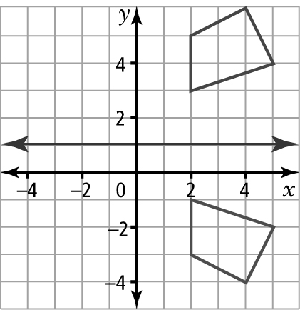
12.

13. a) H(−3, −2), A(−1, −3), T(−3, −6);
H′(7, −4), A′(5, −3), T′(7, 0)
b) 180° counterclockwise
14. a) T(−1, 2), A(−3, 2), P(−3, 5), E(−1, 6); T′(1, 4), A′(1, 6), P′(4, 6), E′(5, 4)
b) 270° counterclockwise
15. a) (−4, −4)
b) 90° clockwise, 270° counterclockwise
16. a) (2, −1)
b) 180° clockwise, 180° counterclockwise
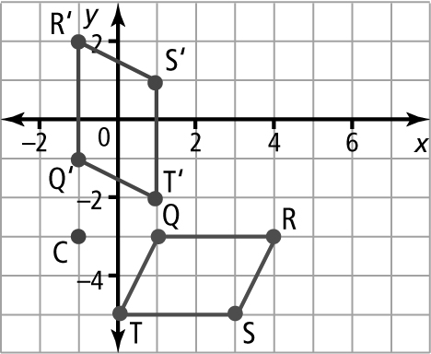  17. a) | b) Q′(−1, −1),  R′(−1, 2), S′(1, 1)  T′(1, −2)

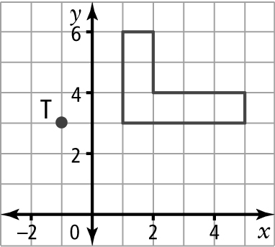  18. a) | b) The rotation image is identical to the original image.
19. a) image B, image C, image D
b), c) STUV to image B: 2 units right, 5 units up; STUV to image
C: 5 units left, 1 unit down; STUV to image D: 6 units left, 5 units up
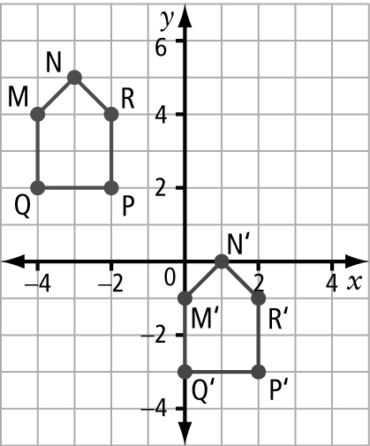  20. a), b) | c) 4 units right,  5 units down

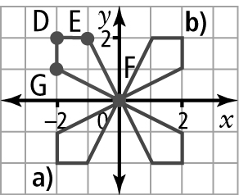  21. a), b) | c) The figures have the same shape, but are located at different positions on the coordinate grid.
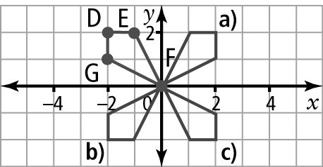
22. a)–c)
23. The final designs in #21 and #22 are the same, but in quadrants I and III, the reflected vertices E and G are in opposite positions from the rotated vertices E and G.
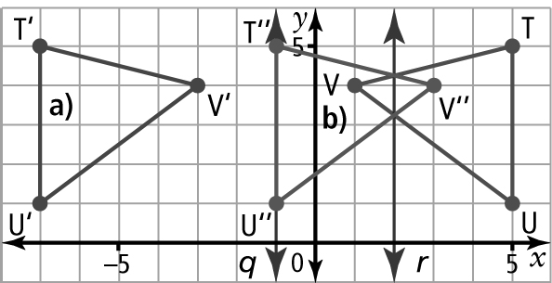
24. a), b)
c) The reflection in b) has overlap and the reflection in a) does not.
25. a) Answers may vary. For example, if the shape is symmetrical and moves in
1 direction only.
b) Answers may vary. For example, reflect a square ABCD in quadrant I in the
x-axis or translate ABCD down.
c) The x-coordinates and y-coordinates of the vertices are the same.

1.4 Horizontal and Vertical Distances, pages 34–35
3. a) 5 units horizontally right, 2 units vertically up
b) 3 units vertically down c) 1 unit horizontally left, 1 unit vertically up
4. a) 5 units horizontally left, 5 units vertically up
b) 5 units vertically up c) 7 units horizontally right, 4 units vertically up
d) 5 units horizontally left, 2 units vertically up e) 3 units horizontally right, 1 unit vertically up
f) 6 units horizontally right
5. a) K′(−5, 0), L′(−4, −1), M′(−6, −3)
N′(−7, −2) b) 7 units horizontally left, 1 unit vertically down

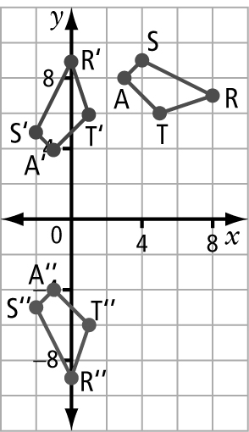  6. | a) A′′(−1, −4), S′′(−2, −5),  R′′(0, −9), T′′(1, −6)  b) S to S′′: 6 units horizontally left,  14 units vertically down;  T to T′′: 4 units horizontally left,  12 units vertically down;  A to A′′: 4 units horizontally left,  12 units vertically down;  R to R′′: 8 units horizontally left,  16 units vertically down
7. a) car C
b) Car A is closest to the bridge (car B is equal in distance but must take a left turn, which may slow it down).
c) Answers may vary. For example,
12 units horizontally right, 10 units vertically up
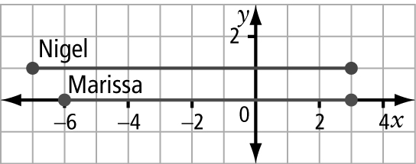
8. a)

b) Marissa’s car travelled a distance of
9 units; Nigel’s car travelled a distance of 10 units. c) Nigel won.
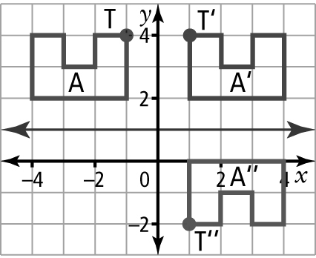  9. | a) 2 units horizontally right, 6 units vertically down  b) Yes. Rotate 180° clockwise about the point (0, 1).
10. a), b) Answers will vary. For example,
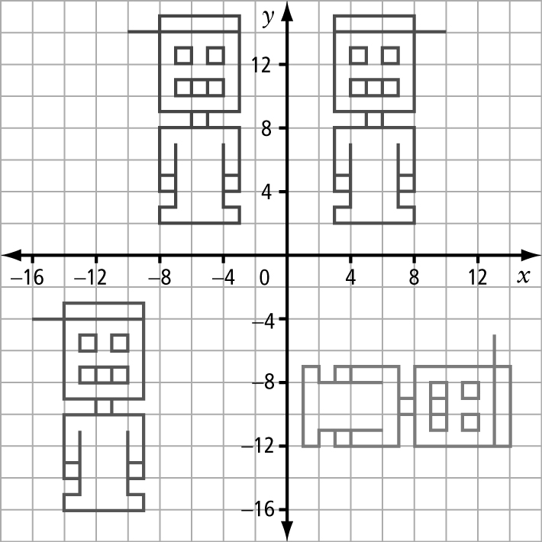
c) Answers may vary.

11. Answers may vary. For example, work with translations/reflections because it is easier to predict the resulting image.
12. C(6, −2)
13. a) A′(6, 4) b) 2 units horizontally left,
10 units vertically down c) 2 units horizontally left, 2 units vertically up
14. a) 6 units b) 20

Chapter 1 Review, pages 36–37
1. B 2. A 3. G 4. H 5. I
6. J 7. E 8. F 9. C
10. a) (0, 0) b) (−1, −3) c) (7, 0) d) (−5, 2)
11. a) E, D, F b) B, C c) A, J d) G, H
12. a) B
b) They appear to create a straight line.
13. A(0, 0), B(1, 3), C(2, 2), D(1, 1),
E(1, 2)
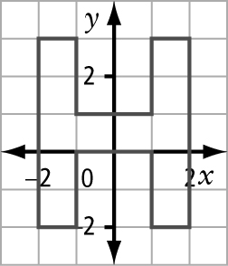  14. | 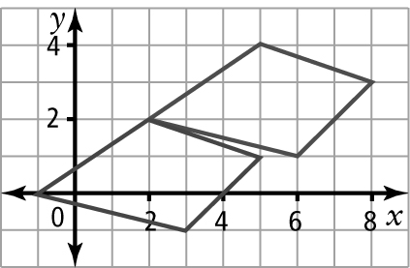  15.  (2, 2), (5, 1), (3, −1), (−1, 0)

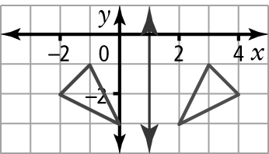  16. | 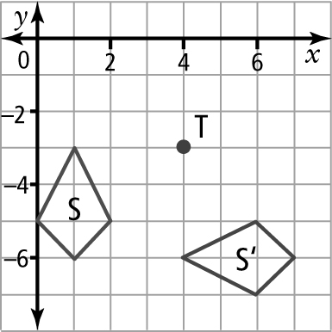  17.  (6, −5), (7, −6), (6, −7), (4, −6)
18. a) 5 units vertically up b) 6 units horizontally left, 6 units vertically up
c) 5 units horizontally left, 3 units vertically up d) 6 units horizontally left
19. a) 8 units horizontally right, 3 units vertically down b) 8 units horizontally right, 3 units vertically down
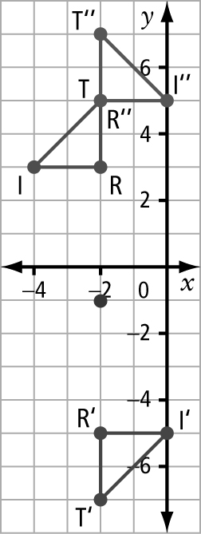  20. | 2 units vertically up,  2 units vertically up;  4 units horizontally right,  2 units vertically up
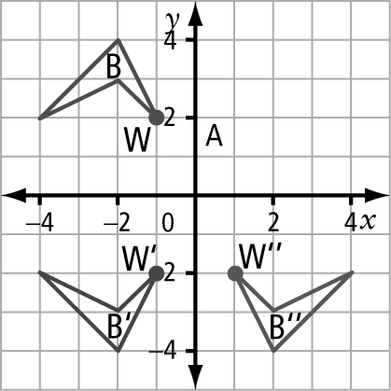
21.
a) 2 units horizontally right, 4 units vertically down
b) Yes. Rotate 180° clockwise about the point (0, 0).

Chapter 1 Practice Test, pages 38–39
1. C 2. D 3. B 4. B 5. D 6. (2, 8)
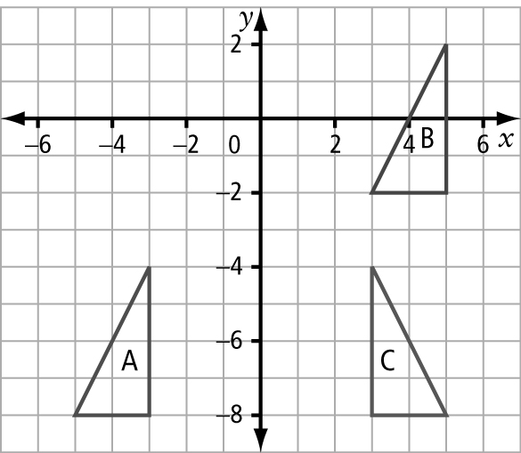
7. a)

b) 8 units horizontally right, 6 units vertically up
c) Reflect triangle A in the y-axis.

8. (2, 4), (2, −2), (−4, −2)
9. a) (4, 2) b) (4, 2) c) (0, 7)
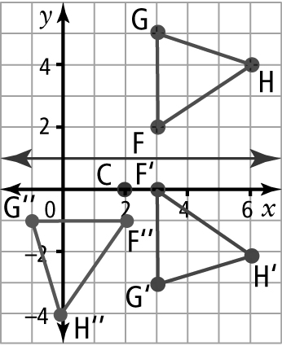  10. | a) F′(3, 0), G′(3, −3), H′(6, −2)  b) F′′(2, −1), G′′(−1, −1),  H′′(0, −4)  c) 1 unit horizontally left, 3 units vertically down  d) 6 units horizontally left, 8 units vertically down
11. a) (1, 2) b) (1, −6) c) (0, 5) d) (2, −1)
12. Answers may vary. translation: riding an elevator; reflection: looking in a mirror; rotation: riding a carousel
13. a) 1 unit horizontally right, 6 units vertically down
b) Answers may vary. Reflect in the
x-axis, translate 1 unit horizontally right and 2 units vertically down.
14. Answers may vary. The second reflection undoes the first reflection, such as a reflection in the y-axis followed by a reflection in the y-axis.

