Chapter 1 BLM Answers

BLM 1–1 MathLinks 7 Scavenger Hunt
1. Chapter 2 Operations on Decimal Numbers
2. Probability
3. page 388
4. a) chapter problem b) Math Link
5. The purpose is to make connections between the math and the real world or connections to what you already know.
6. three
7. a) The beginning of an activity called Explore the Math
b) An Example and the beginning of its Solution
8. a) Key Ideas: It provides the summary of the main new concepts.
b) Communicate the Ideas: Students talk about or write about the concepts to make sure they understand them.
9. Practise, Apply, and Extend
10. problem solving
11. Understand, Plan, Do It!, Look Back
12. Model It, Draw a Diagram, Solve a Simpler Problem, Make an Organized List or a Table, Work Backwards, Guess and Check, Look for a Pattern
13. Math Games and Challenge in Real Life
14. Puzzling Expressions
15. Winner’s Circle
16. Chapter Review and Practice Test: They help review the material in a chapter to prepare for a test.
17. a) Review of Chapters 1 to 4 and a task
b) At the end of Chapters 8 and 12
18. Glossary, page 499
19. Index: It provides an alphabetical list of the book’s contents, with page references.

BLM 1-2 Coordinates and Design
1. a) R b) (3, 3) c) 3 units down
d) 2 units right
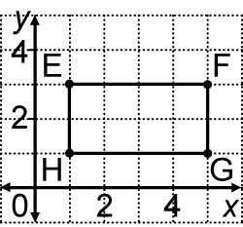
2. a) b) F(5, 3), H(1, 1)
c) length of EF and GH:
4 units; width of EH
and FG: 2 units

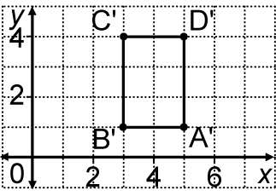
3. a) b) (3, 1)

BLM 1–4 Section 1.1 Extra Practice
1. a) E(3, 1), M(2, 8)
These points are in quadrant I.
b) R(–4, 4), B(–2, 2)
These points are in quadrant II.
c) F(–4, –4), C(–2, –6)
These points are in quadrant III.
d) V(2, –4), H(4, –10)
These points are in quadrant IV.
e) N(–3, 0) This point is on the x-axis.
f) L(0, –9) This point is on the y-axis.
g) P(0, 0) This point is at the origin.
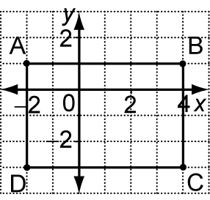
2. a) 6
- b) 4
- c) rectangle
- d) 24

BLM 1–6 Section 1.2 Extra Practice
1. Shape 1: A(2, 5) B(2, 2) C(8, 6) D(8, 1)
Shape 2: E(–6, –2) F(6, –6) G(6, 0)
Shape 3: H(–5, 2) I(–6, 0) J(–1, 0) K(0, 2)
2. Shape 1: trapezoid
Shape 2: triangle
Shape 3: parallelogram

BLM 1–8 Section 1.3 Extra Practice
1. F 2. C 3. A
4. a) 2 units right, 3 units down
b) 4 units up
c) 4 units left, 1 unit up
d) 3 units left, 5 units down
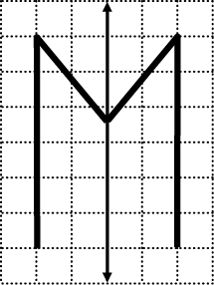
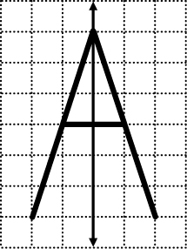
5. a)

Grid A Grid B

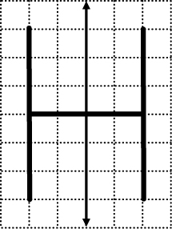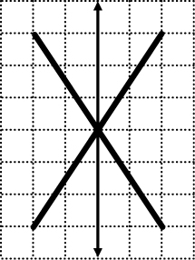
Grid C Grid D
b) Grid A: M Grid B: A
Grid C: H Grid D: X

c) H, X
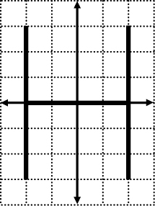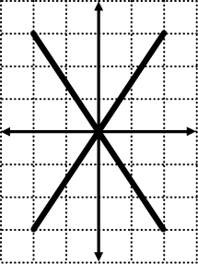

BLM 1–10 Section 1.4 Extra Practice
1. a) C'(5, 7) b) F'(–5, 6)
c) M'(–3, –8) d) S'(6, –1)
2. a) 2 units horizontally right
b) 8 units vertically down
c) 4 units horizontally left, 1 unit vertically up d) 9 units horizontally right, 12 units vertically up
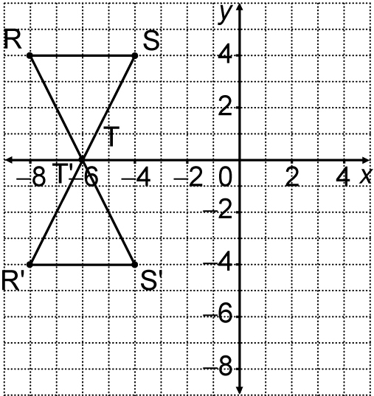
3. a)

R'(–8, –4), S'(–4, –4), T'(–6, 0)
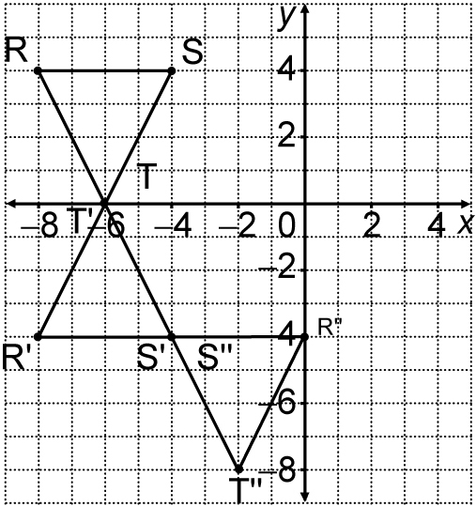
b)

R"(0, –4), S"(–4, –4), T"(–2, –8)
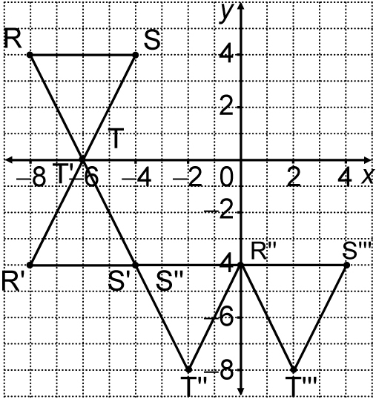
c)

R'''(0, –4), S'''(4, –4), T'''(2, –8)
d) Translation 8 units right, 8 units down

BLM 1–11 Chapter 1 Key Words Puzzle
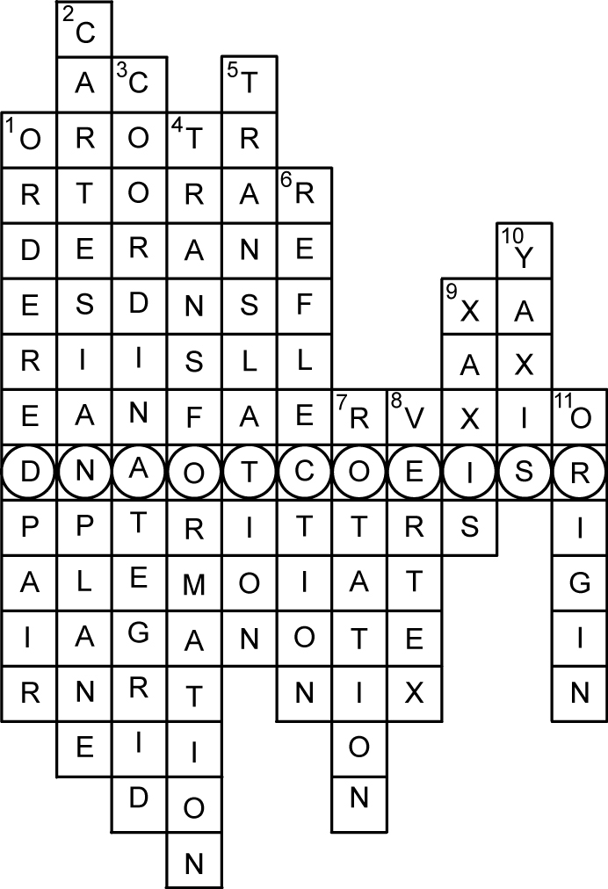
COORDINATES

BLM 1–12 Chapter 1 Test
1. G 2. A 3. D 4. F 5. G
6. C 7. B 8. E 9. B 10. C
11. M(−4, 0), N(−2, 5), P(0, 4),
Q(−2, −5), R(5, −2)
12. a), b)
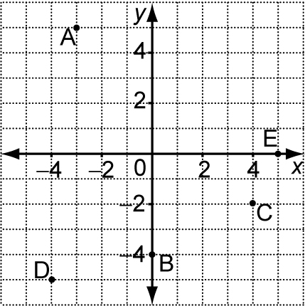
13. a), b)
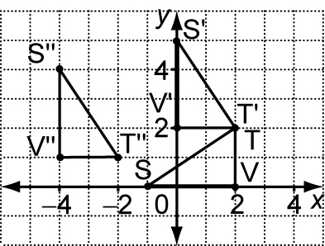
c) (−4, 1)
14. Answers will vary.

