Chapter 4 Self-Assessment
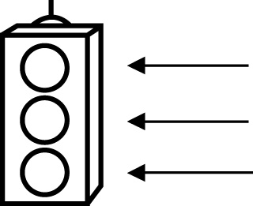 | RED I have not started moving in this area.  YELLOW I am moving along with caution in this area.  GREEN I am moving along confidently in this area.

BEFORE | DURING  (What I can do if I mark yellow or red.) | AFTER  (Proof that I can do this.)
4.1

I can estimate percents as fractions.
I can estimate percents as decimals.
I can compare fractions, decimals, and percents.
I can order fractions, decimals, and percents.
I can estimate and solve problems involving percent.
4.2
I can convert among fractions, decimals, and percents.
I can estimate percent values.
I can distinguish between terminating and repeating
decimals.

I can relate fractions to terminating decimals.
I can relate fractions to repeating decimals.
4.3
I can estimate answers to percent calculations.
I can solve percent problems.

