Comparing Numbers
1. What is the number halfway between the given numbers?

a) 20, , 30 b) 7, , 13

2. Name all the whole numbers that are
a) between 699 and 701.8 b) multiples of 10 as well as between 95 and 125
c) between 6 × 5 and 36

3. Consider fractions with a denominator of 8. Choose a whole number numerator that would make the fraction
a) almost 1 b) a little more than one half c) as small as possible

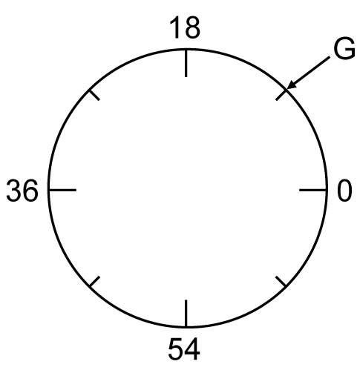
4. State a possible value for G in each of the following diagrams.
a) | 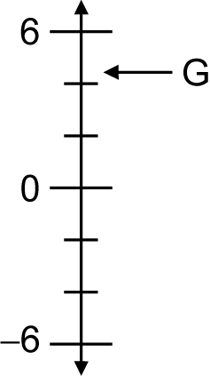  b) | 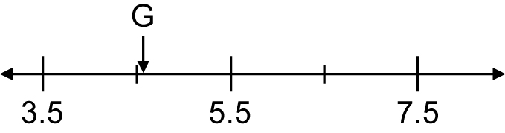  c)

5. Use the number line below to answer the following questions.

a) What letter best corresponds to 335?  b) What number could correspond to the letter Z?  c) What number could correspond to the letter R? | 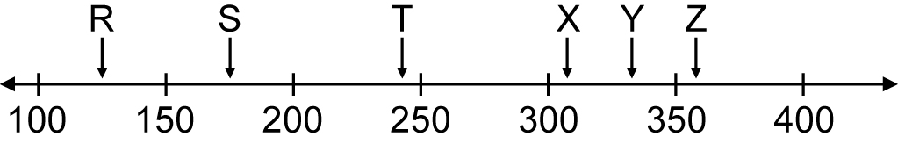

6. Explain where to place the number 60 on the number line below.

7. Fill in the box to make a true statement.
a) 14.2 < < 14.7 b) 89 > > 88

8. Arrange the following numbers from smallest to largest.
2315.6, 2316, 2315.9, 2315.92

