Section 4.1 Art Link
This worksheet will help you with the Art Link on page 131.

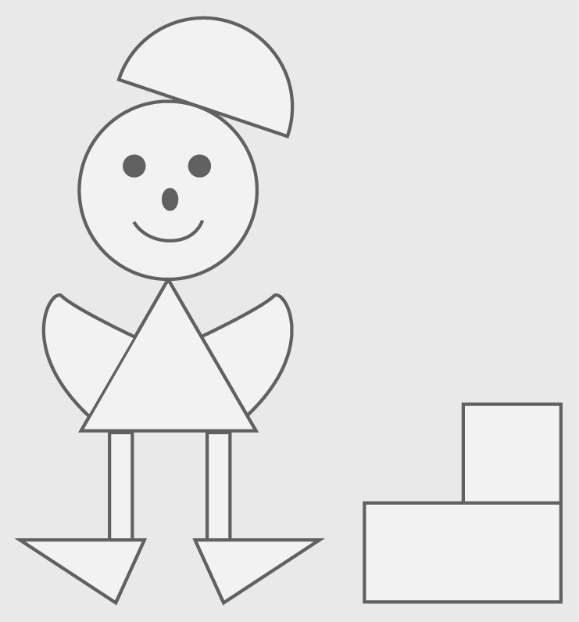

Create a personal logo from triangles, rectangles, and circles. Your logo can resemble a person, animal, or thing.

1. Draw two triangles, two rectangles, and two circles on a sheet of
construction paper.

2. Cut out the six shapes.

3. If you wish, trade some of your shapes with students who have other colours of construction paper.

4. Cut the shapes into halves or quarters of the original shape.

5. Glue your shapes to another piece of paper to create your logo. You must use all of your shapes or their parts. Pieces may partially, but not completely, overlap.

6. Decorate or colour your logo. Give it a name.

7. Label each part shape with its fraction, decimal, or percent equivalent.

