Section 4.2 Math Link
This worksheet will help you with the Math Link on page 139.

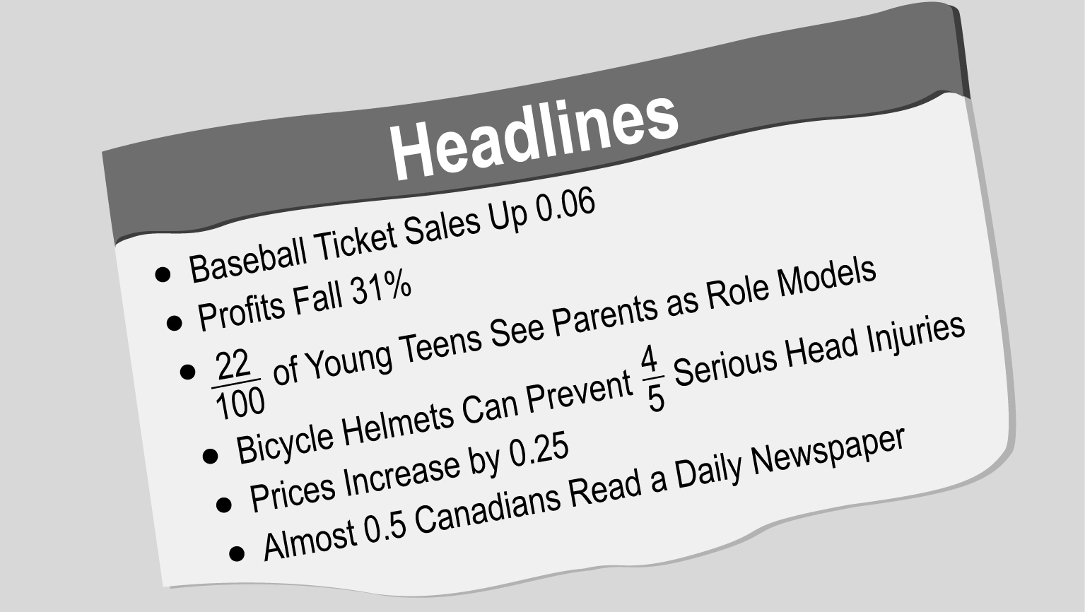

Rewrite these headlines to show what you have learned about converting fractions, decimals, and percents. The first one is done for you.

Headline | Fraction  Form | Decimal  Form | Percent
Baseball Ticket Sales Up 0.06 |  | 0.06 | 6%
Profits Fall 31% |  |  | 31%
of Young Teens See Parents as Role Models
Bicycle Helmets Can Prevent Serious Head Injuries
Prices Increase by 0.25 |  | 0.25
Almost 0.5 Canadians Read a Daily Newspaper |  | 0.5

