Explore the Surface Area of a Cone

How is the surface area of a cone related to the area of the related circles?

Materials
• compass
• scissors
• calculator

1. Determine the area of a circle with a diameter of 5 inches. Show your answer to two decimal places.
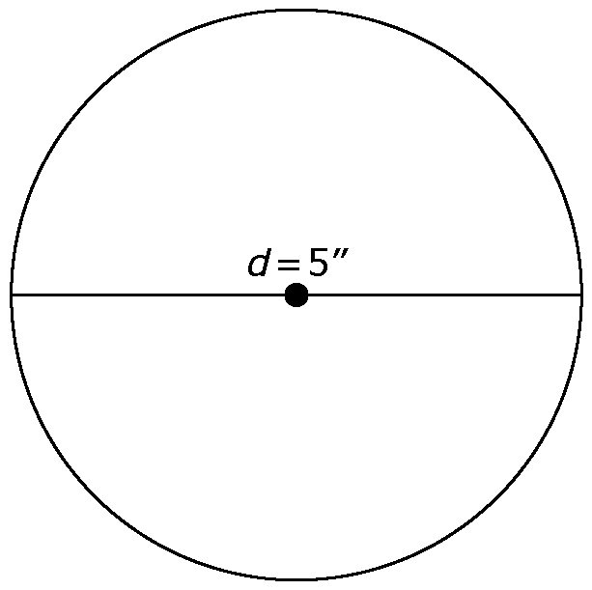

2. a) Use your compass to construct a circle with a diameter of
5 inches. Mark the centre.
b) At one point on the circle, make a straight cut from the circumference to the centre.
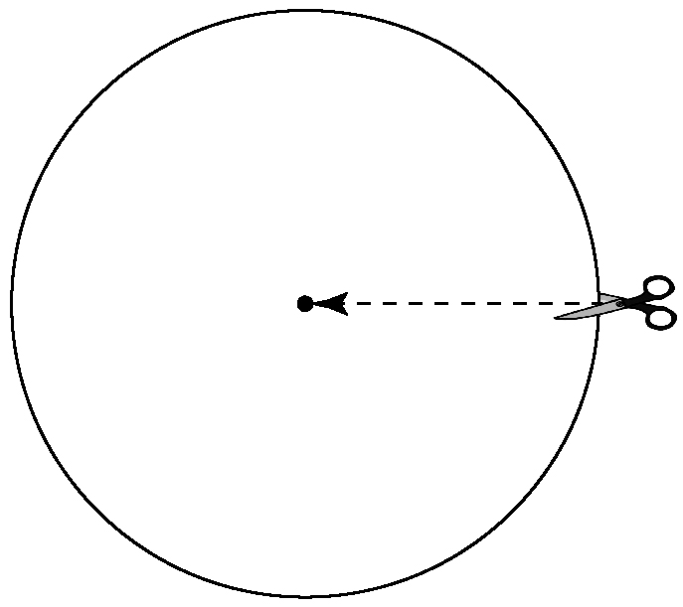
3. a) Fold the cut edges under to make a cone similar to the one shown here.

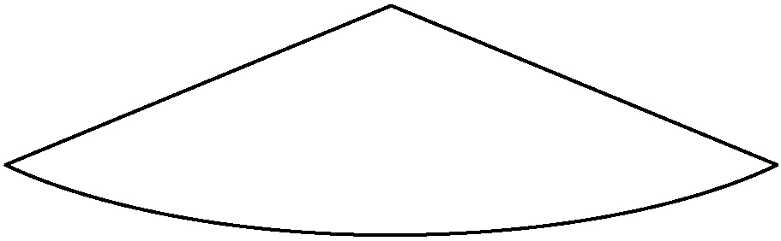

b) What is the diameter of the base of the cone?
c) Calculate the area of that circle.
d) What fraction of the circle from #2 is on the top face of the cone? Estimate the area of that part of the cone.
e) Calculate the total surface area of the cone.

4. a) Refold the cut edges to make a tighter cone similar to the one shown here.

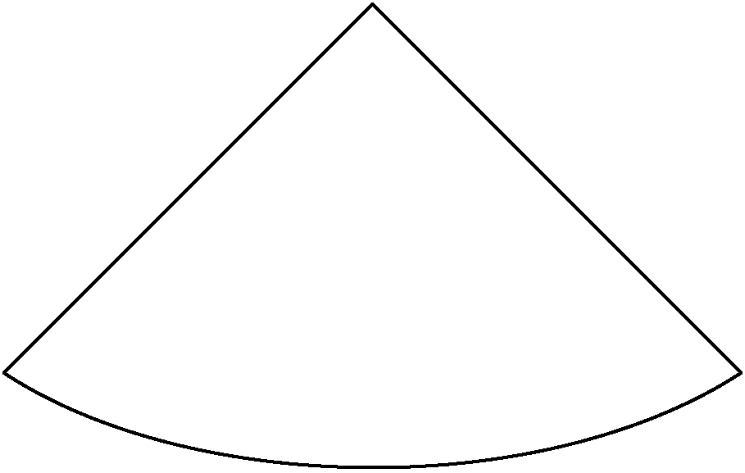

b) What is the diameter of the base of the cone now?
c) Calculate the area of that circle.

d) What fraction of the circle from #2 is on the top face of the cone? Estimate the area of that part of the cone.
e) Calculate the total surface area of the cone.

5. Reflect
How is the surface area of a cone related to
• the area of the circle that makes its base?
• the area of the large circle used to make its top face?

6. Extend Your Understanding Figure A below shows the parts of a cone. Figure B below shows the net of a cone.

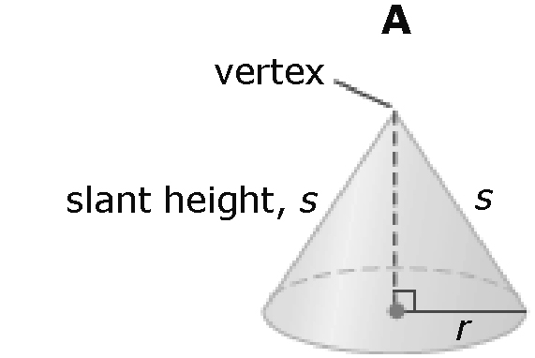

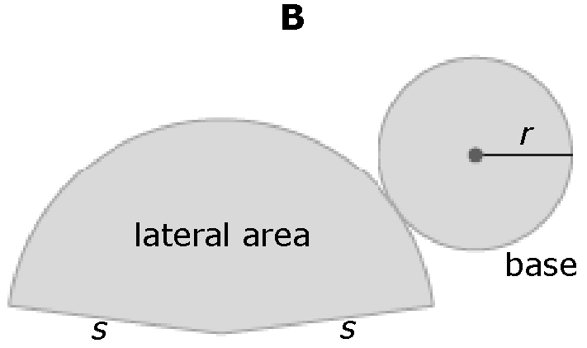

a) How does the diameter of the base of a cone affect its surface area?
b) How does the slant height of the lateral area of a cone affects its surface area?

