Calculate the Surface Area of a Cone
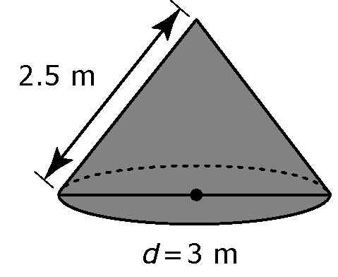
Gravel is released from an overhead storage bin.
The pile is in the shape of a cone with a base
diameter of 3 m and a slant height of 2.5 m.
What is the surface area of the gravel pile, including
the base? Show your answer to one decimal place.

Solution
You can determine the total surface area of a cone using the formula SA = πr² + πrs.

In this formula, r is the radius of the circle and s is the slant height.
The diameter of the circle is 3 m.
Therefore the radius is 1.5 m.

The slant height of the cone is 2.5 m.
SA = πr² + πrs
SA = π(1.5)² + π(1.5)(2.5)
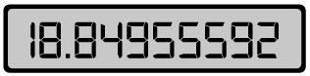
SA = 18.849…
F.Y.I.
Your calculator may require a different keystroke sequence. Test to see what works for your calculator model.

The surface area of the cone is 18.8 m².

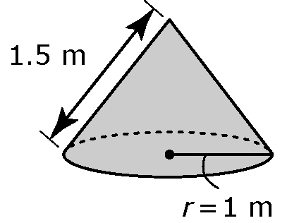
Your Turn
Determine the surface area of the cone, including
the base. Show your answer to two decimal places.

