Work With the Surface Area of a Cone

1. Calculate the surface area of each right cone. Show your answer to the nearest square unit.
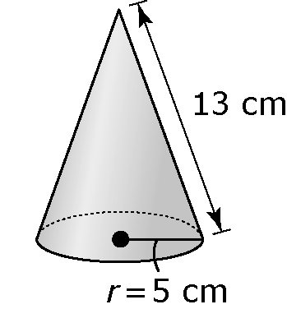
a)

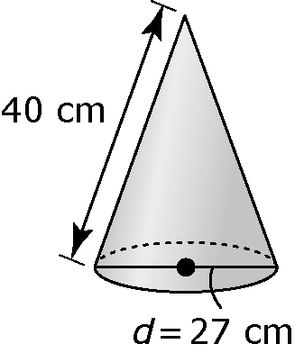
b)

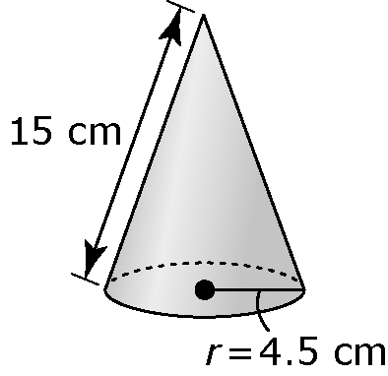
c)

2. Sketch a right cone with a diameter of 16 cm and a slant height of 12 cm. What is its surface area, including the base? Show your answer to two decimal places.

3. A cone and a cylinder have the same base diameter and the same height. Which one has the greater surface area? Explain your reasoning.

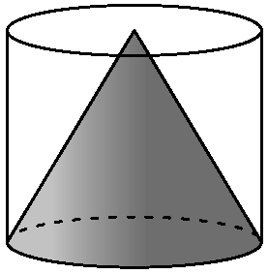
4. A lampshade has the shape of a cone with the top piece cut off. Calculate the outside surface area of the lampshade to the nearest tenth of a square centimetre.

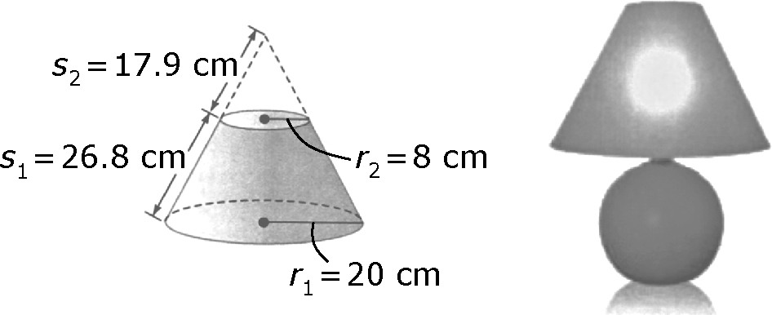

5. A tipi was used by the First Nations and Inuit as a one-room home where families would meet to eat, rest, and socialize. A typical tipi was 16 ft wide and had a slant height of 14.5 ft. Assume that a tipi approximates a cone. How much material was used to cover the tipi, including the floor? Give your answer to the nearest tenth of a square foot.
