Chapter 2 SE Answers

Chapter 2 Measuring Length

Chapter Opener, pages 54 to 55
Examples:
1. distance from shore, length of rope, depth of water, length of fish
2. distance between boats, distance from shore, length of rope below water
3. length of fish or length of lobster
4. farmer, firefighter, police officer, tailor, builder

Get Ready, pages 56 to 57
1. a) $0.75 b) $0.30 c) $0.05 d) $1.38
2. a) 99¢ b) 349¢ c) 7¢ d) 50¢
3. a) Divide by 100. b) Multiply by 100.
4. a) 14 b) 140 c) 1400 d) 14 000
5. a) To multiply a whole number by 10, add one zero to the right of the number; to multiply a number by 100, add two zeros to the right of the number; to multiply by 1000, add three zeros to the right of the number. For a decimal number, move the decimal point to the right the same number of places as the number of zeros. So, to multiply by 10, move the decimal point one place to the right; to multiply by 100, move the decimal point two places to the right, and so on.
b) Add four zeros to the right of the number 346 to get
3 460 000.
c) Add five zeros to the right of the number 22 to get
2 200 000.
6. a) 355 b) 1890 c) 75 d) 263
7. a) $1.23 b) $2.46 c) $12.28 d) $24.56 e) $122.80
f ) 245.60
8. a) 26 000 b) 2600 c) 260 d) 26
9. a) To divide by 10, move the decimal point one place to the left; to divide by 100, move the decimal point two places to the left; to divide by 1000, move the decimal place three places to the left.
b) Move the decimal place five places to the left, so the answer will be 7.
c) Move the decimal place five places to the left, so the answer will be 16.
10. a) 473 b) 47.3 c) 4.73 d) 0.473
11. a) 2 L for $9.99
b) Example: 8 × 250 mL = 2 L, then 8 × $1.99 = $15.92, which makes the smaller size more expensive than the larger size.
12. a) 12, 24, 36, 48, 60, 72, 84, 96, 108, 120
b) 6, 12, 18, 24, 30, 36, 42, 48, 54, 60
c) Because 12 = 2 × 6, some of the multiples of 12 are the same as those of 6.
13. 3 and 4, 2 and 6
14. a) b) or c)
15. a) b) c) d) ,
16. 17.5 L
17. a) b) or c) or
d) Example: , ,
18. a) , 0.9 b) , 0.3 c) , 0.6 d) , 0.7
19.

2.1 Imperial Length Measurements, pages 58 to 69
On the Job 1
Check Your Understanding
1. Examples: a) estimate: 7 ft; actual: 7 ft
b) estimate: 1 ft; actual: 1 ft c) estimate: 1 ft; actual: 1 ft
d) estimate: 1 ft; actual: 1 ft e) estimate: 3 ft; actual: 3ft
2. Examples: a) 68 in. b) 29 in. c) 42 in. d) 10 in.
e) 46 in. f ) 40 in. g) 18 in. h) 78 in.
3. Examples: a) 5 ft 8 in. b) 2 ft. 5 in. c) 3 ft. 6 in.
d) 10 in. e) 3 ft 10 in. f ) 3 ft 4 in. g) 1 ft 6 in.
h) 6 ft 6 in.
4. a) 1 ft 5 in. b) 1 ft 9 in. c) 5 ft 10 in. d) 13 ft 4 in.
5. a) 8 in. b) 6 in.
6. a) 7 in. b) 8 in. c) 6 in. d) 8 in.
7. inches, feet, yards, miles
8. b) Example: 10 yd
9. a) 30 ft b) 2 yd
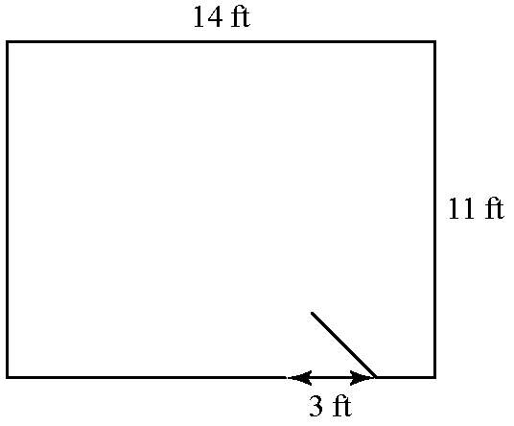
10. a)

b) 47 ft c) Example: six 8-ft lengths or four 12-ft lengths

On the Job 2
Check Your Understanding
1. Examples: a) 8 in. b) 6 in. c) 6 in. d) 3 in.
2. Examples: a) 8 in. b) 5 in. c) 6 in. d) 3 in.
3. Examples: a) 3 ft b) 1 ft c) 3 ft d) 4 ft
4. Examples: a) 3 ft 2 in. b) 10 in. c) 3 ft 4 in.
d) 3 ft 10 in.
5. Examples: a) 100 ft b) 12 ft c) 60 ft
6. a) Example: 10 in. b) 10 in.
c) The estimate was accurate.
7. 2 ft

8. Example: 600 ft
9. Examples: a) estimate: 8 in.; actual: 9 in.
b) 4 hand spans c) estimate: 3 ft; actual: 2 ft 10 in.
d) 1864 strides
10. Example: My stride is approximately 3 ft, so I would take two strides.
11. a) Look for a line that is exactly in. long.
b) Example: George may want to cut a piece measuring 6 in. so that he has an extra in.

Work With It
1. Yes, they are the same. Both of the measuring tapes are accurate.
2. Examples: a) height 7 ft and width 3 ft b) 17 ft
c) one 12-ft length and one 8-ft length
3. 80 studs
4. a) No, the wall length that needs tiles is 16ft.
The bathtub and the door do not need tiles.
b) 33 tiles
5. a) 110 ft b) 1320 in.
6. 5 ft 7 in.
7. Example: I would use the fact that 6′ 11″ is 1″ less than 7′. Add 7′ to 8′ 3″, which gives 15′ 3″. Then, subtract 1″, which is 15′ 2″.
8. The marks are different lengths; each length indicates a different fraction of an inch. This makes it easier to read measurements.
9. a) Examples: room dimensions, furniture dimensions, a person’s height
b) Examples: for room dimensions, you may need exact measurements to determine the amount of flooring to buy; for furniture dimensions, you may need exact measurements to determine furniture placement; for a person’s height, you may need an approximate measurement only.

2.2 SI Length Measurements, pages 70 to 81
Puzzler
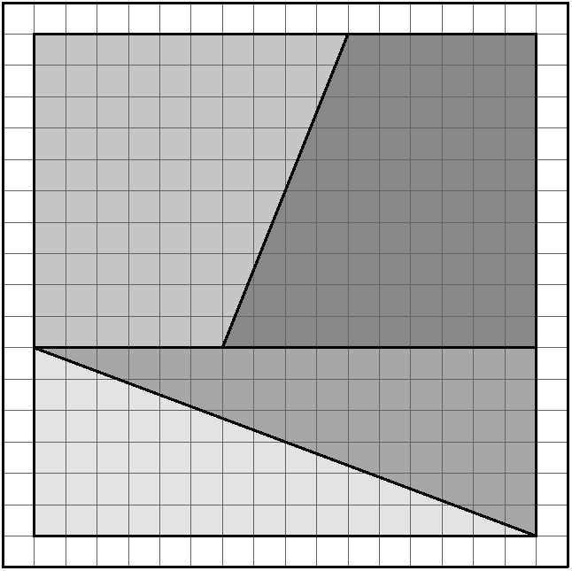
a)

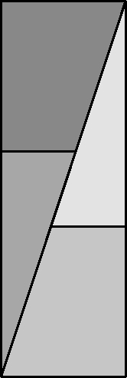
b)

c) 64 units
d) 72 units
e) Example: The rearrangement of the triangles results in a greater perimeter.

On the Job 1
Check Your Understanding
1. Examples: a) 75 mm b) 204 mm c) 30 mm d) 2 mm
2. Examples: a) 300 mm b) 1224 mm c) 90 mm
d) 10 mm
3. Examples: a) 173 cm b) 74 cm c) 107 cm d) 25 cm
e) 117 cm f ) 102 cm g) 46 cm h) 198 cm
4. Examples: a) 2 m b) 20 m c) 3 m d) 10 m e) 1 m
f ) 2 m
5. millimetre, centimetre, metre, kilometre
6. Look for a rectangle that measures 9 mm by 24 mm.
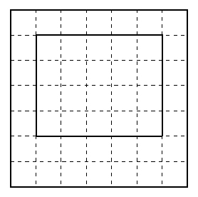
7. Examples: a) 50 cm by 40 cm
b)

8. 720 cm or 7.2 m
9. a) 5 m b) 2.5 m c) 3.5 m

On the Job 2
Check Your Understanding
1. Examples: a) 25 cm b) 14 cm c) 15 cm d) 8 cm
2. Examples: a) 20.3 cm b) 14.3 cm c) 15.2 cm
d) 7.6 cm
3. Examples: a) 1 m b) 2 m c) 1 m d) 1.1 m
4. Examples: a) 1.1 m b) 1.9 m c) 1.02 m d) 1.17 m
5. Examples: a) 30 m b) 3.5 m c) 20 m
6. a) Example: 20 cm b) 18.6 cm
c) My estimate was out by 1.4 cm.
7. Example: 40 m
8. 0.5 m or 50 cm
9. b) Example: Use a piece of string.
10. Example: I could take three stride lengths
(about 1 m each).
11. Step 2: Example: A student may slow down for the corners or cut the corners. Or, a student may take smaller steps to walk around the corners.

Work With It
1. Examples: a) 0.5 cm; pencil eraser b) outside diameter: 4.4 cm; inside diameter: 3.6 cm c) 0.4 cm
2. Example: 120 cm; The salmon’s length is approximately of the man’s height.
3. a) Example: Knee-high is approximately 50 cm.
b) 4.45 m
4. a) Example: approximately 30 m; There are four sides of approximately 5 m plus the extra L-shaped part of the path, which adds approximately another 10 m. b) 29.1 m
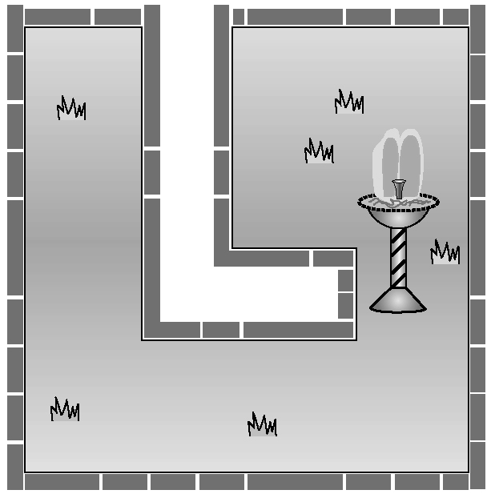
c)

The perimeter is the same as the answer in part b).
d) Example: Changing the width of the pathway has no effect on the perimeter of the border.
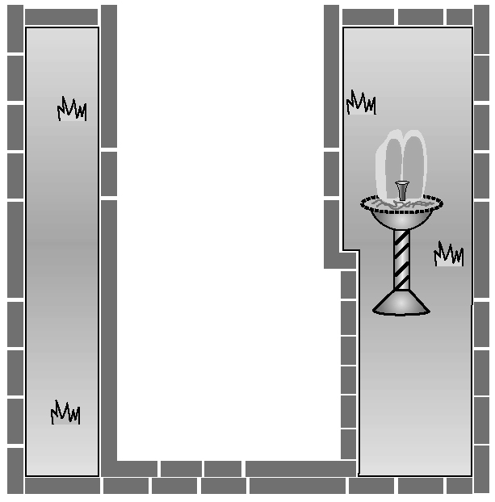

5. a) Each centimetre is divided into tenths or millimetres.
b) Each 5-mm mark is slightly longer.
c) The longer mark identifies half of a centimetre
or 0.5 cm.
6. There are 10 mm in 1 cm, so you multiply by 10 to convert from centimetres to millimetres. Multiplying by 10 moves the decimal point one place to the right but does not change the digits.
7. Examples: a) I prefer to use the SI system because it is easier to work with units that have a base of 10. The imperial system requires using fractions, which is more difficult.

b) I am comfortable with both systems, but I prefer using the SI system.
c) At school, I use the SI system but at home I use the imperial system for measurements such as my height. (The SI system is more predominant in Canada.)
8. Examples: metal measuring tape, plastic ruler. Both tools have SI and imperial measurements. I used a metal measuring tape to measure my room before buying paint. I used a plastic ruler to measure photos that I want to frame.

2.3 Length Conversions, pages 82 to 93
On the Job 1
Check Your Understanding
1. Examples: a) 10 cm b) 15 cm c) 25 cm d) 30 cm
2. a) 10.16 cm b) 15.24 cm c) 25.4 cm d) 30.48 cm
3. a) 101.6 mm b) 152.4 mm c) 254 mm d) 304.8 mm
4. a) 3 in. b) 7 in. c) 11 in. d) 15in.
5. a) 30.48 cm b) Example: The accuracy required depends on the reason for making the conversion. For estimation, 30 cm is easiest to work with.
c) 180 cm d) 183 cm e) 182.88 cm
f ) Example: estimating the length of a car
g) Example: buying a length of copper wire for a building project
6. 21 in.
7. Examples: a) I used two stride lengths to represent
1.8 m.
b) Example: Two stride lengths measured 1.7 m.
c) 71 in. or 5 ft 11 in.
8. 6 ft 7 in. to 8 ft 2 in.
9. a) 45.5 ft b) 13.8684 m
c) I changed the length to metres because the total length is long.
10. No, the two board sizes are very similar. Callie’s boards measure 88.9 mm by 19.05 mm, so her boards are approximately 1 mm smaller in width, but approximately 1 mm larger in depth.
11. a) 1 yd is 3 ft, or approximately 90 cm, so 115 yd is approximately 103.5 m.
b) 105.156 m or approximately 105.2 m

On the Job 2
Check Your Understanding
1. a) 6.2 mi b) 15.5 mi c) 37.3 mi d) 55.9 mi
e) 217.5 mi f ) 466.1 mi
2. a) 16.1 km b) 40.2 km c) 96.5 km d) 144.8 km
e) 563.2 km f ) 1206.8 km
3. a) approximately 10 min b) approximately 24 min
c) approximately 58 min d) approximately 1 h 27 min
e) approximately 5 h 38 min f ) approximately 12 h 4 min
4. a) approximately 26 mi b) approximately 41 mi
c) approximately 54 mi
d) approximately 82 mi e) approximately 107 mi
5. a) 110.7 km b) approximately 69 mi

6. a) approximately 856 km b) approximately 246 km
c) approximately 177 km d) approximately 104.6 km
7. approximately 1206.75 m
8. a) Example: about 700 km b) Example: about 430 mi
c) about 13.21 gal d) $40.95 e) $43.00

Work With It
1. Examples: a) I used 3 hand spans (each 20 cm).
b) I was out by about 3 cm.
c) approximately 25 in. d) The distance from my shoulder to my wrist is close to 25 in.
2. Examples: a) Assuming that the vehicle is
about 5 ft tall, the snow bank is about 15 ft tall.
b) 4.572 m
3. 540 km ≈ 335.5 mi; 254 km ≈ 158 mi; 34 km ≈ 21 mi; 220 km ≈ 137 mi; 296 km ≈ 184 mi
4. a) Example: in. b) Example: 1 in.
c) Use the conversion 2.54 cm = 1 in. If you know a length in inches, multiply by 2.54 to get the number of centimetres. If you know a length in centimetres, divide by 2.54 to get the number of inches.
5. a) St. Lawrence b) approximately 5857 km
c) approximately 3639 mi
6. Examples: a) SI units: distances between places in Canada (km); length of swimming pools (m); mechanical pencil leads (mm). Imperial units: distances between places in the US (mi); distances on a football field (yd); dimensions of televisions (in.)
b) SI units: approximate measurements are used for distances between places; exact measurements are needed for lengths of swimming pools to help determine the amount of materials needed to build patios and decking; exact measurements are needed for pencil lead sizes to ensure that a lead fits a specific pencil. Imperial units: approximate measurements are used for distances between places; exact measurements are used for distances marked on a football field; exact measurements are needed for dimensions of televisions.
7. Examples: a) imperial b) SI
c) Even though Canada uses SI units, people often refer to their own height in feet and inches but they refer to distances between places in kilometres.
8. Examples: It depends on the purpose of the measurement. Li-ying is correct for most measurements because if you measure a short distance inaccurately and then use the measurement to determine a longer distance, you risk having an even more inaccurate measurement for the longer distance. Being precise is not usually important when measuring a longer distance. For example, the distance from Halifax to Moncton is approximately
400 km or 408.456 km. The precise measurement is not needed for most purposes.

2.4 Working With Length, pages 94 to 105
Puzzler
1. a) 3.14 in.; 6.28 in.; 9.42 in.
b) Example: The diameter of the 2-inch circle is double the diameter of the 1-inch circle. So is the circumference. The diameter of the 3-inch circle is triple the diameter of the 1-inch circle. So is the circumference.
c) Prediction: 3.14 × 7 = 21.98 in.
d) Calculation: π(7) = 21.99 in. Example: I rounded the answers to two decimal places. This made a small difference in the answer.

On the Job 1
Check Your Understanding
1. a) 19 cm b) 14 in.
2. a) 156 cm b) 39 in. c) 11.6 m
3. Jaime may have thought that the units were in inches since 30 in. (not 30 cm) is 2 ft and 48 in. (not 48 cm) is 4 ft. Jaime may be converting units when no conversions are required.
4. 39 in.; answers are the same because the perimeter of a rectangle is made up of 2 lengths plus 2 widths.
5. 11.6 cm; answers are the same because the perimeter of a rectangle is length plus width plus length plus width.
6. a) 240 cm or 2.4 m b) approximately 29.41 in.
c) 26.5 in.
7. 4.2 m; 420 cm
8. approximately 94.2 ft
9. approximately 43.96 in.
10. 184 in.

On the Job 2
Check Your Understanding
1. a) 2 in. b) 67 cm c) 18in. d) 10.3 cm e) 8 in.
f ) 4 in.
2. a) 14 in. b) 166 cm c) 74 in. d) 221.2 cm e) 43 in.
f ) 19in.
3. a) 1 ft 2 in. b) 1.66 m c) 6 ft 2 in. d) 2.212 m
e) 3 ft 7 in. f ) 1 ft. 7 in.
4. For AB, the midpoint is 1.5 cm; for BC, the midpoint is 2 cm; for BD, the midpoint is 2.5 cm.
5. a) The midpoint is 6.5 cm from the edge of the circle and is located at the centre of the circle.
b) The midpoint is 8 in. from the edge of the circle and is located at the centre of the circle.
6. a) 4 in. b) 1.86 m c) 5 ft 2 in. d) 167.5 cm
e) 3 in. f ) 54 in.

7. 0.9 m
8. a) 4 ft by 5 ft
b) Example: I halved the 9-ft length so the table can fold along the edge where the net is located (across the middle of the table).
9. a) The midpoint is 30 ft from either end of the semicircular wall.
b) The walkway will start approximately 46 ft along the wall from each end of the semicircle.
c) Example: Determine the circumference of a circle with diameter 60 ft; half of the circumference is the length of the wall. Subtract the 2-ft wide path from the wall length, and divide the answer by 2 to get the distance from each end of the wall to the pathway.

Work With It
1. a) 1 m b) 0.25 m
2. 1.0 m
3. a) 18 in. from each edge of the wall
b) 9 in. to each side of the midpoint
4. approximately 21.98 m
5. a) 272 in. b) 23 ft c) Example: 7 ft d) Example: 33 ft
6. a) approximately 62.8 cm to approximately 78.5 cm
b) Example: The larger disc has a greater circumference to grab.
7. Example: Divide the width by 2 to get 13 in. from each side of the frame. You can convert the width to decimal form, 27.5 in., to make dividing by 2 easier. The midpoint using this method is 13.75 in. from either side of the frame.
8. Example: A carpenter would use the formula to determine how much trim is needed around a window frame.
9. Example: It is easier to divide whole numbers and decimals by 2 than to divide fractions by 2.
Skill Check, pages 106 to 107
1. a) Look for a reasonable personal reference and a line that is 5 in. long.
2. Look for a line that measures each of the following lengths.
a) 3 in. b) in. c) in. d) in. e) in.
3. a) Look for a reasonable personal reference and a line that is 18 cm long.
4. Look for a line that measures each of the following lengths.
a) 6 cm b) 6 mm c) 8.7 cm d) 48 mm
5. 4.8 cm
6. a) 42 in. to 48 in.
b) 42 in. = 106.68 cm and 48 in. = 121.92 cm, so the
90-cm cooler is not large enough.
7. 1 ft is approximately 30 cm, so 20 ft is approximately 600 cm or 6 m. Yes, the 20-ft rope ladder should reach the water 5 m below the railing.
8. 39 in.
9. The total circumference of 6 speakers is more than
14 m and John has only a 12-m strand of lights. No, he will not have enough lights.

Test Yourself, pages 108 to 109
1. B
2. D
3. B
4. C
5. D
6. B
7. a) 604 yd b) 6 cans
8. Example: 50 cm; Knee-high is approximately 50 cm above the ground.
9. Since 8 m to 10 m is equivalent to approximately 26 ft to 33 ft, Nick and Amanda should not plant the tree below the wires.
10. a) 13 in. b) 11in.
11. a) 23.9 cm b) 4 m

