Chapter 5 SE Answers

Get Ready, pages 220 to 221
1. a) 90 b) 90 c) 180 d) 180 e) 180
2. a) 45 b) 20 c) 55 d) 120 e) 55 f ) 270 g) 180
3. a) 30 b) 45 c) 20 d) 60 e) 50 f ) 105 g) 180 h) 150
4. a) a bit more than 90 b) a bit less than 45
c) a bit less than 360 d) a bit less than 90
e ) a bit more than 180 f ) a bit less than 180
5. Examples: a) 80 b) 30
6. K, L, M, and N
7. a) E = 60 b) F = 120 c) G = 110
d) H = 155
8. a) P = 75 b) Q = 135 c) R = 95 d) S = 160 e) T = 90

5.1 Estimating and Measuring Angles,
pages 222 to 233
On the Job 1
Check Your Understanding
1. f )
2. e)
3. c)
4. b)
5. a)
6. g)
7. a) obtuse angle b) acute angle c) right angle
d) acute angle e) obtuse angle f ) right angle
8. a) An acute angle measures between 0 and 90.
Example: 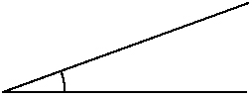; estimate: 20
b) An obtuse angle measures between 90 and 180.
Example: 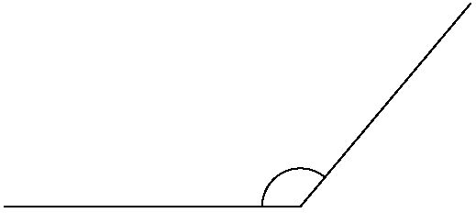; estimate: 130
c) A right angle measures 90.
Example: 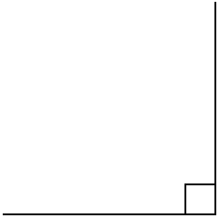; estimate: 90
9. a) Example: 90; right angle b) Example: 50;
acute angle c) Example: 130; obtuse angle
10. Example: 110
11. a) Example: 15 b) 90 c) 25 is an acute angle,
90 is a right angle

On the Job 2
Check Your Understanding
1. a) reflex angle b) reflex angle c) straight angle
d) reflex angle
2. Examples: a) 345; a straight edge b) 250;
the corner of a book c) 180; a straight edge

d) 190; a straight edge
3. a) 345 b) 255 c) 180 d) 195
4. a) A straight angle is a 180 angle, or a straight line; example: ; estimate: 180
b) A reflex angle is an angle between 180 and 360;
example: 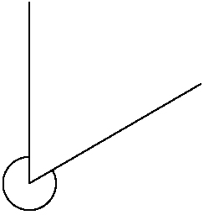; estimate: 300
5. Examples: Figure A: There is a straight angle at each side of the window and a reflex angle at the corner.
Figure B: There are two straight angles at the top and bottom of the window and a reflex angle at the decorative roof.
6. a) Example: estimate: 330; actual: 325; The estimate is greater than the actual measurement.
b) Ling is 35 short of landing the rotation correctly.
7. a) Examples: 220, 220, 200, and 140
b) 225, 230, 200, and 145°
8. a) 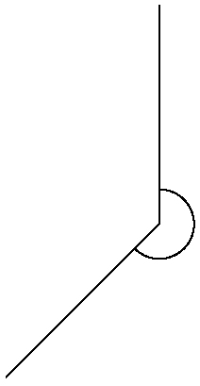; 135° b) 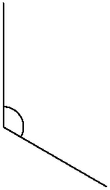; 240°

Work With It
1. a) Examples: The smaller angle in each diamond shape is an acute angle. The corner formed between the horizontal string and vertical string near the hands is a right angle. The larger angle in each diamond shape is an obtuse angle. The horizontal string forms a straight angle. A reflex angle is the angle closest to the right hand, formed by the top diagonal string near the small finger where the string turns down and to the left. b) Examples: acute angles: 70°; obtuse angles: 110° c) acute angles: 75°; obtuse angles: 105°
2. a) Examples: A = 40°; B = 85°; C = 55°
b) A = 45°; B = 85°; C = 50° c) 180°
3. a) Examples: A = 140°; B = 40°; C = 140°;
D = 40°
b) A = 135°; B = 45°; C = 135°; D = 45°
4. The ladder is not placed safely because the angle with the ground is 65°.
5. a) 30° b) 35° c) both are acute angles
6. Examples: a) corners of windows are 90°, door wedges slope at 25°, windows open outward to a maximum of 50° b) Right angles are the most common.

7. Examples: The opposite acute angles are equal and the opposite obtuse angles are equal. Each pair on a line has a sum of 180° and all four angles have a sum of 360°.
8. Yes, Tyler is correct. You can use a protractor to measure a reflex angle of 312° and an acute angle measuring 48°. Together, their sum is 360° which is one complete turn.
9. a) Andrée is correct. b) Peter read the protractor in the wrong direction.
10. Examples: They make sure the frames have
90° corners and that each end of a frame is cut at a
45° angle.

5.2 Angle Constructions, pages 234 to 245
Puzzler, page 235
To create an angle of 75°, use a 30-60-90 set square and a 90-45-45 set square. Place them together so that the
30° angle of the first set square is next to one of the
45° angles of the second set square, as shown in
the diagram.
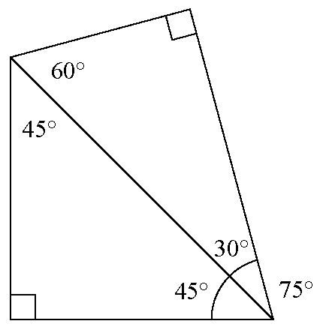

On the Job 1
Check Your Understanding
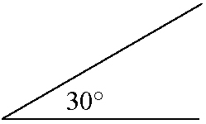
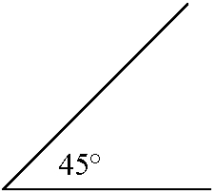
1. a) b)

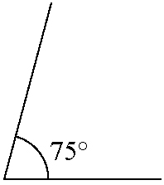
c)

2. Sketches may vary.
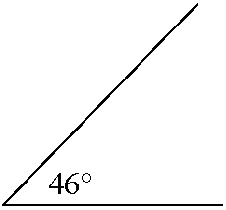
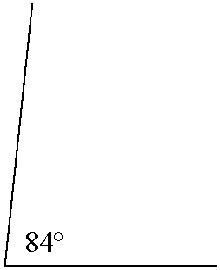
a) b)

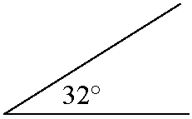
c) d)

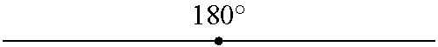
e)

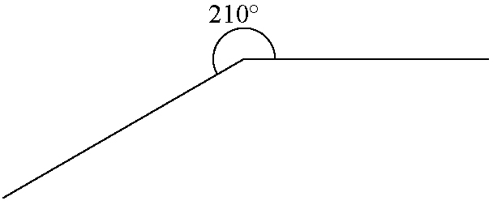
f )

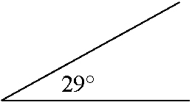
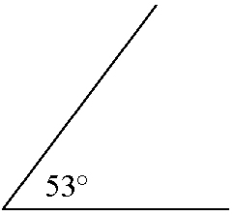
3. a) b)

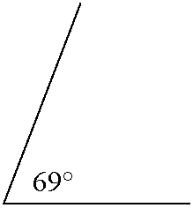
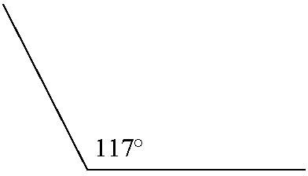
c) d)

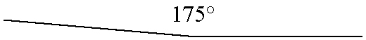
e)

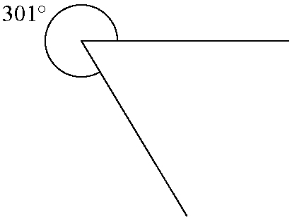
f )

4. a) Katie b) She has not placed the centre of the baseline of the protractor on the vertex of the angle to be measured.
5. a) He has not measured around in increasing size direction. b) Start with the base line on one arm of the angle and the centre on the vertex. Then, measure around the scale in increasing order from 0 until you reach 220°. It will be past a straight angle.
6. 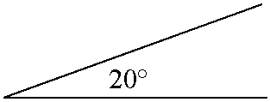
7. a) Each angle measures 60°. b) The length of side each side is 6 cm.
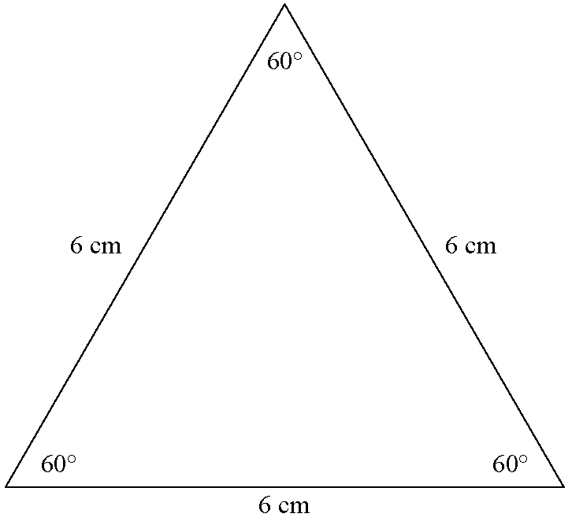
c)

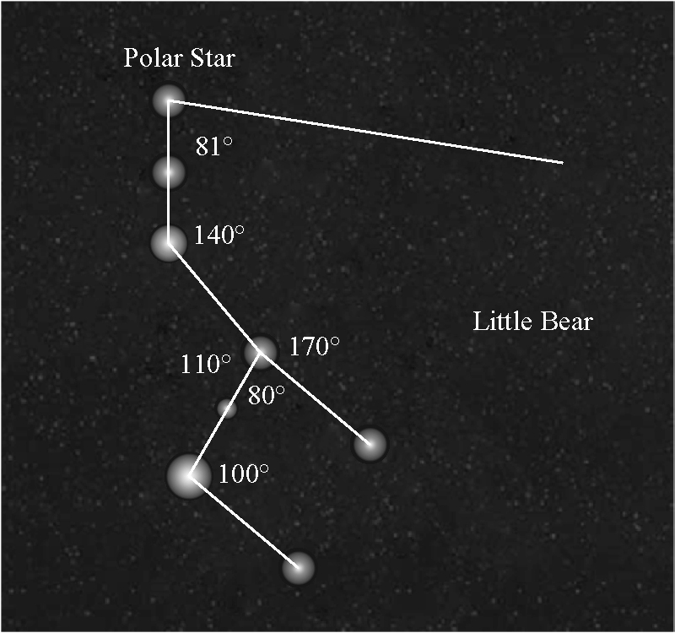
8.

On the Job 2
Check Your Understanding
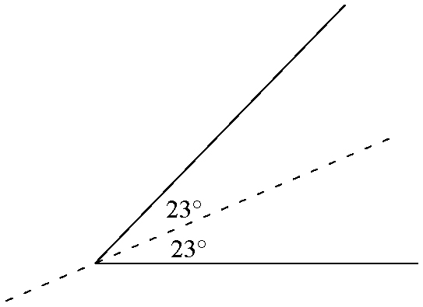
1. a)

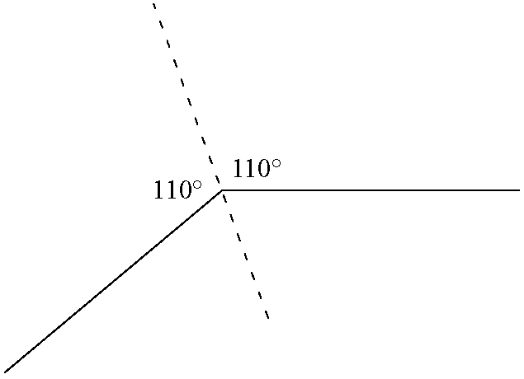
b)

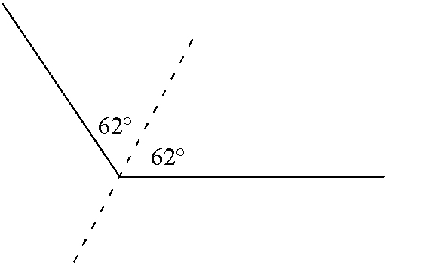
2. a)

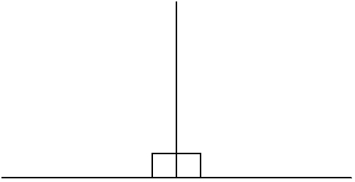
b)

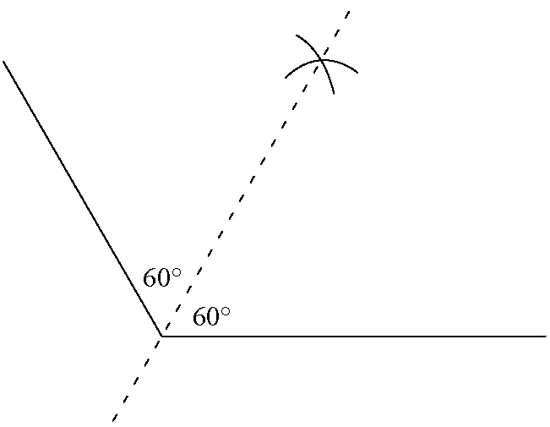
3. a)

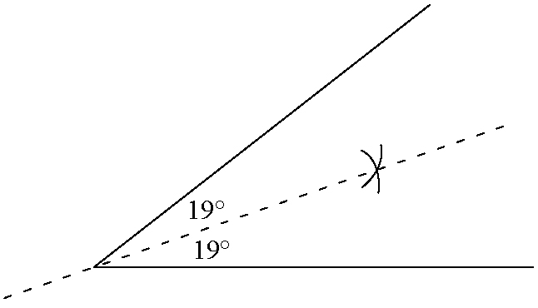
b)

4. The worker should place the beam so that it bisects the angle.
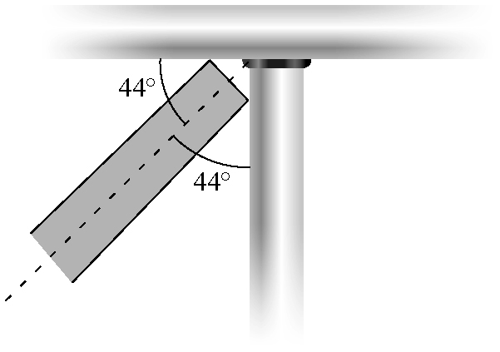
5. The middle rod is placed correctly, because the measure of the angle between the top and middle rods (approximately 30°) is equal to the measure of the angle between the bottom and middle rods.
6. a) Example: Use a ruler and compass to determine a point on the bisector. Then, draw a line to connect that point and the vertex. 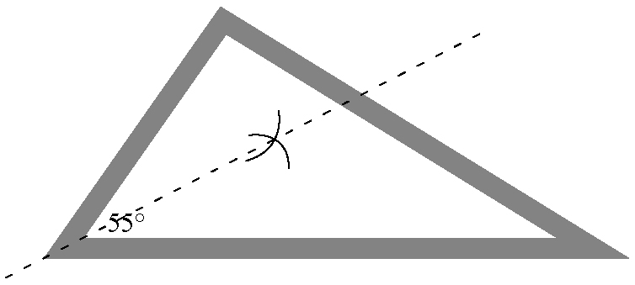
b) Each angle measure is 27.5°.
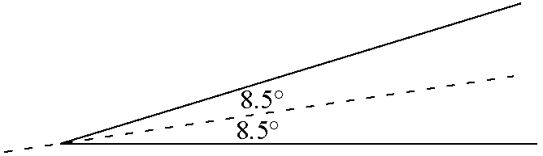
7.

Work With It
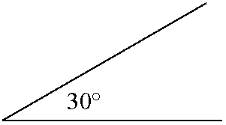
1. a)

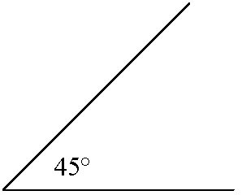
b)

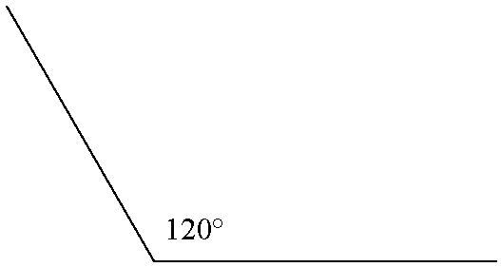
c)

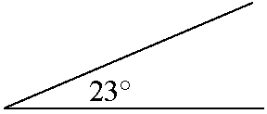
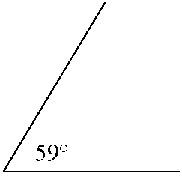
2. a) b)

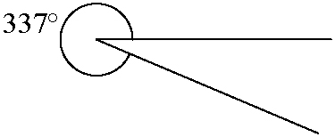
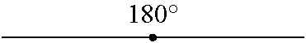
c) d)

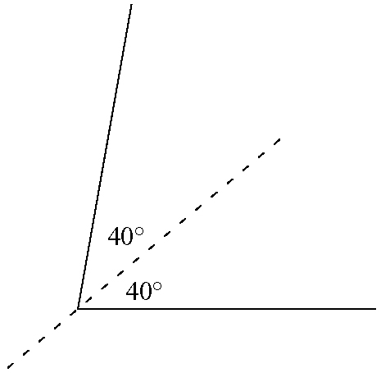
3.

4. Minilab
Step 1 west
Step 2 a) south b) 90°
Step 3 c) Examples: North is a 90° clockwise turn from west. South is a 180° clockwise turn from north. Northeast is a 45° counterclockwise turn from east. Southeast is a 135° clockwise turn from north.
d) Examples: 45°, 90°, 22.5°, and 67.5°
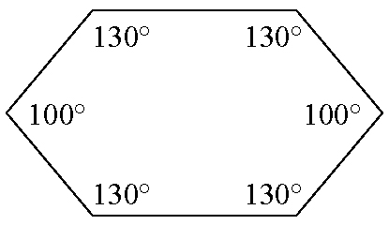
5.

6. 32°
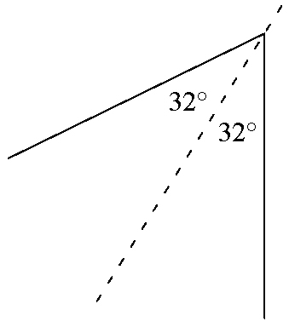
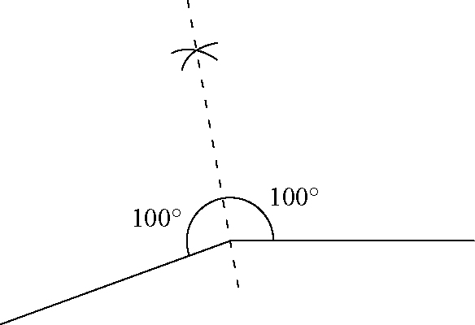
7. a) and b)

c) This step is necessary to ensure that the arcs intersect each other.
d) Example: Bisect the obtuse angle that measures
360° − 200°, and extend the line through the reflex angle.
8. Examples: Paper folding is quite easy but may not always be accurate. Using a protractor means you have to measure the angle carefully. Divide the measure by two. Then, carefully plot the half angle. It is not difficult, but you could easily make an error. Using a ruler and compass is the most accurate. You do not need to know the actual angle measure to divide it.
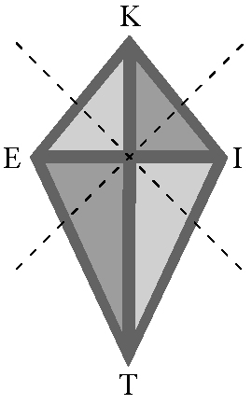
9. a)

; IKE is bisected by KT; KIT is bisected by IE; ITE is bisected by KT; TEK is bisected by IE
b) Examples:
corner of a picture frame:
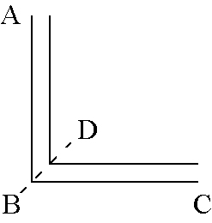 ABC is bisected by BD;
intersection of a straight angle (180°) floor with a vertical wall:
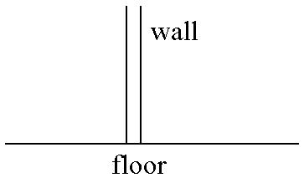

5.3 Lines and Angles, pages 246 to 261
On the Job 1
Check Your Understanding
1. a) The lines are parallel because they will never cross. b) neither c) The lines are perpendicular because a right angle is marked at the intersection of the lines. d) neither
2. a) The two angles are complementary because
60° + 30° = 90°. b) The two angles are complementary because 55° + 35° = 90°. c) The two angles are not complementary because 60° + 60° = 120°.
3. a) The two angles are supplementary because
115° + 65° = 180°. b) The two angles are not supplementary because 140° + 30° = 170°.
c) The two angles are supplementary because
90° + 90° = 180°.
4. a) t = 48°, u = 132°, and v = 48° b) w = 98°, x = 82°, and y = 98°
5. a) 135° b) obtuse because it is between greater than 90° and less than 180°, and supplementary with 45° because
a + 45° = 180°.
6. a = 45° and b = 45°
7. c + 45° = 90°, so c = 45°; a = b = 45°

On the Job 2
Check Your Understanding
1. a) s and z, t and y b) v and w, u and x
c) s and w, v and z, t and x, u and y
2. a) a = 120° b) b = 110° c) d = 70°
3. a) corresponding angles; e = 75° b) same side
interior angles; g = 84°
4. h = 125°; The angle opposite h, to the left of the transversal but inside the parallel line, is also 125° because it is a corresponding angle to the given 125°. Opposite angles are equal, so h = 125°.
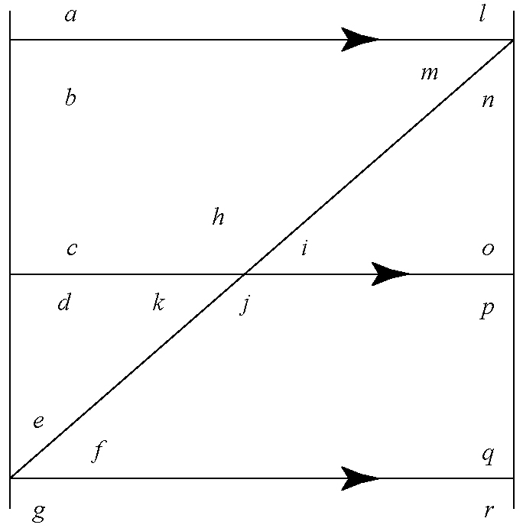
5. b = 80°; c = 80°; d = 100°
6.

Examples: a) a and c, b and d, d and g, n and p, o and q, p and r, f and i, k and m
b) b and c, h and m, f and j, p and q
7. 45°, 90°, 180°

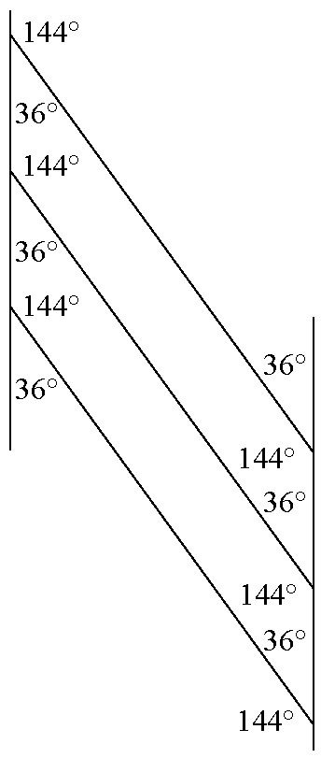
8.

On the Job 3
Check Your Understanding
1. a) s and y, t and z b) v and x, w and u
2. a) alternate exterior angles; 100° b) alternate interior angles; 75° c) alternate interior angles; 137°
d) alternate exterior angles; 110°
3. e = 71°, alternate interior angles; f = e = 71°,
opposite angles
4. a) 6 b) 6
5. Reasoning may vary. g = 180° – 112° = 68°, supplementary angles; h = 112°, opposite angles;
i = g = 68°, opposite angles; m = 112°, corresponding angles; k = m = 112°, opposite angles;
j = 180° – 112° = 68°, supplementary angles; l = j = 68°, opposite angles.
6. a) x = 180° − 42° = 138°, x and 42° are same side interior angles. b) The angle to the left of x at the top is an alternate interior angle with the angle of 42°. Its measure is 42°. Because x is the supplementary angle to this angle,
x = 180° − 42° = 138°.
7. Reasoning may vary. a = 48°, alternate interior angles; b = 180° − 48° = 132°, supplementary angles;
d = 180° − 48° = 132°, supplementary angles;
c = d = 132°, alternate interior angles

Work With It
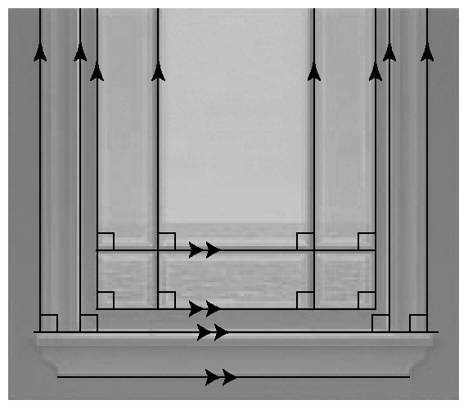
1. a)

b) Perpendicular lines are lines that cross each other at right angles. Parallel lines are lines that do not cross each other.
c) Example: All of the vertical lines in the window are perpendicular to all of the horizontal lines. Therefore, right angles are formed at each point where the lines intersect. Any two such angles are a pair of equal angles.
d) Example: Two beveled edges of glass meet in each corner of the window at a 45° angle. The 45° angles created in each corner are complementary because their sum is 90°. Right angles are created at each point where the vertical and horizontal lines intersect. Any two adjacent right angles are supplementary because their sum is 180°.
2. a = 65°, b = 55°, c = 60°, and d = 65°
3. Examples:
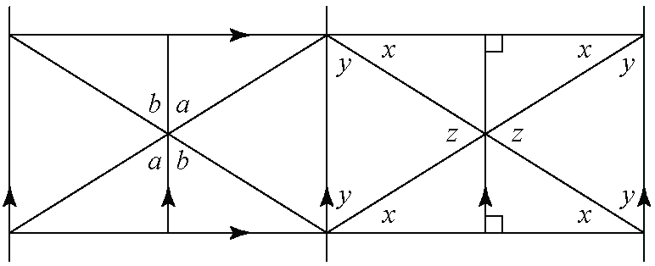
a)

There are many equal pairs of angles. Angles marked
x are alternate interior angles. Angles marked a are opposite angles, as are the pairs of angles marked b and z. All corners of the gate will be 90° and x + y = 90°. The same patterns are repeated on each half of the gate.
b) a = 58°, b = 58°, x = 32°, y = 58°, and z = 64°
c) Angles marked with the same letter are equal.
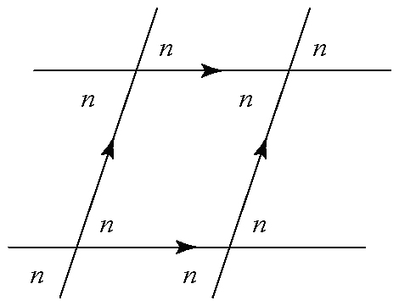
4. a)

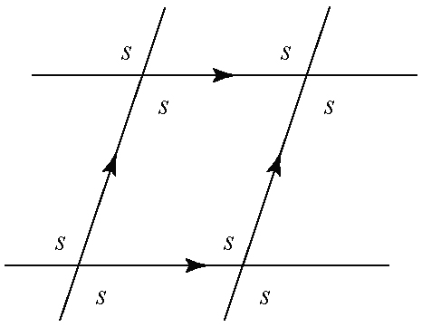
b)

5. Reasoning may vary. p = 140°, supplementary to 40°;
q = 40°, opposite angles; s = 140°, supplementary to 40°; u = 40°, alternate interior angles; v = 40°, opposite angles; t = 140°, corresponding angle to p; w = 140°, corresponding angle to s.
6. a) x = 27.5° b) No pair of the individual angles shown are complementary.
7. Ellie is correct because a is opposite 46°.
8. a) a = 70°, b = 70°, c = 110°, d = 60°, e = 120°, and
f = 60° b) Answers are the same. Reasoning may vary.

5.4 Angles in Our World, pages 261 to 273
On the Job 1
Check Your Understanding
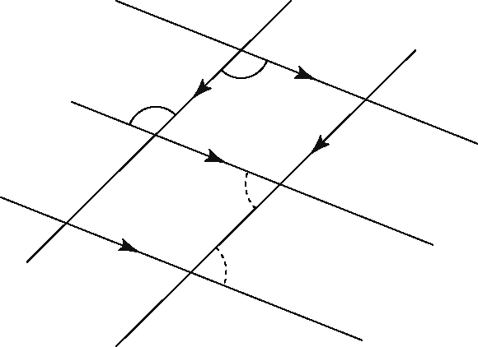
1. a)

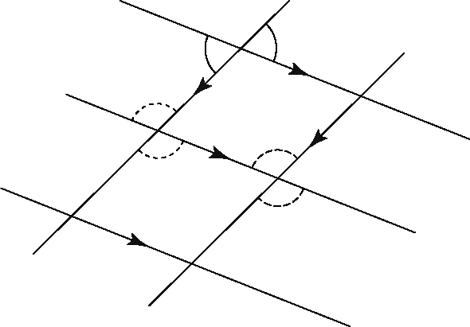
b)

2. There does not appear to be any special pattern, but the three angles made at the middle of the K will have a sum of 180° because they make a straight angle.
3. a) a = 65° b) b = 70° and c = 70° c) d = 40° and
e = 40° d) f = 30° and g = 30°
4. a) a = 155°, alternate interior angle b) b = 55°, supplementary angle c) c = 40°, corresponding angle;
d = 140°, supplementary angle d) e = 68°, supplementary angle; f = 112°, alternate interior angle e) g = 120°, corresponding angle; h = 60°, supplementary angle
5. a = 45°, b = 45°, and c = 45°
6. 19°
7. a) Inside the diamonds, all acute angles are 84° and all obtuse angles are 96°.

On the Job 2
Puzzler
The side-by-side lines are parallel.

Check Your Understanding
1. a) parallel; alternate exterior angles b) not parallel; corresponding angles c) not parallel; corresponding angles and supplementary angles d) not parallel; same side interior angles
2. a) 128° b) 30° c) 82° d) 19°
3. AB is parallel to EF because angles in corresponding positions are both 90°. AB is perpendicular to GH and GH is perpendicular to EF because both have 90° marked at their intersections. GH and IJ are parallel because angles in corresponding positions are both 90°. IJ is perpendicular to AB and EF because it is parallel to GH, which is perpendicular to AB and EF.
4. x = 133°

5. a) parallel lines: AB and CD; transversals: AD and BC
b) Yes, the stretcher can be lowered and it will still be parallel to the horizontal braces.
6. The two centre lines are parallel because corresponding angles are equal. It is unknown whether the two outside vertical lines are parallel to each other or to the centre lines.

Work With It
1. two; If Kali measures one internal angle and one angle that is made with the outside frame, she can then determine all of the other angles.
2. a) all of the acute angles are 40°, all of the obtuse angles are 140° b) two
3. a) The transversal is the vertical line that touches the two mirrors.
b) b = 45°, c = 45°, and d = 45°
4. Consider the triangle formed by the right side, the lower cross bar, and the diagonal. Two angles are given, so the third is 180° − (57° + 35°) or 88°. The sides are not parallel; they are converging towards the top bar.
5. Examples: N, I, and H. Each letter consists of two parallel lines and a transversal.
6. George is correct. If EF is perpendicular to CD, then it must also be perpendicular to AB, by corresponding or alternate angles.
7. If the transversal intersects the parallel lines at 90°, then all angles formed are 90°.
8. Kristen is not correct. FIH = 64°, because they are alternate interior angles. At the point I,
62° + 54° + 64° = 180°, so the three angles make a straight angle. EF is parallel to GH.
9. Yes, because the angles will be equal alternate angles.

Skill Check, pages 274 to 275
1. a) The first roof is steeper. b) Examples: 50° and 30° c) 45° and 30°; The first estimate is too large.
2. Examples:
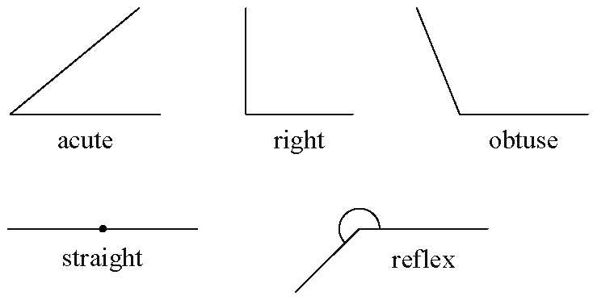
a)

b) 45°, 90°, 115°, 180°, and 220° c) 40°, 90°, 110°, 180°, and 225°
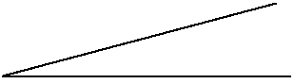
3. Examples a)

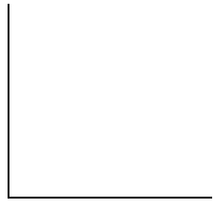
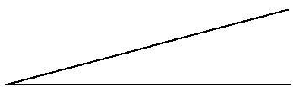
b) c)

d)

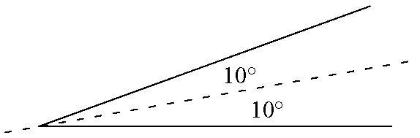
4. a)

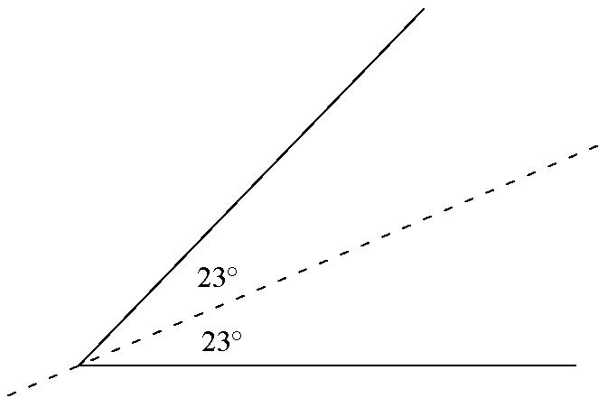
b)

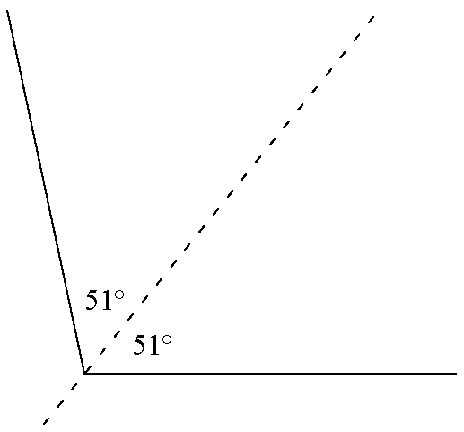
c)

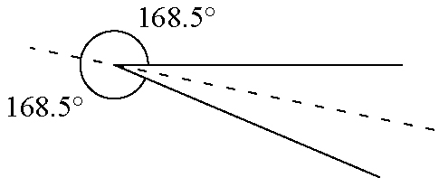
d)

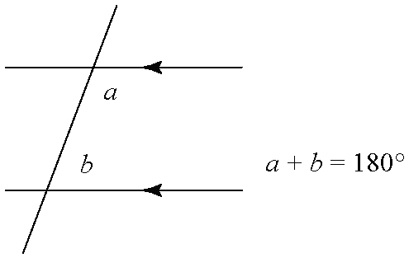
5. a)

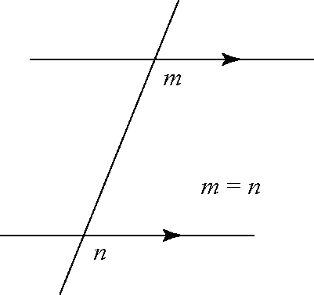
b)

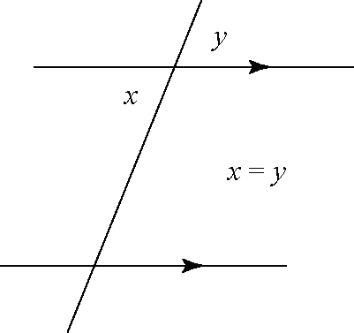
c)

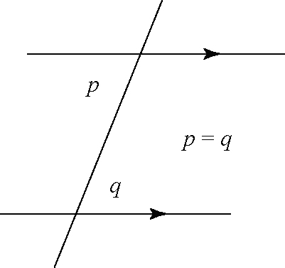
d)

6. y = 27°; 2y + 126° = 180°, supplementary angles
7. Subtract the angle from 90°; the complementary angle for 72° is 18°.
8. If you measure one of the acute angles at the right, then the other angle is its complement. Each of these pairs of angles has equal alternate angles in the lower left corner.

Test Yourself, pages 276 to 277
1. D
2. B
3. D
4. C
5. C
6. Examples: Measure the acute angle and then subtract from 360° to determine the reflex angle. Alternatively, use a circular protractor to measure the reflex angle.
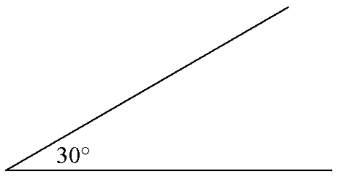
7. a)

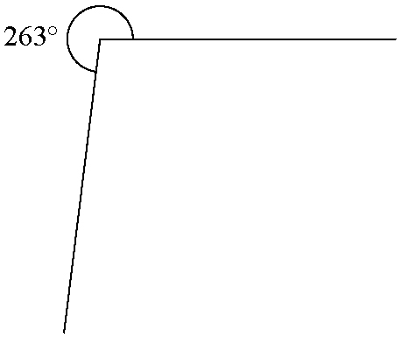
b)

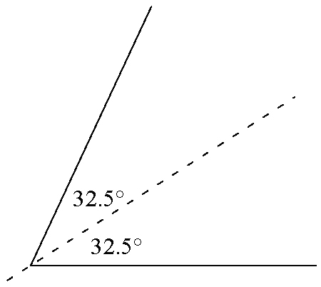
8.

9. 45°
10. 120°
11. Example: Check that the other angles in the alternate angle pattern in each part of the fence also measure 17°.

