Chapter 6 SE Answers

Get Ready, pages 284 to 285
1. a) 9 cm²   b) 25 cm² c) 49 cm²
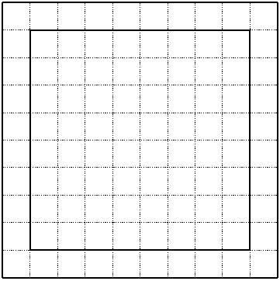
2. a)

; 64 cm²

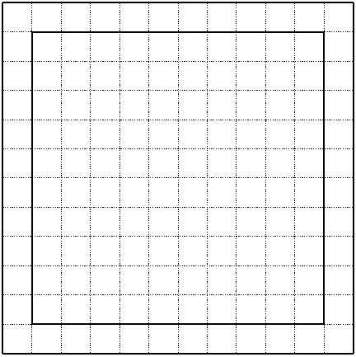
b)

; 100 cm²

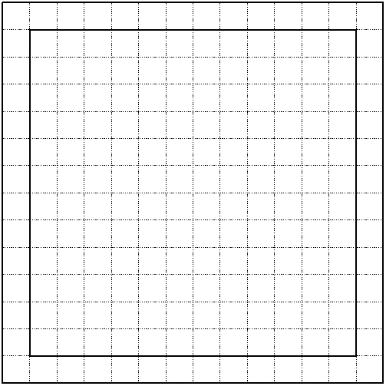
c)

; 144 cm²

3. a) 4 b) 16 c) 81 d) 121 e) 1600 f ) 4900
4. a) Estimate: 1; actual: 1.21
b) Estimate: 35; actual: 34.81
c) Estimate: 60; actual: 59.29
d) Estimate: 101; actual: 104.04
e) Estimate: 2550; actual: 2601
f ) Estimate: 10 010; actual: 10 100.25
5. a) 37 b) 25 c) 125 d) 200 e) 1625 f ) 160
6. a) 48 b) 55 c) 80 d) 75 e) 140 f ) 500
7. a) 2 b) 4 c) 6 d) 10
8. a) Estimate: 2.1; actual: 2.2
b) Estimate: 3.9; actual: 3.9
c) Estimate: 5.9; actual: 5.8
d) Estimate: 10.1; actual: 10.1
9. a) 4 or −4 b) 5 or −5 c) 7 or −7
d) 10 or −10 e) 11 or −11 f ) 100 or −100
10. a) 5 or −5 b) 13 or −13 c) 15 or −15
d) 10 or −10
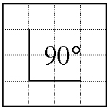
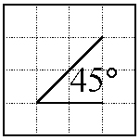
11. a) b)

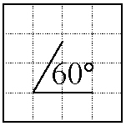
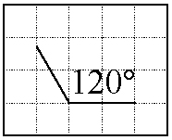
c) d)

12. 25°

6.1 Right Triangles, pages 286 to 293
On The Job 1
Check Your Understanding
1. Examples: a) 9.5 ft b) 385 m c) 55 yd
d) 160 cm
2. Examples: a) 85 ft b) 42 m c) 46 yd
d) 250 cm
3. a) 5 m b) 5.4 m
4. Examples:
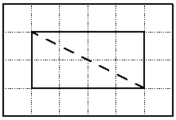
a)

Scale: 1 square represents 5 ft; estimated length of the hypotenuse: 22 ft
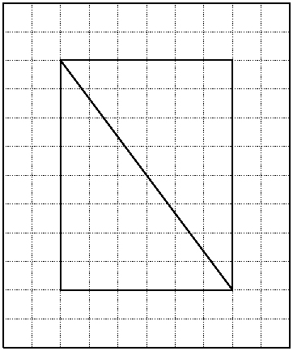
b)

Scale: 1 square represents 10 ft; estimated length of the hypotenuse:100 ft
5. Example: 10 ft
6. Example: 3.6 m

Work With It
1. The solar panel is taller than the roof. So, it will not fit.
2. a) The angle is 39°. The stairs are within the guideline. b) Example: 2 m
c) Example: 2.3 m
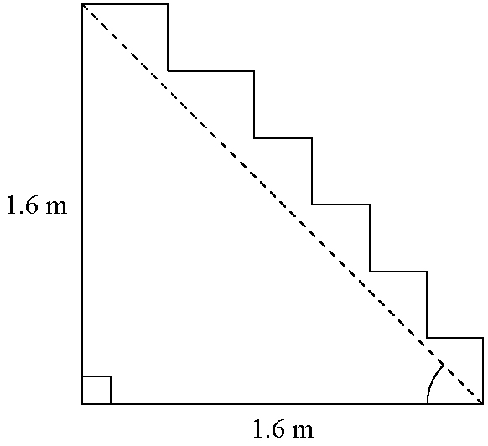
d)

The angle is 45°, which is not within the guideline. We know the angle is 45°, because the two legs of the right triangle are equal.
3. The length of the hypotenuse must be more than the length of the longer leg but less than the sum of the lengths of the two legs.
4. Example: A ruler only ever gives approximate measurements. Accuracy can depend on the thickness of the lines, or the person’s eyesight.
5. Kayla is correct. The hypotenuse must be longer than the longest leg, but it cannot be more than the sum of the lengths of the legs.
6.2 The Pythagorean Relationship, pages 294 to 304
On the Job 1
Check Your Understanding
1. a) between 40 m and 70 m
b) between 24 ft and 40 ft
2. a) 23.3 m  b) 42.4 cm
3. a) Estimate: 27 ft; actual: 26 ft
b) Estimate: 15 in.; actual: 14.5 in.
4. a) 312 in.  b) 1 ft 2.5 in. or 1 ft 3 in.
5. 4.51 m
6. 92 ft
7. a) Example: 48 km  b) 46 km
On the Job 2
Check Your Understanding
1. a) 16 m  b) 10 ft  c) 15 cm
2. a) Estimate: 4 in.; actual: 8 in.
b) Estimate: 20 m; actual: 21 m
c) Estimate: 16 cm; actual: 22 cm
3. a) 64 yd b) 51 yd
4. 30 in.
5. 9 ft 9 in. or 117 in.
6. a) The side labelled c is not the longest side; it is one of the legs. The second step in the solution should be = 15² + c².
b) The student has used the formula a² + b² = c², but because the length c in the diagram is one of the legs of the triangle, c² in the formula is not the same as c² on the diagram.
Work With It
1. Let d represent the size of the hatch opening, in centimetres:
d² = 95² + 110²
d² = 21 125
d = 145.344
The table with a diameter of 150 cm will not fit, because 150 cm is greater than the opening of 145.3 cm.
2. 101 ft
3. 34 ft
4. 89 ft
5. Estimate: 3.3 km; actual: 3041 m (to the nearest metre) or 3.04 km (to the nearest hundredth of a kilometre)
6. a) 9 mi b) 13 mi
7. a) The square of the length of the hypotenuse is equal to the sum of the squares of the lengths of the two legs. You add the squares of the two legs to get the square of the hypotenuse.
b) Finding one of the legs is a subtraction problem, because if you subtract the square of one leg from the square of the hypotenuse, you get the square of the
other leg.
8. a) Toby added the lengths of the two legs, which might be the driving distance from the fire station to the fire if the legs are perpendicular roads.
b) To find the shortest distance to the fire along the hypotenuse, add the square of 3 km to the square of
500 m and then find the square root. You need to decide whether to work in kilometres or metres, and convert the lengths accordingly.
9. Claire can conclude that the triangle is not a right triangle. Because 64 + 36 = 100, the longest side should have a square of 100 cm², if it is a right triangle.
10. Examples: building roof trusses or framing pictures
6.3 Using the Pythagorean Relationship,
pages 305 to 315
On the Job 1
Check Your Understanding
1. a) 25 in. b) 26.9 cm c) 22.7 m d) 41 cm
2. a) Yes, it is a right triangle, because
10² + 24² = 676 and 26² = 676.
b) Yes, it is a right triangle, because
12² + 16² = 400 and 20² = 400.

3. Example: From one corner mark 3 ft across the top of the window frame and 4 ft down the side of the window frame. If the diagonal distance between the two marks is 5 ft, the corner of the window frame is square.
4. 38 in.
5. d² = 14² + 20²
d² = 596
d =
d = 24.413
If the corners are square, then the diagonal distance between corners should be approximately 24.4 ft. Because the landscaper determined the distance to be
23 ft, the garden does not have 90° corners.
6. For the two sides: 3² + 5² = 34
For the diagonal: 5′ 10″ = 5.833′ and (5.833)² = 34.028
The square of the diagonal is approximately equal to the sum of the squares of the other two sides, so the frame is square.
7. 28.3 cm
8. Max is not correct. A triangle can still be a right triangle, even though the side lengths may not follow the 3–4–5 pattern:
For the two shorter sides: 15² + 36² = 1521
For the longest side: 39² = 1521
Because the square of the longest side equals the sum of the squares of the other two sides, this is a right triangle, but it does not follow the 3–4–5 pattern.
On the Job 2
Check Your Understanding
1. a) 9² + 12² = 225 and 14² = 196.
So, ∠Q is not a right angle.
b) 30² + 72² = 6084 and 78² = 6084.
So, ∠Q is a right angle.
c) 8² + 15² = 289 and 17² = 289.
So, ∠Q is a right angle.
d) 9² + 39² = 1602 and 41² = 1681.
So, ∠Q is not a right angle.
2. a) The triangles in parts a) and d) are not right triangles.
b) For part a), the hypotenuse would need to be 15 in. For part d), the hypotenuse would need to be 40.02 cm.
3. Example: a) and b)
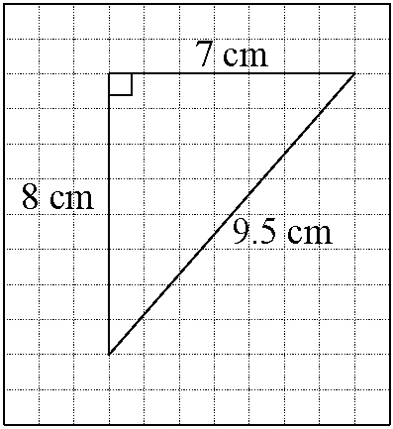

c) 10.6 cm
d) In the diagram, hypotenuse is incorrectly labelled
9.5 cm.

4. a) approximately 20.5 in. b) The angle is obtuse.
5. a) 12.1 m
b) She can increase the angle between the 5-m and 11-m boards until the diagonal distance measures 12.1 m.
6. a) 3.8² + 2.2² = 19.28 and 4.42² = 19.5364. Because the square of the diagonal is not equal to the sum of the squares of the two sides, the corner is not 90°, but because the sum of the squares of the legs is close to the square of the hypotenuse, the error may be in his measuring.
b) Example: Martin should double check the length of each side and use a carpenter’s square to ensure he has a 90° corner.
Work With It
1. a) 11² + 4² = 137 and 12² = 144. So, the DVD will not fit through. b) 11.7 cm
2. a) 5.22 m b) Examples: he should double check his measurements; he should decrease the size of the angle slightly to make the diagonal equal 5.22 m; he should use a set square to check that the corners are 90°
3. a) and b)
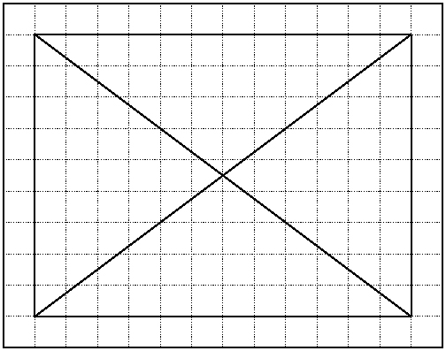

c) Example: 14 ft. d) 15 ft e) The corners are square.
4. a) 4.24 m b) 3.61 m c) Example: 11 m
d) d² = 2² + 10² = 104, so the diagonal on the design is approximately 10.20 m. The distance that Marnie and Fred measured is less than it should be for a right angle at E.
e) Examples: they can use a carpenter’s square to check that the angle at E is 90°; they should check that the lengths of the sides are 10 m and 2 m; they should increase the angle at E to make the diagonal equal
10.2 m.
5. a) The angle opposite measures more than 90°.
b) The angle opposite measures less than 90°.
6. If the square of the side opposite the angle is not equal to the sum of the squares of the two legs forming the angle, then the angle is not 90°.
7. For a right triangle, the square of the longest side should equal the sum of the squares of the two shorter sides. 3² + 4² = 25, but 6² = 36, so this is not a right triangle.

6 Skill Check, pages 316 to 317
1. a) between 10 ft and 16 ft b) Example: 12 ft
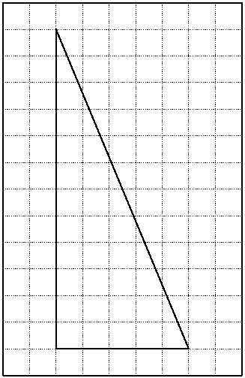
2. a)

Scale: 1 square represents 3 ft
b) 13 squares c) 39 ft
3. a) 31.83 m b) 26.46 m
4. a) between 102 km and 129 km
b) Example: 105 km c) 106 km
5. 114 cm
6. a) If the tiles are set square, and the distance across the diagonal is d, then d² = 15² + 15², which is 450, so the distance should be approximately 21.21 cm. The distance he measured is 21 cm, so the diagonal distance is 0.21 cm short of being square.
b) If he continues, the tiles will be slightly off the horizontal or vertical and may leave a slanting gap at one or more edges of the wall.
Test Yourself, pages 318 to 319
1. A
2. B
3. D
4. C
5. D
6. A
7. Let d represent the distance from Drew to the receiver.
d² = 20² + 20²
d² = 800
d =
d = 28.28
Because the diagonal distance is less than 30 m, Drew’s pass should reach the receiver.
8. 24 ft 6 in.
9. a) 72² + 48² = 7488 but 85² = 7225.
Because 7488 ≠ 7225, the corner at A is not square.
b) 72² + 47² = 7393 but 85² = 7225.
Because 7393 ≠ 7225, the corner at C is not square.
c) ∠A and ∠C are both a bit greater than 90° because the distance BD is greater than it should be for a right triangle in each case.
d) Janice should accurately determine the corner angles before cutting the linoleum.
10. a) 72 yd b) length: 180 ft;
width:120 ft; diagonal: 216 ft

