Chapter 7 SE Answers

Get Ready, pages 322 to 323
1. a) 0.8 b) 0.83 c) 1.52 d) 0.27 e) 0.89 f ) 2.72
2. a) 2 b) 16 c) 24 d) 30 e) 44 f ) 54
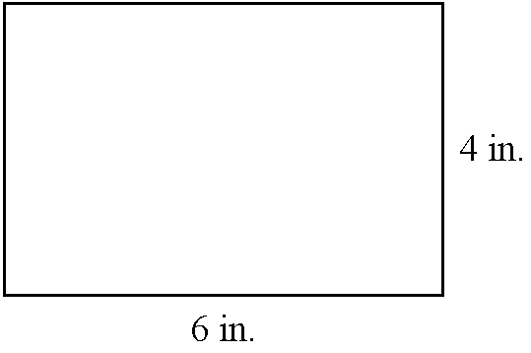
3. a)

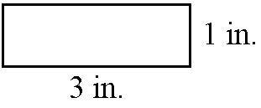
b)

4. a) 12 b) 8 c) 4 d) 2
5. a) x = 15 b) x = 6 c) x = 11 d) x = 1.8
6. a) x = 2.4 b) x = 2.4 c)
d) x = 12 e) x = 1.6 f ) x = 6.3
7. a) x = 3 b) x = 4 c) x = 40 d) x = 15
8. a) 65° b) 74° c) 52°
9. a) 15 m b) 16.76 cm c) 15.59 in.

7.1 Similarity and Scale,
pages 324 to 335
On the Job 1
Check Your Understanding
1. matches d)
2. matches c)
3. matches b)
4. matches a)
5. a) The triangles are not similar because the angles do not match. In ΔABC, the acute angles measure 53° and 37°. In ΔDEF, the acute angles measure 50° and 40°.
b) The rectangles are similar because the lengths of the sides of MNOP are twice the lengths of the corresponding sides of RSTQ.
6. a) 7.2 cm b) 12.5 in.
7. Examples:
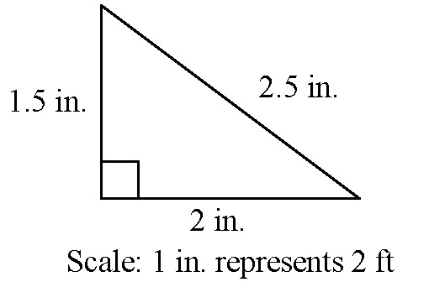
a)

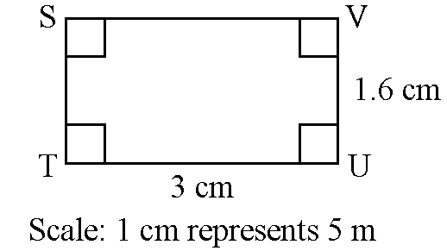
b)

8. a) 5 cm and 6.25 cm
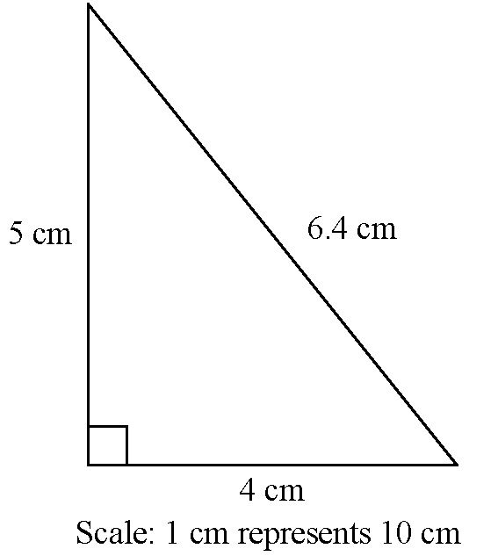
b) Example:

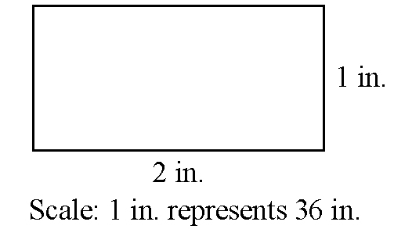
9. Example:

On the Job 2
Check Your Understanding
1. PQ = 5 ft, QR = 12.5 ft, RS = 11 ft,
ST = 7.5 ft, TU = 16 ft
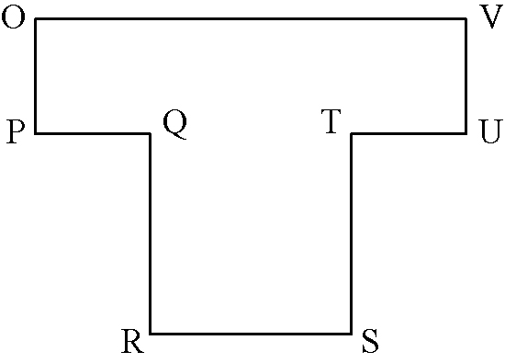
2.

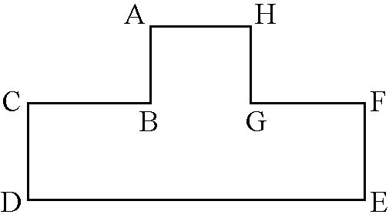

a) Shape #1: OP = 3 cm, PQ = 2 cm, QR = 5 cm,
RS = 4 cm, ST = 5 cm, TU = 2 cm, UV = 3 cm,
VO = 8 cm;
Shape #2: AB = 1.2 ft, BC = 1.6 ft, CD = 1.5 ft,
DE = 4.4 ft, EF = 1.5 ft, FG = 1.6 ft, GH = 1.2 ft,
HA = 1.2 ft
b) All angles will be 90°.

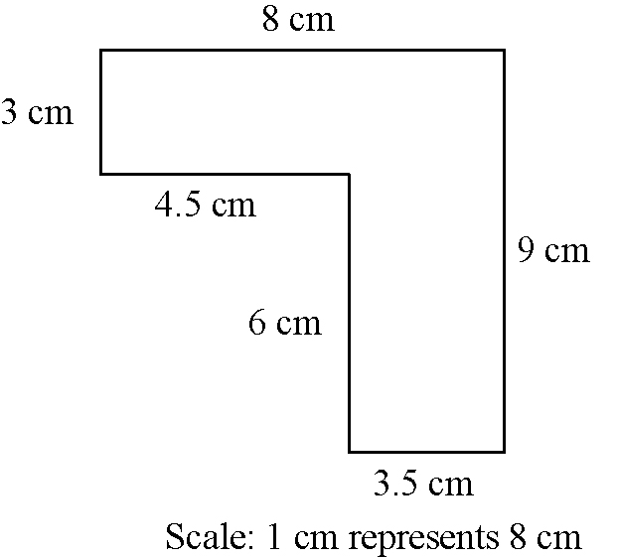
3.

4. a) , ,
, ,
,
b) All of the ratios are equivalent to 2.5 to 1, so the corresponding sides are proportional.
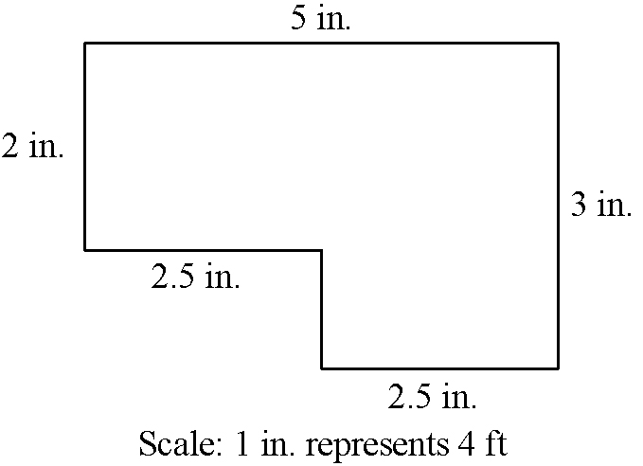
5. Example:

6. Example:
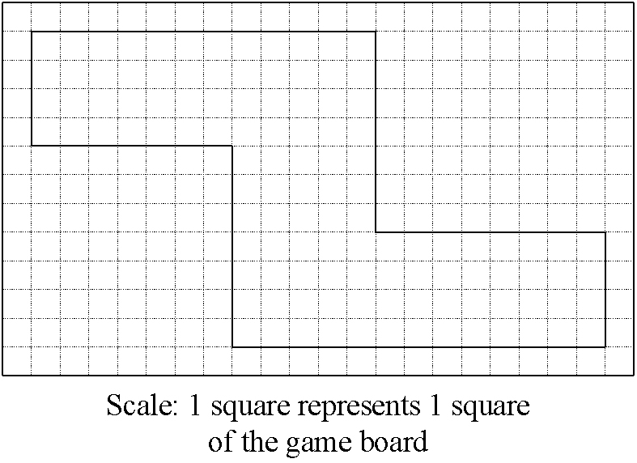

Work With It
1. Sarah chose to use a scale of 1 square to represent 1 m. So, the depth at the top left should be 1 square, not half a square.
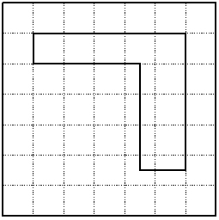

2. Examples: ΔKLM: ∠K = 37°, ∠L = 53°,
∠M = 90°, KL = 10 m, LM = 6 m, MK = 8 m;
ΔXYZ: ∠X = 37°, ∠Y = 53°, ∠Z = 90°, XY = 100 cm, YZ = 60 cm, ZX = 80 cm.
3. The rectangles are not similar because corresponding sides are not in the same proportion. Check the ratios of corresponding sides:
4. On Kenny’s scale drawing the length should be 25 squares and the width should be 20 squares.
5. 2 m
6. Yes, the triangles are similar because they will always have the same three angles: 90°, 30°, and 60°, and thus the same proportion of side lengths
Example:
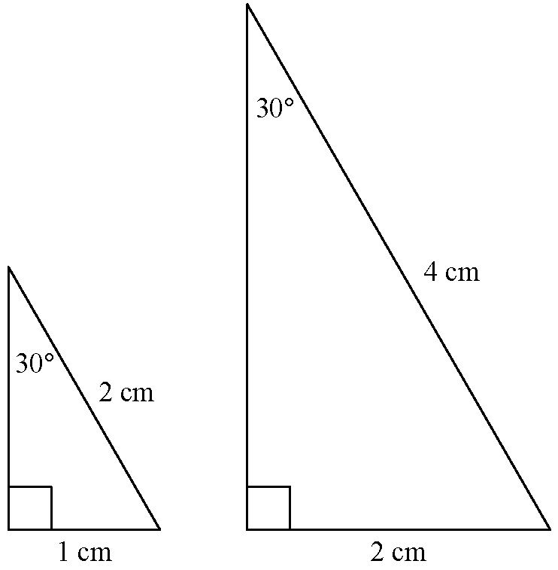

7. The triangles are not similar because corresponding sides are not in proportion. Comparing the heights, Comparing the bases, Comparing the hypotenuses,

8. a) If the polygons are similar, then corresponding pairs of sides must have the same ratio.
b) If the polygons are similar, then corresponding pairs of angles must have the same measure.
9. Examples: a) A rectangular room measures 4 m by 3 m. In a scale diagram of the room, the length is 2 cm. What is the width of the room on the scale diagram? b) 1.5 cm
c) Determine from the given facts that the length of 4 m is shown as 2 cm, so the scale is 1 cm represents 2 m. Therefore, the width of 3 m will be represented by 1.5 cm.

7.2 The Tangent Ratio, pages 336 to 347
On the Job 1
Check Your Understanding
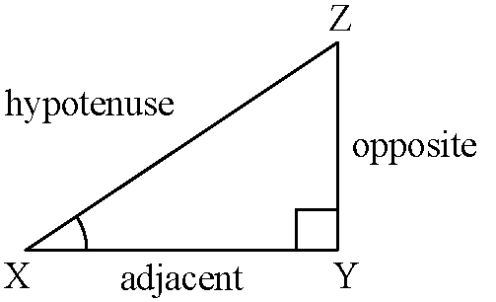
1. a)

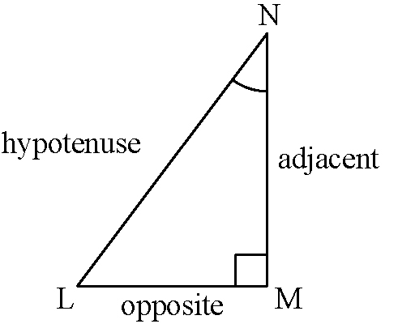
b)

2. a) b)
3. a) 0.62 b) 1.60
4. a) The values for tan A and tan 32° are the same. The values for tan B and tan 58° are the same.
b) Because the tangent ratio gives the same answer as the tangent of a specific angle, ∠A must be 32° and ∠B must be 58°.
5. a) 0.306 b) 14.301 c) 0.554 d) 1.483
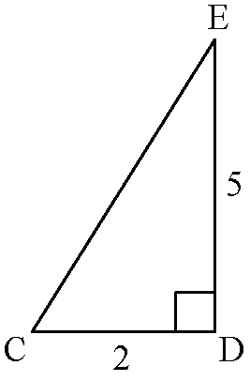
6. a)

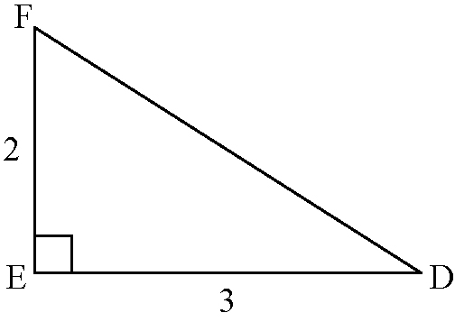
b)

7. Example: 14 ft
8. 180 m
9. 58 m
On the Job 2
Check Your Understanding
1. Example:
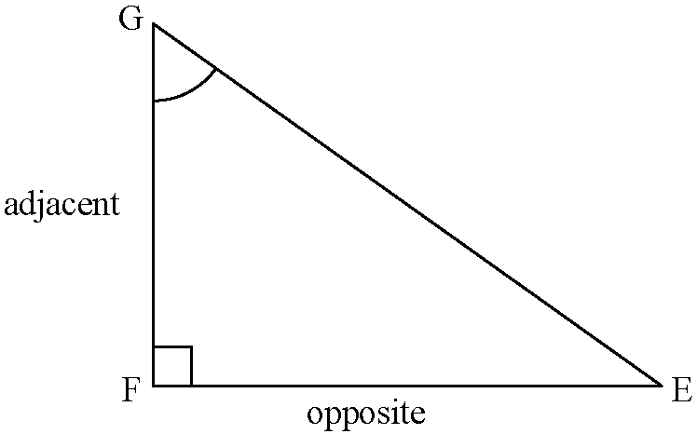
a) and b)

c)
2. a) 9 in. b) 28 cm
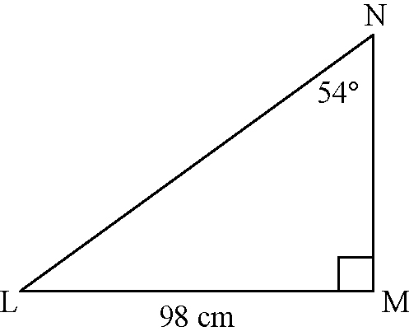
3. a)

b) 71 cm
4. a) 16 m b) 31 ft
5. 19.9 km
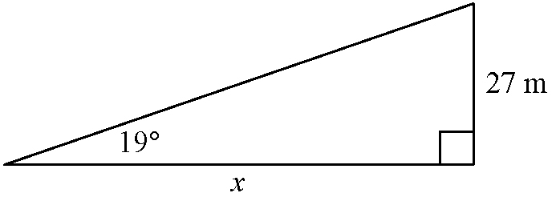
6. a)

b) 78 m

7. a) The boat is not a safe distance from the cliff because the boat is approximately 60.8 m from the cliff.
b) tan 40° 0.84, so the distance between the boat and the cliff is approximately 1.2 times the height of the lighthouse, or approximately 61.2 m.

Work With It
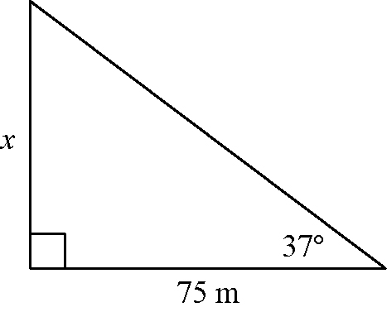
1. a)

b) 56 m c) 57 m
2. a) 0.8 m b) Example: if the angle the ramp makes with the ground is 48°, the angle the ramp makes with the vertical is 42°. tan 42° 0.9; multiply this by the height of the ramp (the adjacent side) to get a base length of approximately 0.81 m.
3. 49 m
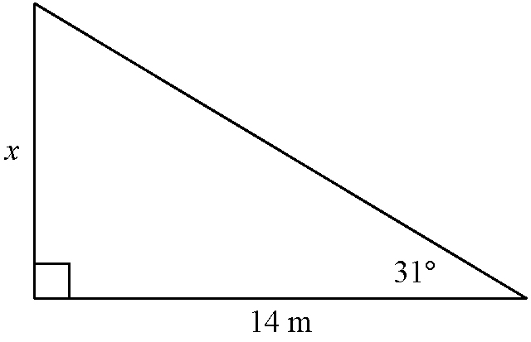
4. a)

b) 8.4 m
5. No, David is not correct. You need to know at least one side length to be able to determine the other side lengths.
6. Yes. Any two right triangles with the same given acute angle will have the same tangent ratio because the triangles are similar.
7. No. To use the tangent ratio you need to know the measure of one of the acute angles so that you can relate the angle to its opposite and adjacent sides.
8. Example: The tangent ratio will be useful in surveying for calculating distances across rivers. The tangent ratio is useful in carpentry for determining proper positioning of roof trusses and stairs.
9. a) Alice used the wrong formula to calculate the tangent ratio. b) The tree is approximately 36.5 m tall.
10. a) Because tan 21° is approximately 0.4, the opposite side is just less than half the length of the adjacent side.
b) 0.4 × 95 m = 38 m
7.3 The Sine and Cosine Ratios, pages 348 to 363
On the Job 1
Check Your Understanding
1. a) b) c) d)
2. a) 0.292 b) 0.998 c) 0.485 d) 0.829
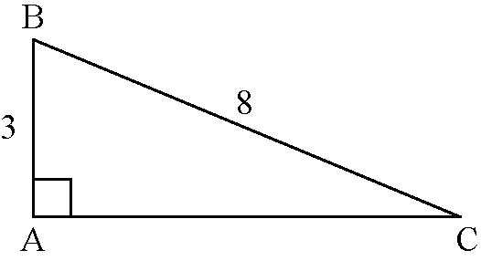
3. a)

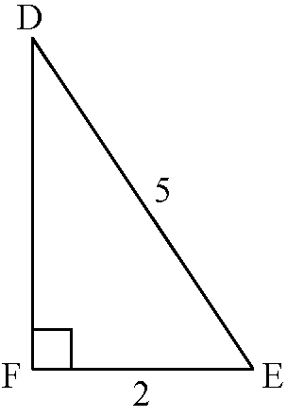
b)

4. a) 6.8 b) 35.7 c) 24.7 d) 2.6
5. a) Estimate: 22 m; actual: 22.7 m
b) Estimate: 19 cm; actual: 19.1 cm
6. a) 1.1 cm b) 12.9 ft
7. a) 31.9 m b) Because sin 53° 0.8, the height of the kite is approximately 80% of the length of the string; 80% of 40 m is 32 m.
8. a) 17.1 ft b) They will need three 2 by
8 boards; each side of the stair requires one full 12-ft board, plus almost half of another 12-ft board.
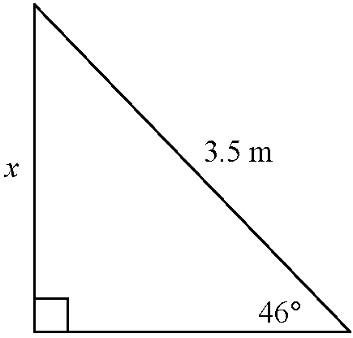
9. a)

b) 2.5 m
On the Job 2
Check Your Understanding
1. a) b) c) d)
2. a) 0.956 b) 0.070 c) 0.875 d) 0.559
3. a) 5.7 b) 11.9 c) 2.0 d) 6.4
4. a) Estimate: 13.5 in.; actual: 13.8 in.
b) Estimate: 11 m; actual: 10.9 m
5. a) 9.1 cm b) 5.7 ft

6. 60.5 ft
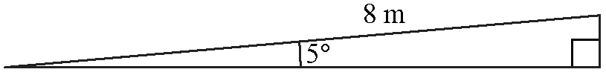
7. a)

b) Yes. The ramp will fit because 8 m is the hypotenuse of the right triangle and the base will always be less than the hypotenuse. So, the horizontal distance from the door is less than 8 m, which is less than 8.2 m.
8. 6.8 ft
9. height: 6.9 ft; hypotenuse: 8.5 ft
On the Job 3
Check Your Understanding
1. a) 42.5 cm b) 54.4 m c) 44.4 ft d) 2.6 in.
2. a) 6.1 km b) 10.4 m
3. a) x = 1.8 m, y = 3.4 m
b) Use the Pythagorean relationship to find
y using (3.8)² − (3.4)² = y². This method
gives y = 1.7 m.
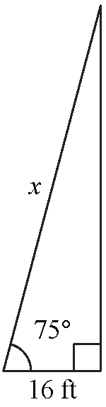
4. a)

b) Example: 64 ft c) 62 ft
5. Estimate: 3000 m; actual: 2995 m
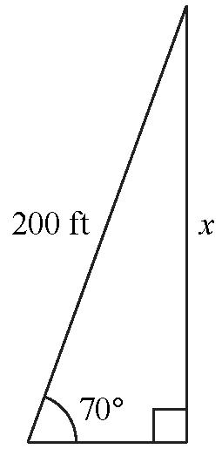
6. a)

b) 188 ft c) Example: Calculated using the cosine ratio, the base measures approximately 68.4 ft. Then, from the Pythagorean relationship, (200)² − (68.4)² = x².
This method gives x 188 ft.
Work With It
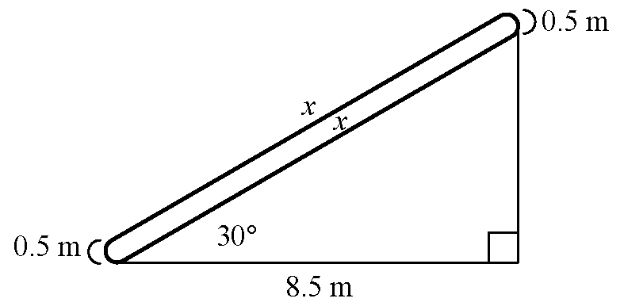
1. 34 ft
2. a)

b) 20.6 m
3. x = 12.8 ft, y = 32.3 ft
4. a) Example: A 10-ft pole is leaning so it makes an angle of 80° with the ground. What is the height of the top of the pole above the ground, to the nearest tenth of a metre? Answer: 9.8 m
b) Example: Sketch a diagram, with 10 ft as the hypotenuse and an angle of 80° at the bottom. Let x be the height. Then, x is opposite the 80° angle.
Use sin 80° = , so x = 10 × sin 80°.
5. a) Example: It is a good idea to estimate the answer so you know if your answer is reasonable. It may help you to identify times when you make an error.
b) Example: Look back at the problem to check if the answer seems reasonable. If possible, try to solve the problem using another method.
6. Ben’s solution is correct. Because x is in the denominator, you must multiply both sides by x to bring it into the numerator on the left: x (sin 17°) = 8. Then, divide both sides by sin 17° to isolate x.
7. Example: Use the sine ratio:
sin 42° = . The Pythagorean relationship can be used only if two side lengths are known.
8. a) The hypotenuse is always the longest side of a right triangle. b) x 4.4 km

7.4 Determining Unknown Angles, pages 364 to 375
On the Job 1
Check Your Understanding
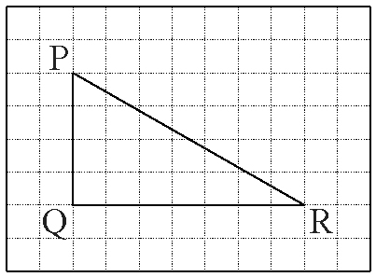
1. a)

b) Example: ∠R = 25° c) 23°
d) Example: Estimate was larger than the actual value.
e) The ratio tan R shows the relationship between the
side opposite from ∠R and the side adjacent to ∠R;
tan R = .
f ) represents the angle that has an opposite side measuring three units and an adjacent side measuring
7 units.
2. a) 33.1° b) 51.4° c) 21.7° d) 69.6°
3. a) 6° b) 54° c) 87° d) 74°
4. a) ∠A = 37° b) ∠B = 25°
5. a) 53° b) 65°
6. 26°
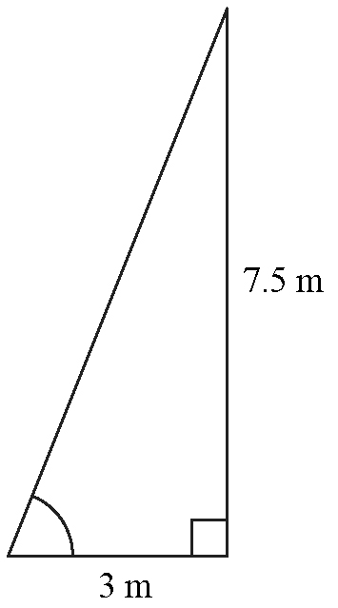
7. a)

b) 68° c) No, the ladder is not safe. The angle between its foot and the ground should be 75°.
8. a) Estimate: 15°; actual: 18°
b) Park facing downhill so the slope of the ground reduces the angle of the foot of the ramp.

On the Job 2
Puzzler
a) ΔABC is an isosceles right triangle. So,
AB = BC = 100 m. ΔBCD is an isosceles right triangle. So, CD = BC = 100 m. Using the Pythagorean relationship, AC = 141.42 m and BD = 141.42 m.
b) Example: As described in part a), AB = BC = 100 m because ΔABC is an isosceles right triangle. Similarly, CD = BC = 100 m because ΔBCD is an isosceles right triangle. AC is the hypotenuse of ΔABC. BD is the hypotenuse of ΔBCD. To solve for each of these sides, use the Pythagorean relationship or the sine or cosine trigonometric ratio (sin 45° or cos 45°).

Check Your Understanding
1. a) 41° b) 15° c) 23° d) 44°
2. a) 58.4° b) 77.5° c) 23.4° d) 74.4°
3. a) 6° b) 21° c) 26° d) 34°
4. a) 84° b) 51° c) 70° d) 60°
5. a) 32° b) 28°
6. a) 60° b) 24°
7. a) ∠A = 34° and ∠C = 56° b) ∠L = 65° and ∠N = 25°
8. a) 41° b) 24°
9. a) 49° b) 66°
10. The propose road would have a grade of 10°, so it would not meet safety requirements.
11. a) Example: 85° b) 86°

Work With It
1. Student’s work on mini-lab will vary.
2. 13°
3. a) 55° b) 45°
4. Example:
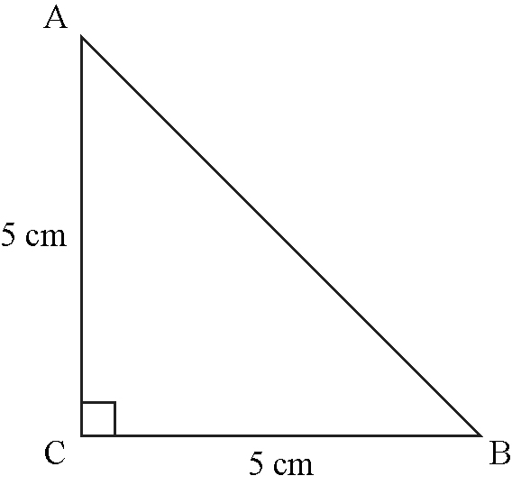

tan A = tan B = 1. The triangle has two perpendicular sides of equal length; it is a right isosceles triangle.
5. Yes, Nikita is correct. To use the sine ratio she needs to know the lengths of the opposite side and the hypotenuse. If one of these sides is not given, she can calculate it using the Pythagorean relationship with the two given sides to determine the third side length.
6. Example: A builder uses primary trigonometric ratios to calculate the length of struts needed in framing a staircase or to determine the angle at the peak of a roof.
7. a) The lengths of the opposite side and the hypotenuse are used to calculate the sine ratio, not the cosine ratio. Also, a sine ratio of 0.5 gives an angle measure of 30° (not 45°).
b) Because the sine ratio is a little more than 0.6, a reasonable estimate for ∠B is 40°.
Skill Check, pages 376 to 377
1. Examples:
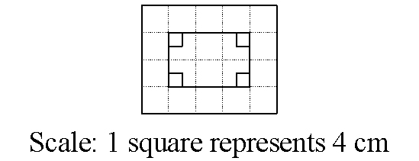
a)

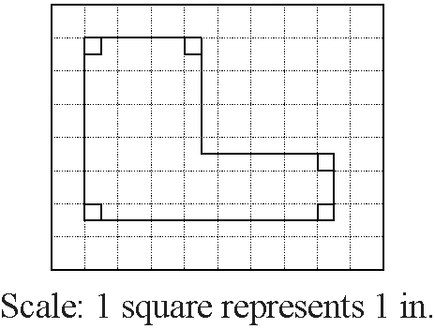
b)

2. The triangles are not similar, because corresponding pairs of sides do not have the same ratio: , and
3. a) 4.7 cm b) 16.4 m
4. 11.2 m
5. a) Estimate: 14.0 m; actual: 13.9 m
b) Estimate: 3.0 m; actual: 3.1 m
6. 1.1 m
7. 38°

Test Yourself, pages 378 to 379
1. D
2. B
3. C
4. C
5. A
6. hypotenuse = 20.2 cm,
other side = 13.5 cm, other angle = 42°
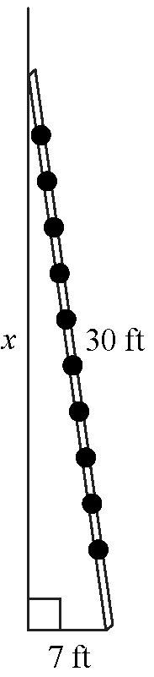
7. a)

b) 29 ft c) 77°
8. a) hypotenuse = 7.5 m, other side = 5.6 m, other
angle = 48° b) hypotenuse = 6.4 m, angles = 30° and 60°
9. a) Method 1: Use the Pythagorean relationship:
x² = 7² + 8².
Method 2: Use a trigonometric ratio: cos 49° = .
b) Method 1:
Check:
cos 49° =
L.S. = cos 49° R.S. =
0.66 =
0.66
L.S. = R.S. so the hypotenuse measures approximately 10.6 in.

