Chapter 2 Warm-Up

Section 2.1 Warm-Up

1. Evaluate 2.765 × 1000 without using a calculator.

2. How much would you pay for
100 L of fuel priced at 118.6¢ per litre?

3. Evaluate 681 ÷ 1000 without using a calculator.

4. Determine the better buy: 200 mL of juice for 0.29 or 2 L for $2.59. Show your work.

5. One juice pack contains 200 mL. How many litres of juice are in a case of 24 juice packs?

Section 2.2 Warm-Up

1. Use your personal reference for
1 in. to estimate the length of a book. Then, measure it.

2. Express 5 in. + 8 in. in feet and inches.

3. Express 5 ′ 4 ″ + 2 ′ 9 ″ in feet and inches.

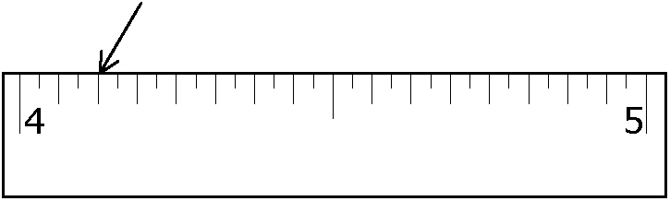
4. Give the distance from the beginning of the measuring tape to the arrow.

5. How could you use personal references to mark off a length of approximately 5 feet on a piece of fabric?

Section 2.3 Warm-Up

1. Measure the width of a mug handle. Round to the nearest millimetre.

2. Measure the height of a mug. Round to the nearest centimetre.

3. Measure the length of a table to the nearest metre.

4. Use your personal reference for
1 cm or 10 cm to estimate the length of a magazine. Then, measure it.

5. Use your personal reference for
1 m to approximate the height of a refrigerator. Then, measure it.

Section 2.4 Warm-Up

1. Convert 25 cm to inches. Round to the nearest inch.

2. Convert 13 in. to centimetres. Round to the nearest centimetre.

3. Convert 200 m to yards. Round to the nearest yard.

4. Convert 18 km to miles.

5. Convert 60 mi to kilometres.

