Chapter 3 Warm-Up

Section 3.1 Warm-Up

1. How many inches are in feet?

2. Convert 6 feet 7 inches to inches.

3. A 12-pack of fruit juice boxes costs $1.79. What is the unit price?

4. Each juice box in #3 contains
250 mL. How many litres of juice are in the 12-pack?

5. While in Miami, Florida, you consider buying an $89.99 pair of shoes. The currency exchange rate is US$1 = C$1.08. What is the cost of the shoes in Canadian funds?

Section 3.2 Warm-Up

1. What is the area of a 4 ft by 8 ft sheet of plywood?

2. How many square inches are in
3 square feet?

3. How many square feet are in
5 square yards?

4. Estimate the area of a circle with a radius of 6 inches.

5. Calculate the area of a circle with a diameter of 10 inches. Round your answer to one decimal place.

Section 3.3 Warm-Up

1. What is the area of a picture that is 30 cm by 40 cm?

2. How many square centimetres are in 6 m²?

3. How many square metres are in a rectangle that measures 20 cm by 50 cm?

4. What is the area of a circle with a radius of 10 cm? Show your answer to the nearest square centimetre.

5. What is the area of a circle with a diameter of 14 cm? Show your answer to two decimal places.

Section 3.4 Warm-Up

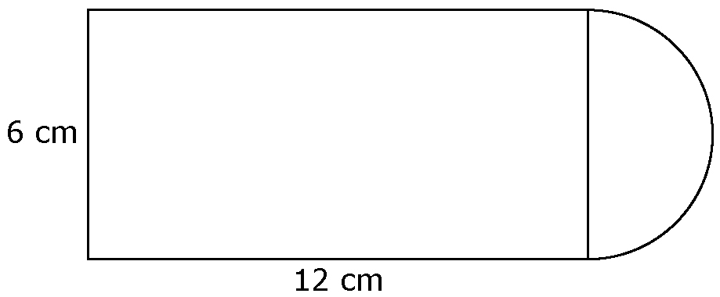
1. What is the total area? Show your answer to one decimal place.

2. What is the total area?

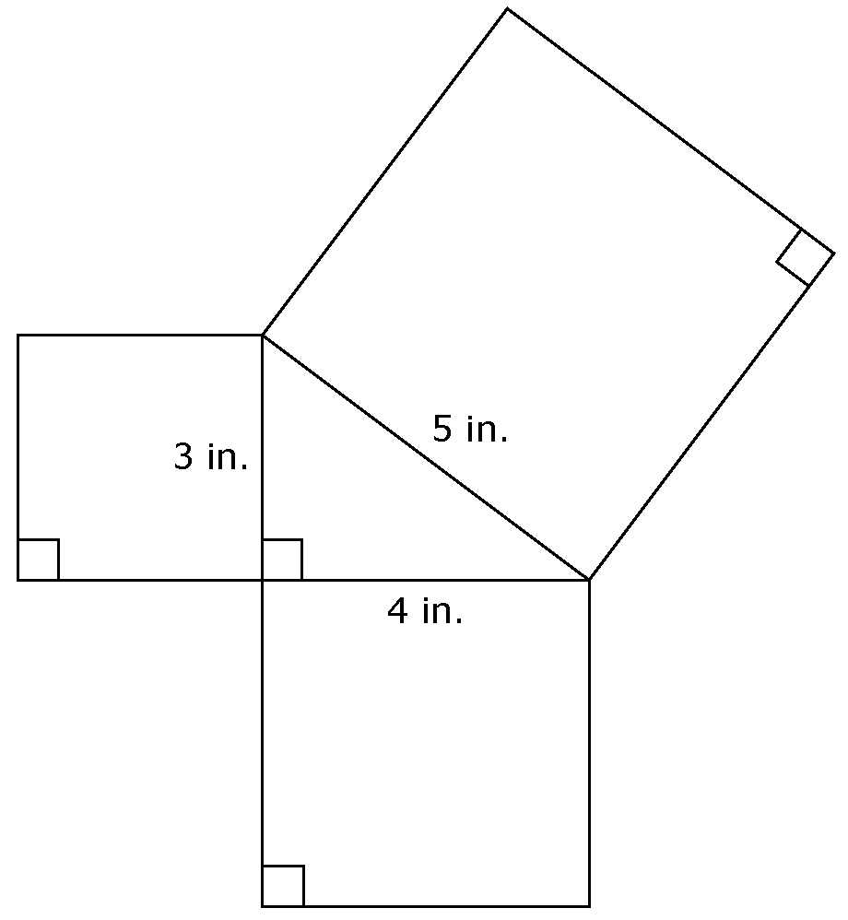
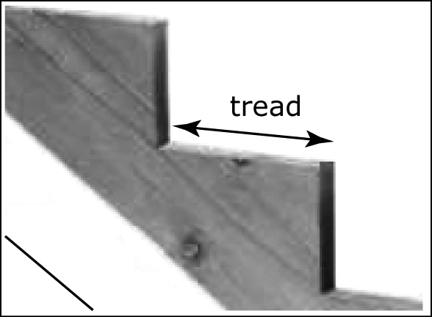

3. A stair case has 13 steps, each measuring 1 ft by 4 ft. The tread of each step is being stained. What is the total area being stained?

4. A rectangle with a 3-inch width and 5-inch length is doubled in length. What is the new area?

5. A rectangle is doubled in both length and width. How does the new area compare to the original area?

