Chapter 5 Warm-Up

Section 5.1 Warm-Up

1. A map uses a scale of 1 cm represents 5 km. What length on the map represents a distance of 15 km?

2. Calculate: 35 + 55

3. Calculate: 180 − 120

4. Calculate: 360 − 270

5. Determine the unknown value:
 + 110 = 180

Section 5.2 Warm-Up

Classify each angle as acute, obtuse, right, reflex, or straight.

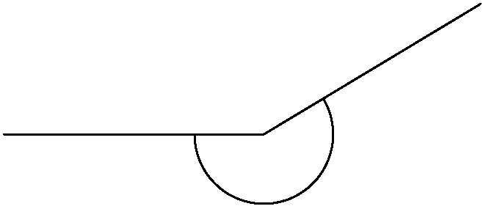
1.

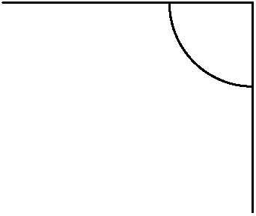
2.

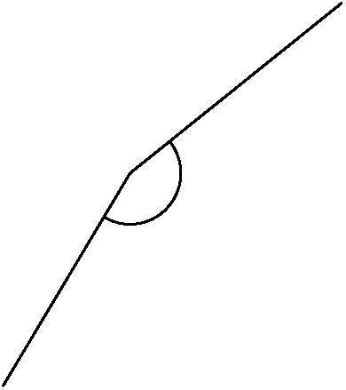
3.

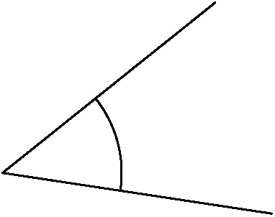
4.

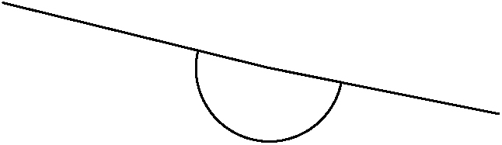
5.

Section 5.3 Warm-Up

1. Use a method of your choice to construct a 75° angle.

2. George is constructing a 110° angle incorrectly. What is his error?

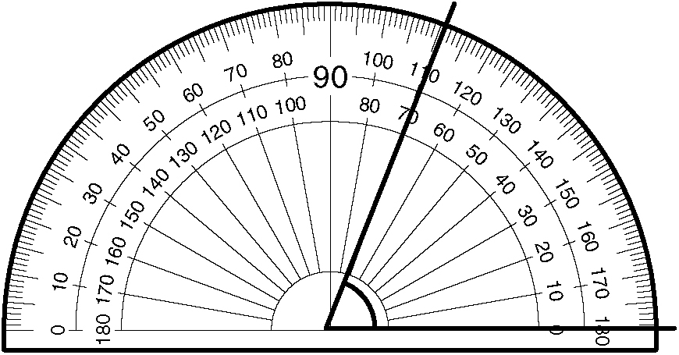

3. Construct a 64° angle and bisect it using paper folding.

4. Construct a 170° angle and bisect it using a protractor.

5. Construct a 98° angle and bisect it using a compass and a ruler.

Section 5.4 Warm-Up

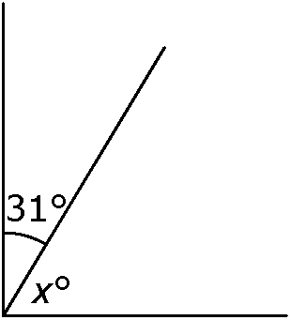
1. Classify the pair of angles.
What is the measure of x?

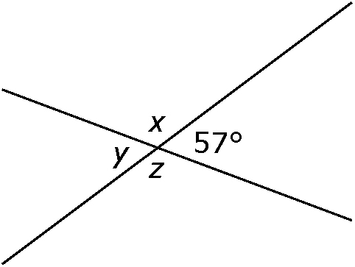
2. Determine the measure
of each angle.

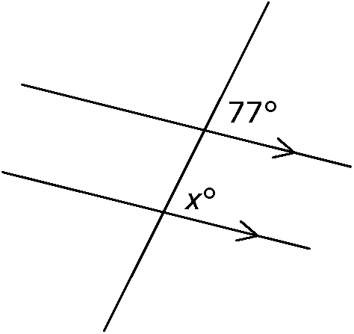
3. Classify the pair of indicated angles.
What is the measure of x?

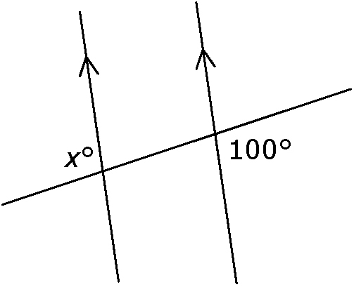
4. Classify the pair of indicated angles.
What is the measure of x?

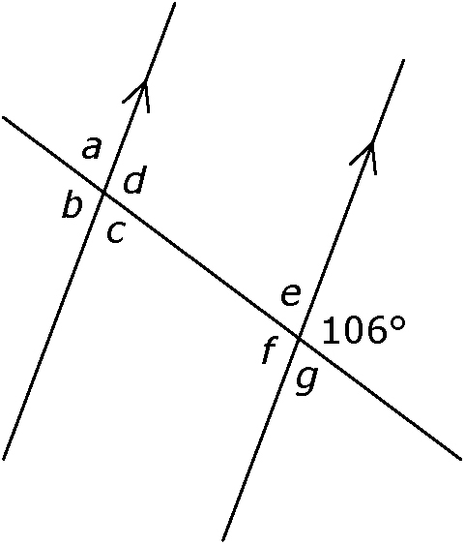
5. Determine the measure of all
indicated angles.

