Chapter 7 Warm-Up

Section 7.1 Warm-Up

1. Convert to a decimal.

2. Using a scale of 1 cm to 500 m, how many centimetres equal
12 km on a scale diagram?

3. Solve for x:

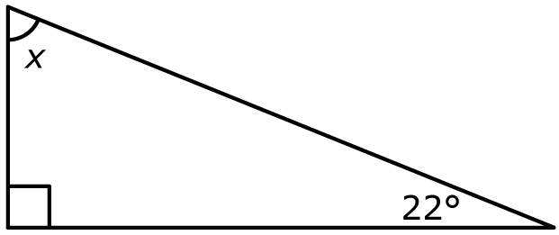
4. Determine the measure of x.

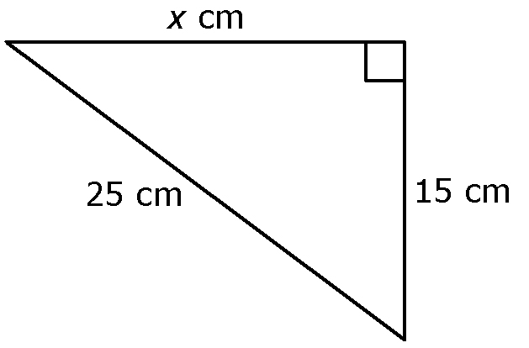
5. Determine the length of x.

Section 7.2 Warm-Up

1. Are these shapes similar?
Explain how you know.

2. Are these shapes similar? Justify your response.

3. The following triangles are similar. Determine x.

4. The following shapes are similar. What is the value of x?
5. These shapes are similar. Determine all the missing side lengths.

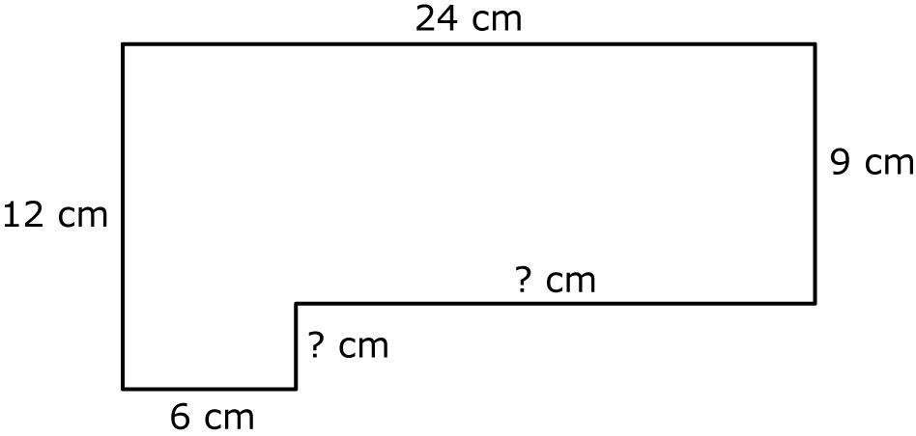
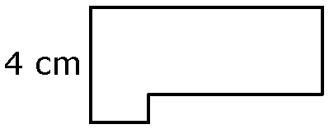

Section 7.3 Warm-Up

1. Determine tan 43°, to three decimal places.

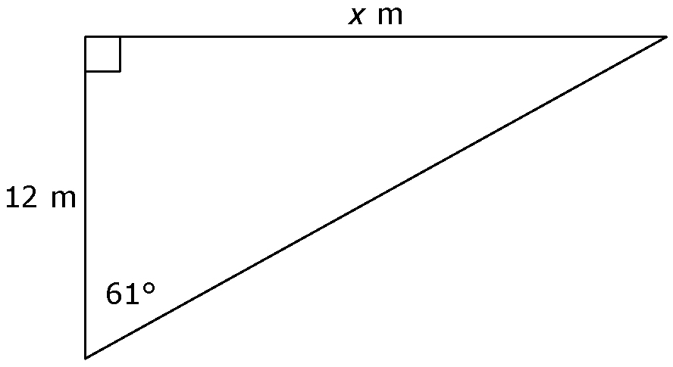
2. What is the length of x, to the nearest
unit?

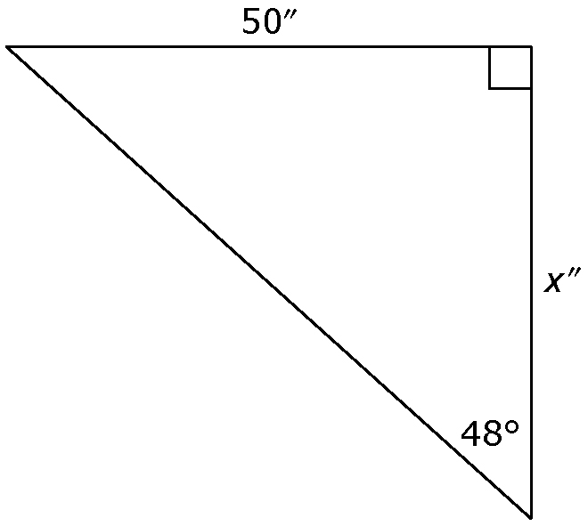
3. Determine the value of x,
to the nearest unit.

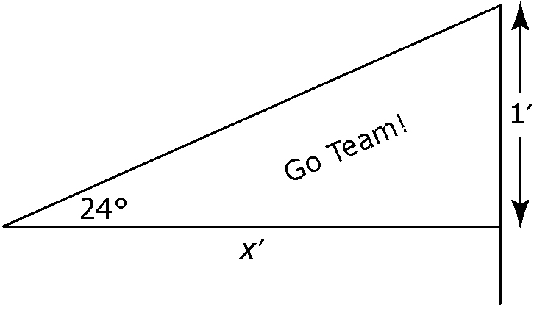
4. How long is the sports flag,
to the nearest tenth of a foot?

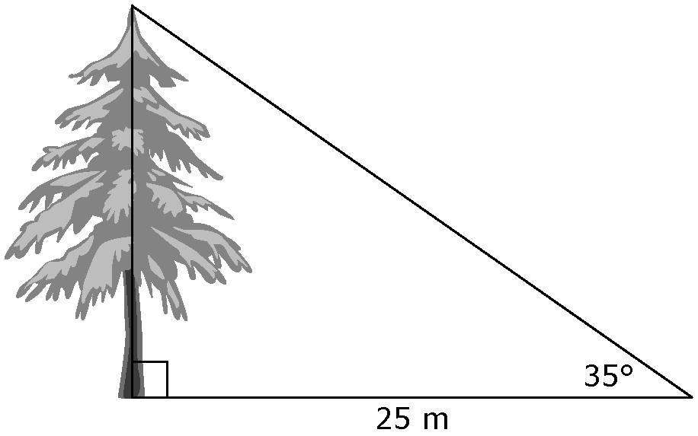
5. Determine the height of the tree,
to the nearest tenth of a metre.

Section 7.4 Warm-Up

1. Determine sin 49°, to three decimal places.

2. What is cos 33°, to three decimal places?

3. Determine the value of x, to the nearest inch.

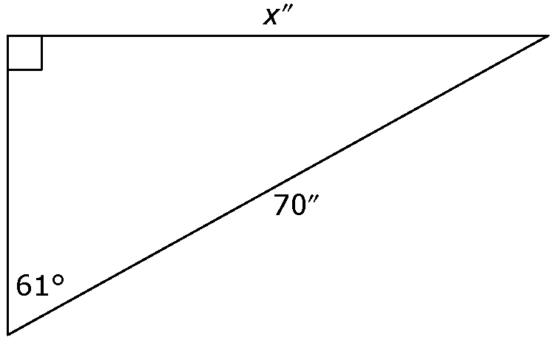

4. How long is x, to the nearest tenth of a metre?

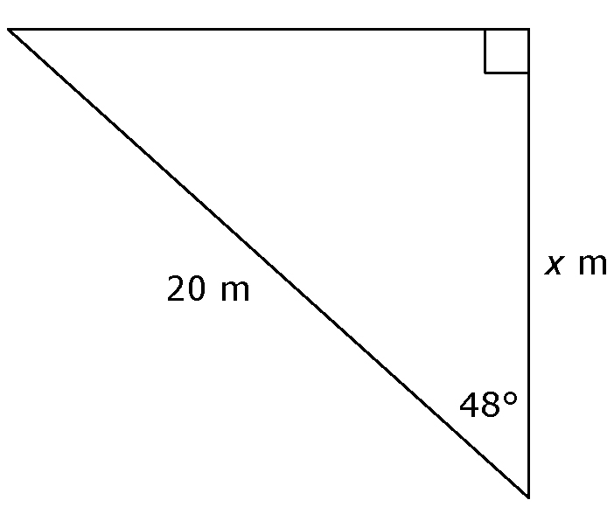

5. What is the length of the hypotenuse, to the nearest
tenth of a centimetre?

