Chapter 1 Warm-Up

Section 1.1 Warm-Up

1. Convert 78 inches to feet and inches.
2. Estimate how many metres are
in 10 feet.
3. Estimate how many inches are
in 70 centimetres.
4. Determine the length of the hypotenuse.
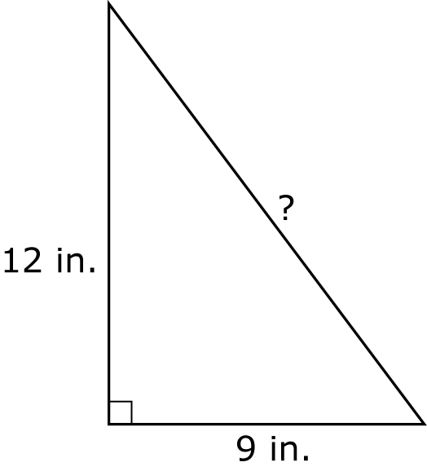
5. Find the length of the
unknown side.
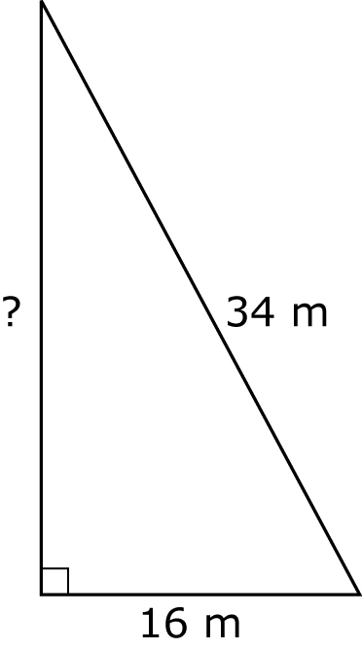

Section 1.2 Warm-Up

1. Calculate the area of the triangle.
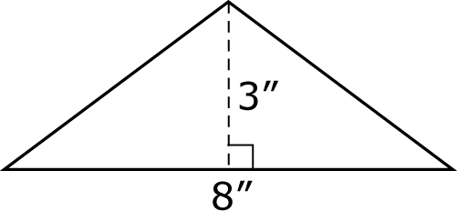
2. Calculate the area of the triangle.
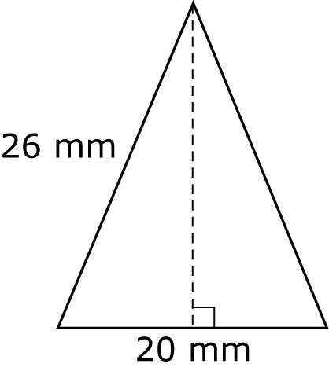
First, use the Pythagorean relationship.

3. Calculate the area of the rectangle.
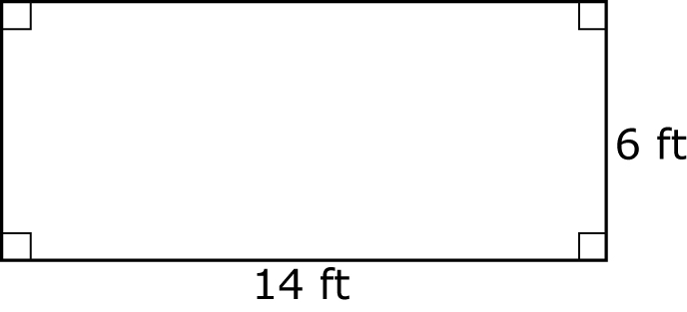
4. Calculate the area of the circle,
to the nearest square inch.
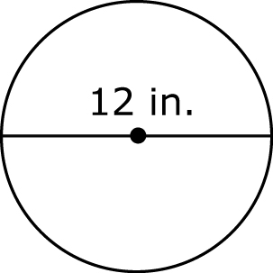
5. Calculate the area of the circle,
to the nearest square metre.
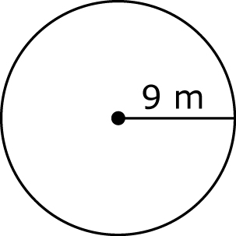

Section 1.3 Warm-Up

1. Use your personal reference for
1 in. to approximate the length
of a laptop screen. Then, measure it.
2. Use your personal reference for
1 cm to approximate the length of a laptop touch pad. Then, measure it.
3. Use your personal reference for
1 ft to approximate the length of a projection screen. Then, measure it.
4. Use your personal reference for
1 m to approximate the length
of a classroom wall. Then, measure it.
5. A puck is 2.5 cm thick and has a diameter of 7.6 cm. Estimate the surface area of a puck.
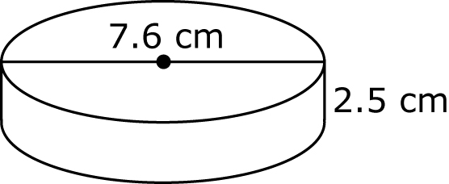

Section 1.4 Warm-Up

1. Calculate the surface area of
the rectangular prism.
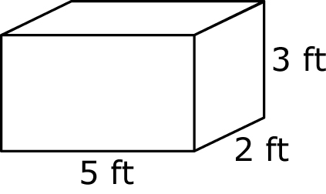
2. Calculate the surface area of the inside of the box. The box has a bottom but no top.
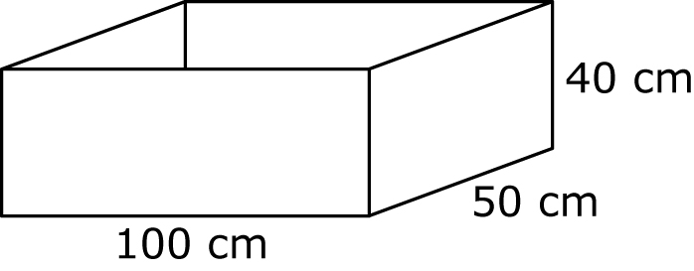
3. Calculate the surface area of the triangular prism.
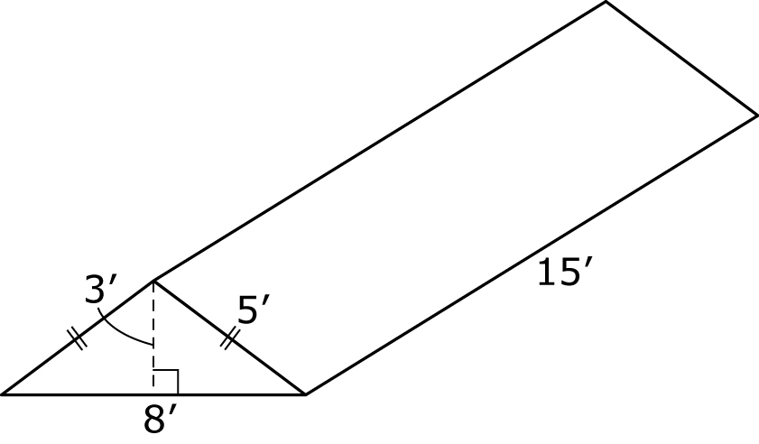
4. Calculate the surface area of
the square-based pyramid, to
the nearest square foot.
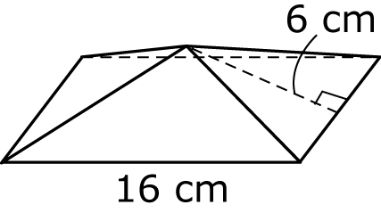
5. Calculate the surface area of
the cylinder, to the nearest square centimetre.
