Chapter 2 Warm-Up

Section 2.1 Warm-Up

1. Convert to inches.
a) 2′ b) 22′
c) 3′ 2″ d) 5′ 7″
2. Express in feet and inches.
a) 24″ b) 26″
c) 38″ d) 55″
3. Solve to create equivalent fractions.
a) b)
c) d)
4. What is the length of sides AC and BC in the diagram below?
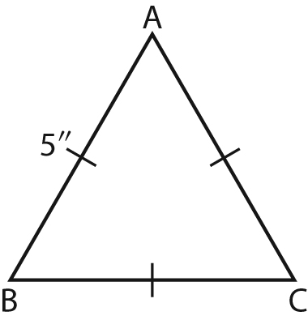
5. What is the perimeter of
the triangle from #4, in feet
and inches?

Section 2.2 Warm-Up

1. Write each scale as a 1 : ratio.
a) 1 mm to 1 m
b) 1 ft to 1 yd
c) 3 in. to 1 ft
2. A children’s bench is a smaller model of a garden bench with a scale of 4 inches to 1 foot. The children’s bench is 2 feet long. How long is the garden bench?
3. Suppose floor tiles are 6 in. by
6 in. How many tiles are needed to cover the floor of the room shown? One square on the diagram represents 1 foot.

4. Determine the unknown lengths in the diagram.
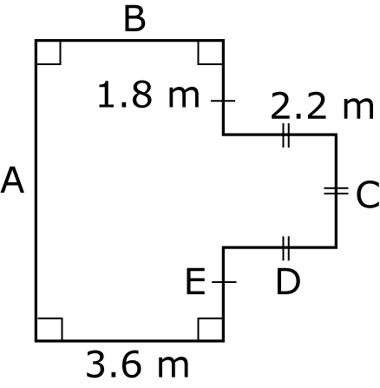
5. Calculate the perimeter of the diagram in #4.

Section 2.3 Warm-Up

1. Draw the three orthographic views of the prism shown. Use
a scale of 1 square to 1 foot.
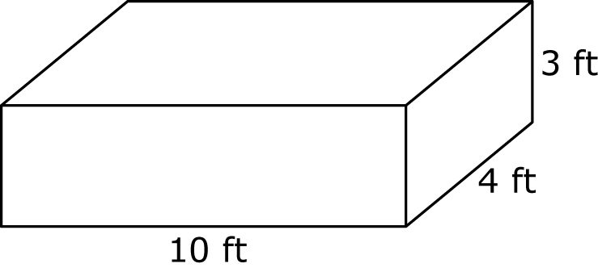
2. Draw a set of orthographic drawings of a rectangular box with dimensions 3 cm by 4 cm
by 6 cm.
3. Draw the three orthographic views of a cylinder that is
5 inches high and has a diameter of 3 inches.
4. A prism has dimensions 5 units by 2 units by 3 units. Use isometric dot paper to create an isometric drawing of the prism.
5. Draw the front, top, and side views of the object shown.
