Chapter 3 Warm-Up

Section 3.1 Warm-Up

1. Calculate the area of
the rectangle.
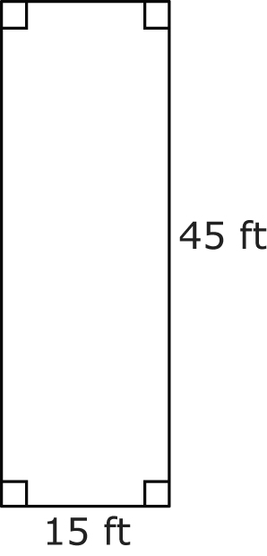
2. Calculate the area of the triangle.
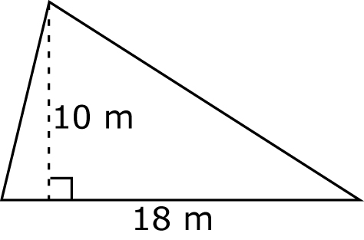
3. Calculate the area of the triangle.
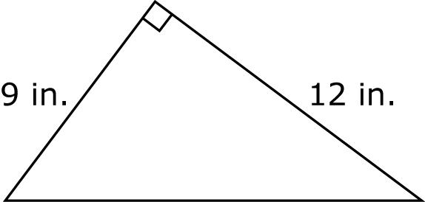
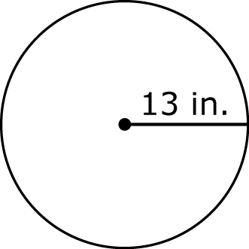
4. Calculate the area
of the circle, to
the nearest
square unit.

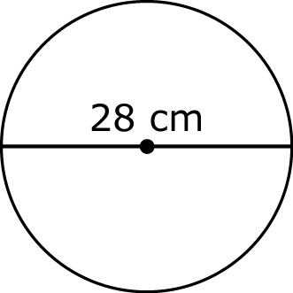
5. Calculate the area
of the circle, to
the nearest
square unit.

Section 3.2 Warm-Up

1. Calculate the area of the base of this prism.
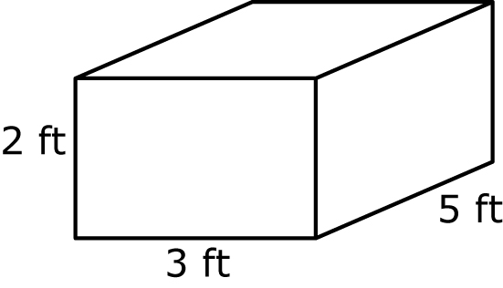
2. Calculate the volume of the prism in #1.
3. Calculate the area of the base of this prism.
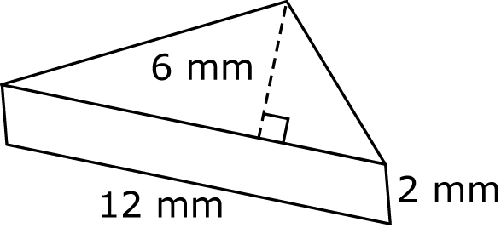
4. Calculate the volume of the prism in #3.
5. Calculate the volume of
the cylinder, to the nearest
cubic metre.
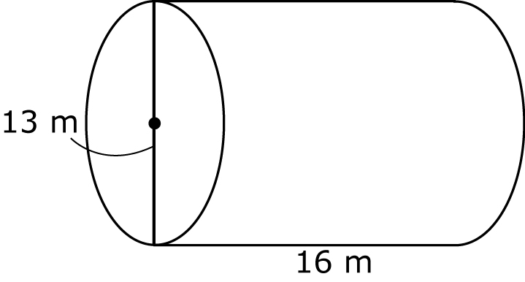

Section 3.3 Warm-Up

1. Covert 3 gallons to quarts.
2. Convert 6 cups to fluid ounces.
3. Convert 12 fluid ounces to cups.
4. Convert 5 quarts to cups.
5. How many 125-mL glasses can be filled with a 5-L water tank?

Section 3.4 Warm-Up

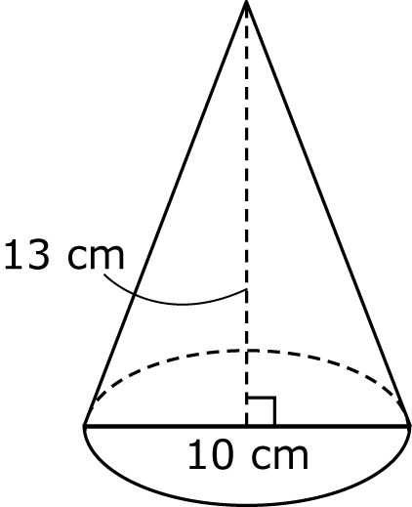
1. Calculate the volume of
the cone.

2. Calculate the volume
of the cone.
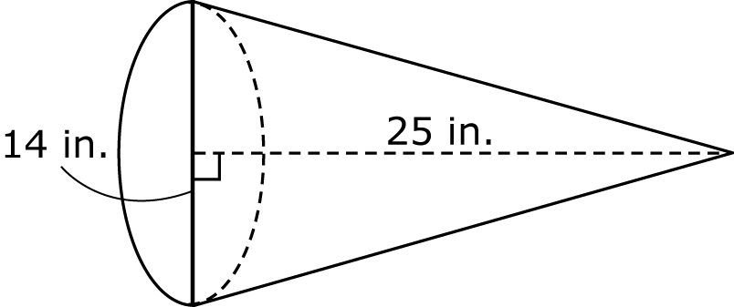
3. What two individual 3-D shapes create this figure?
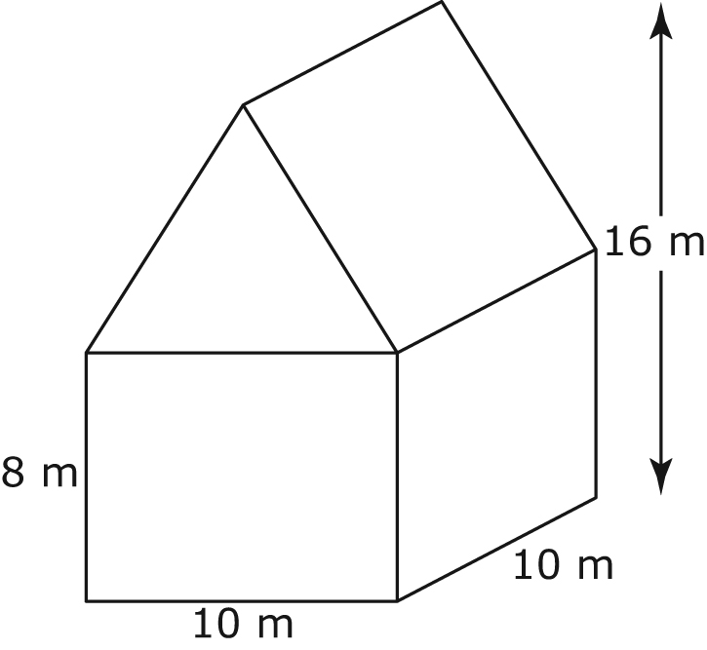
4. Calculate the volume of the composite figure in #3.
5. Calculate the air capacity of a room that has a ceiling height
of 8 feet and the floor layout illustrated below.
