Chapter 4 Warm-Up
Section 4.1 Warm-Up

1. Show each as a percent.
a) b) c)
d) e)
2. Estimate, and then calculate.
a) 5% of 15
b) 22% of 200
c) 46% of 475
3. A survey asked students about their favourite hot beverage.
Forty students responded.
Hot Beverage | Number of Votes
Hot chocolate | 9
Tea | 6
Coffee | 3
Cappuccino | 7
Latte | 4
Espresso | 11
What percent of the students chose hot chocolate as their favourite hot beverage?
4. Represent the survey data
from #3 using a circle graph.
5. A local fitness chain has
four locations. The number of members is shown for each location. Draw a bar graph
to represent the data.
Location | Number of Members
Capital Mall | 1600
Eastern Centre | 900
Harbour Drive | 400
Mount Village | 1100

Section 4.2 Warm-Up

1. Cindy keeps track of her customers’ favourite sandwiches. What is the most appropriate graph to represent her data?
2. Francine tracks the number
of swimmers at the local pool
for a day. What is the most appropriate graph to represent her data?
3. Helen keeps a record of the grades for her students over
the year. What is the most appropriate graph to represent her data?
4. Jim’s class was surveyed
about where they want to
go on their next field trip.
The results are shown.
Location | Number  of Votes
The Science Place | 12
GeoCentre | 15
Marine Institute | 18
Salmonier  Nature Park | 5
Represent the data using an appropriate graph.
5. Tara’s class was surveyed
about how many hours of television they watch. The
results are shown.
Number of  Hours Watched | Tally
0–5.5 | ll
5.5–10.5 | lll
10.5–15.5 | llll
15.5–20.5 | llll lll
More than 20.5 | llll llll ll
Represent the data using an appropriate graph.

Section 4.3 Warm-Up

Use the table to answer #1 to #3.
Age (years) | Height (in.)
0 | 22
1 | 28
2 | 30
3 | 33
4 | 37
5 | 40
6 | 41
7 | 43
Maria’s mother kept a record of Maria’s height on her birthday
until she was 7 years old.
1. Create a graph to represent
the data.
2. What is Maria’s approximate height at 3.5 years old?
3. Predict Maria’s approximate height at 8 years old.
Use the graph to answer #4 and #5.
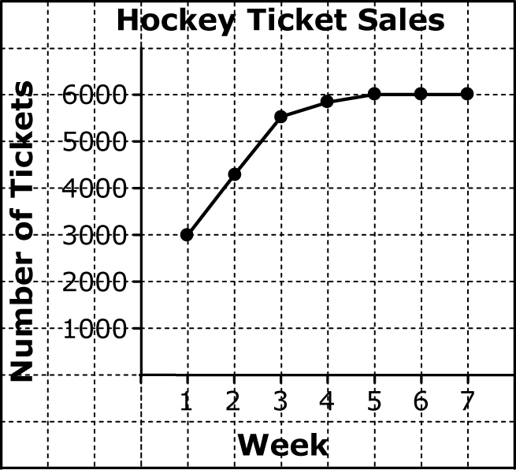
4. The graph shows the weekly hockey tickets sales at Mile One Centre. Describe the trend over time for the number of hockey ticket sales.
5. Is it possible for the graph to constantly increase? Explain
why or why not.

