Chapter 6 Warm-Up
Section 6.1 Warm-Up

1. Show in lowest terms.
2. Solve for x to create an equivalent ratio.
2 : 5 = x : 30
3. Express 0.09 as a percent.
4. Express 13% as a decimal.
5. Express as a percent.

Section 6.2 Warm-Up

1. What is the rise and run of
the line?
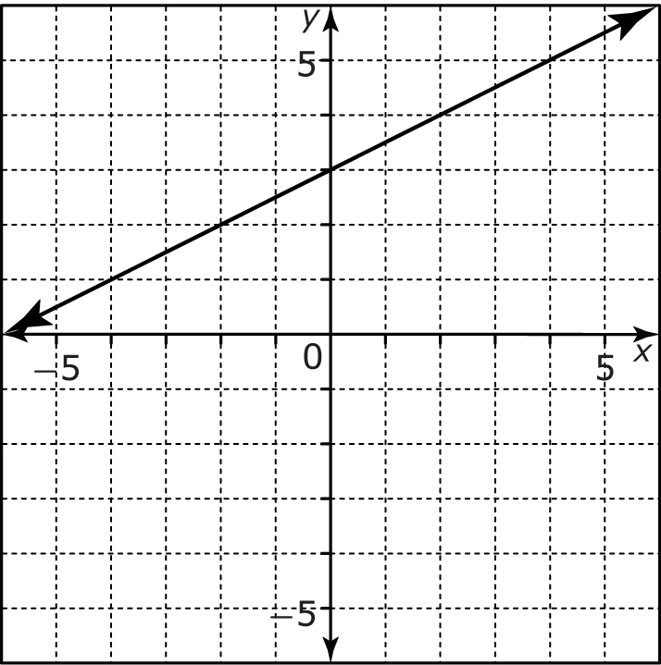
2. What is the slope of the
line segment?
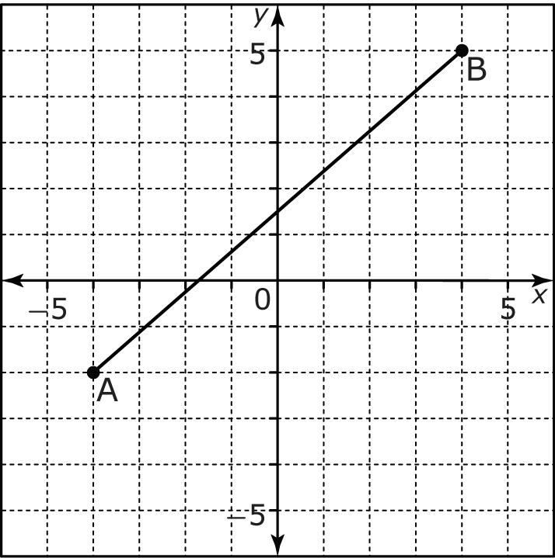
3. What is the slope of the line?
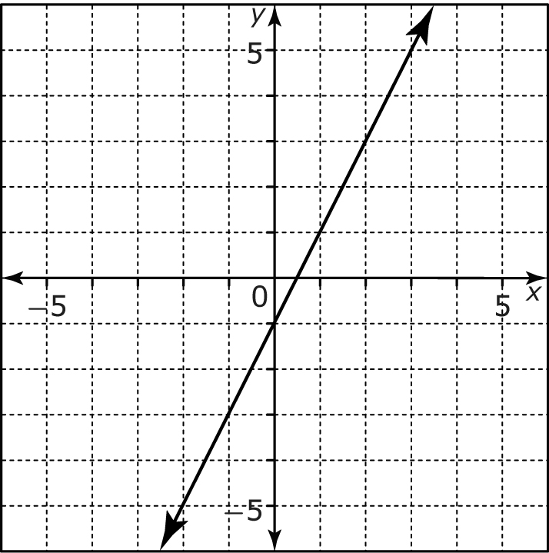
4. Solve the proportion.
5. Determine the slope of the
ramp shown.
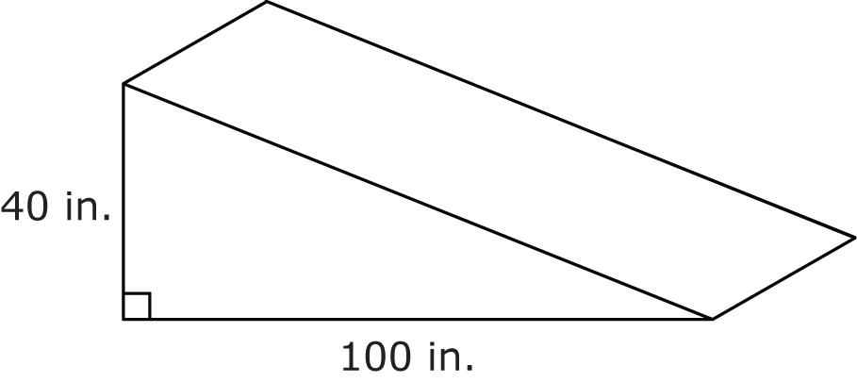

Section 6.3 Warm-Up

1. Determine the tangent ratio of ∠A in the triangle shown.
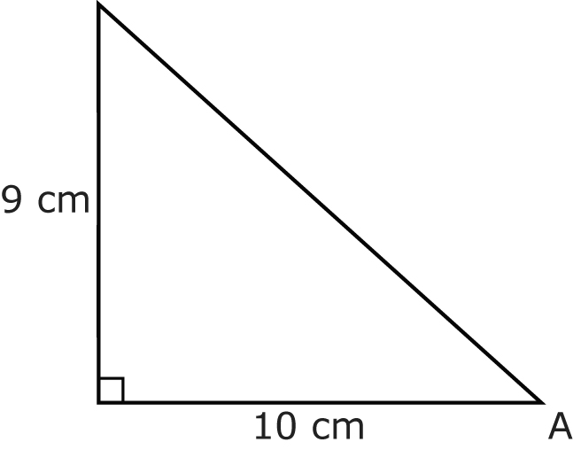
2. Determine the measure of ∠A
in #1.
3. Determine the slope of the line.
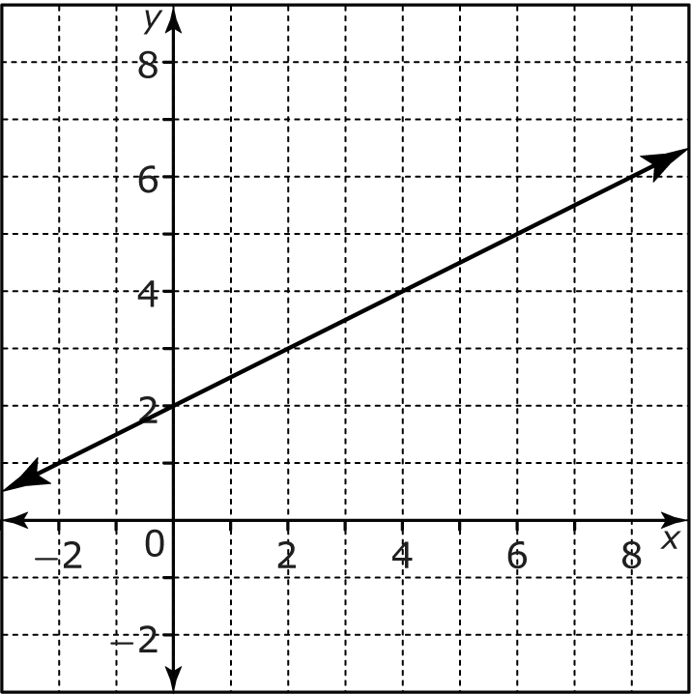
4. Determine the angle of elevation of the line in #3.
5. Determine the angle of elevation of a road with a 7% grade.

