Chapter 7 Warm-Up
Section 7.1 Warm-Up

1. Evaluate 13² – 7².
2. Calculate , to the nearest hundredth.
3. Solve for x.
a) 18 =
b) 6 =
c) 13.2x = 4.4
4. Estimate. Then, calculate. Express your answer to the nearest tenth.
a) 10²
b) 5.7²
c)
d)
5.
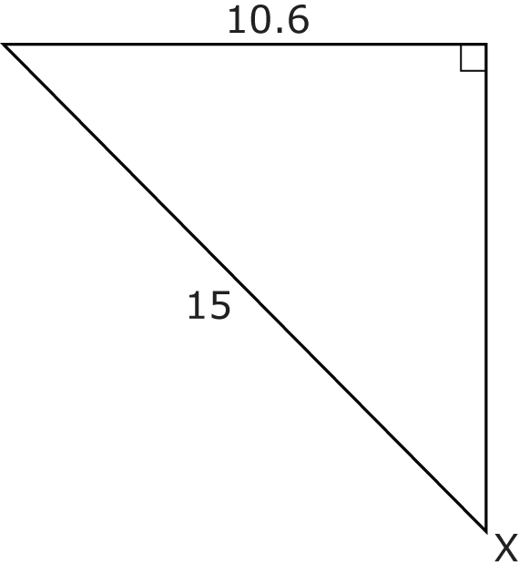
a) Estimate the size of X.
b) Which side is adjacent to X? Which side is opposite X?
c) What trigonometric ratio could you use to find X?
d) Calculate the measure of X, to the nearest degree.
e) How close was your estimate from part a)?

Section 7.2 Warm-Up

1. Determine the length of
the indicated side using the tangent ratio. Express your answer to the nearest tenth
of a unit.
a)
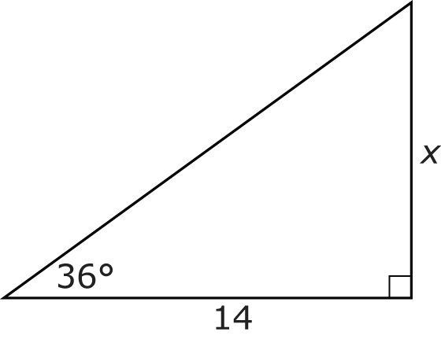
b)
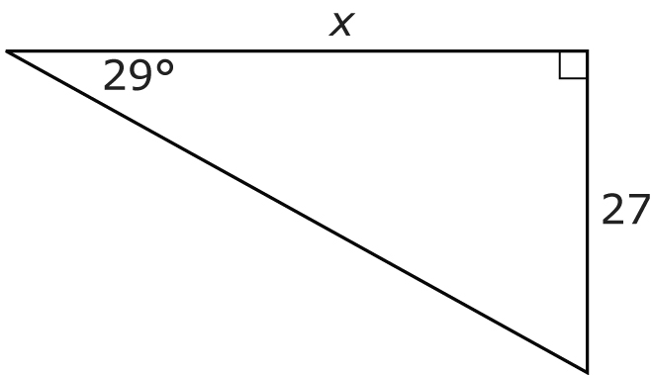
2. Determine the length of
the indicated side, to the
nearest hundredth.
a)
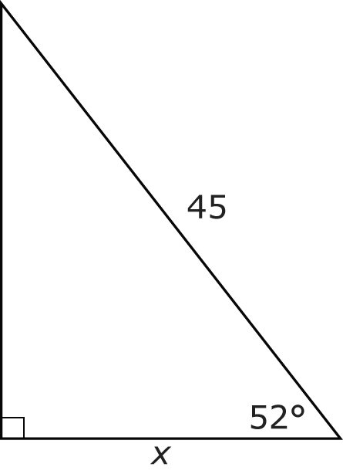
b)
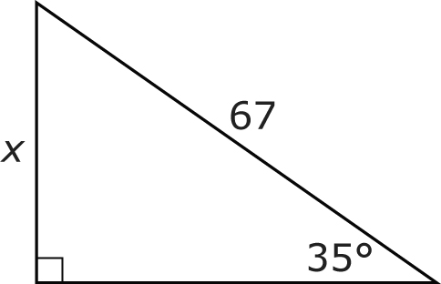
c)
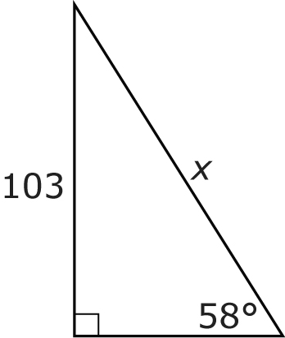
3. The flag of Newfoundland and Labrador has a number of right triangles in it.
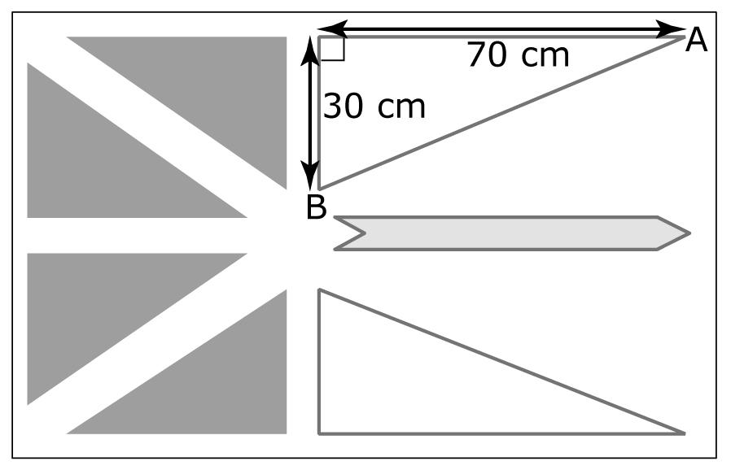
a) Determine the measure of A, to the nearest degree.
b) Determine the measure of B, to the nearest degree.
4. A gardener uses a special pickup truck that acts as a dump truck to move soil. If the 80-in. truck bed is raised to a 40° angle, how high is the upper end of the truck bed above the wheels? Express your answer to the nearest inch.
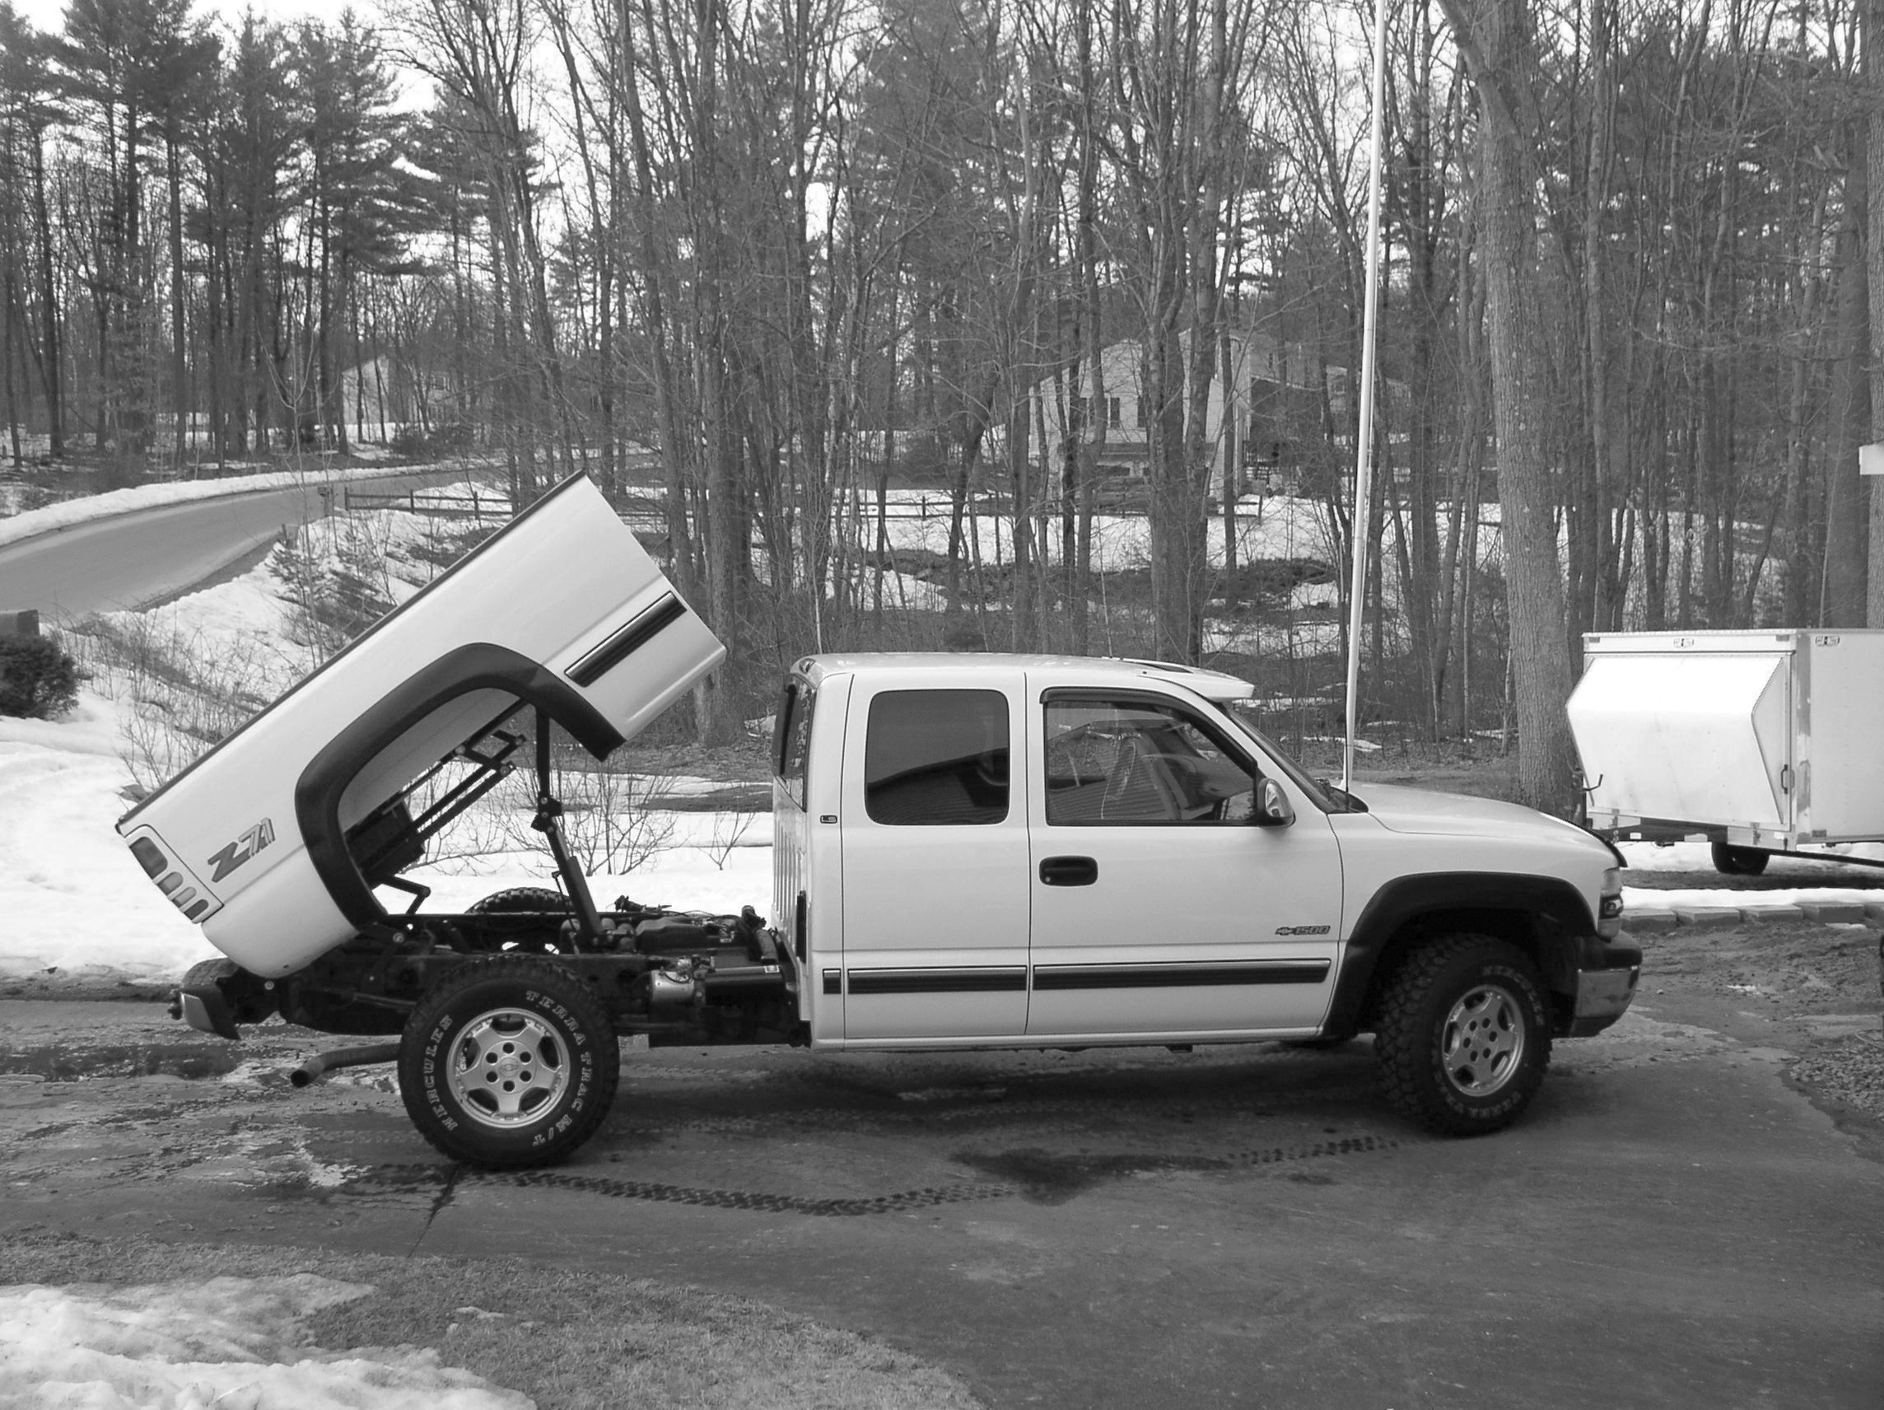

Section 7.3 Warm-Up

1. Determine the length of the indicated side given the angle
of elevation. Express your answer to the nearest tenth of a unit.
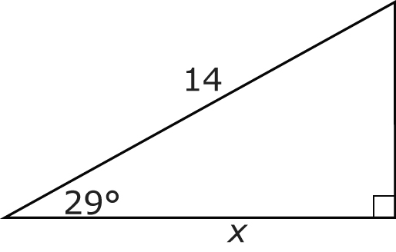
2. Determine the length of the indicated side given the angle
of depression. Express your answer to the nearest hundredth
of a unit.
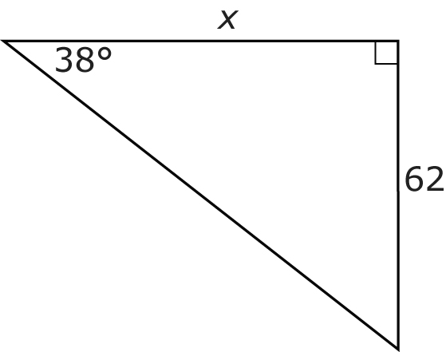
3. Determine the measure of
the indicated angle to the
nearest degree.
a)
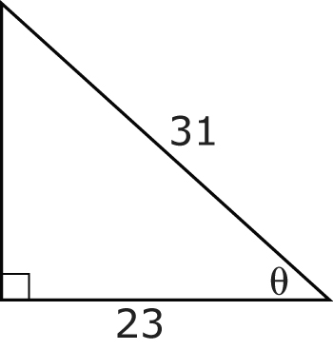
b)
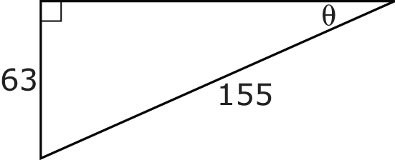
4. A lighthouse is 18 m high. The angle of elevation from a ship
to the top of the tower is 22°. How far is the ship from the base of the lighthouse, to the nearest tenth of a metre?
5. Ashleigh moves into a new apartment. From her window,
she can see a grocery store across the street. If her apartment is 30 m above the ground, and she looks at the store with an angle of depression of 63°, what is the horizontal distance from the store to the apartment building, to the nearest tenth of a metre?

