Chapter 3 Warm-Up Answers

BLM 3–2 Chapter 3 Warm-Up

Section 3.1

**1.** (2,1), (4, 4), (7, 5), (8, 7), (9, 10)

**2.** Examples:   
**a)** 3600 g **b)** 1350 g

**3. a)** 0 **b)** undefined **c)** 1

**d)** –2 **e)** 

**4.** Examples: **a)** an increasing pattern that starts at 3 and increases by 3 each time

**b)** a decreasing pattern that starts at 80 and divides by 2 each time

**c)** an increasing pattern of squares of whole numbers that starts at the square of 1

**5. a)** 13 **b)** 8 **c)** 200

Section 3.2

**1.** Yes; positive

**2.**

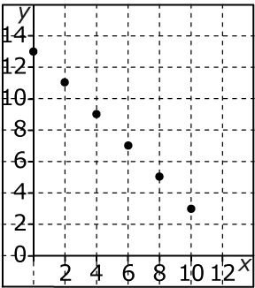

linear trend; negative

**3.** non-linear. The points do not lie in a straight line.

**4.** linear. The points lie in a straight line.

**5.** *x*: by 1; *y*: by 3; linear

Section 3.3

**1.** No. The initial value is not zero and *y* is not a fixed multiple of *x*.

**2.**

|  |  |
| --- | --- |
| *x* | *y* |
| 0 | 0 |
| 1 | 11 |
| 2 | 22 |
| 3 | 33 |
| 4 | 44 |

**3.** Yes. The graph is linear because the slope is fixed at . The graph intercepts the   
*y*-axis at zero.

**4.** **a)** 0, 3, 6, 9

**b)** Yes. The initial value is zero and *y* is a fixed multiple of *x*.

**5.** No. The initial value is (0, 3), not zero, and *y* is not a fixed multiple of *x*.