Chapter 5 Warm-Up Answers

BLM 5–2 Chapter 5 Warm-Up

Section 5.1

**1.** octagon

**2.**

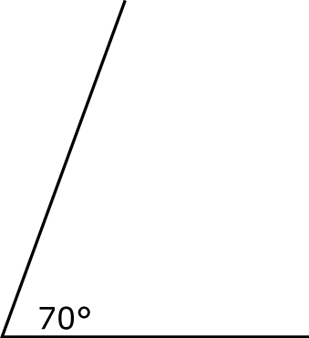

**3.** 10.2

**4.** 12.5

**5.** 54 cm2

Section 5.2

**1.** 120°

**2.** 540°

**3.** Yes

**4.** No

**5.** Yes

Section 5.3

**1.** ED = 7 units, BD = 14 units,  
CD = 9 units, EC = 4 units

**2.** FG = 6 units, ∠FIG = 58°,   
∠EIF + ∠FIG + ∠GIH + ∠HIE = 360°

**3.** False

**4.** True

**5.**

