Chapter 6 Warm-Up Answers

BLM 6–2 Chapter 6 Warm-Up

Section 6.1

**1.**

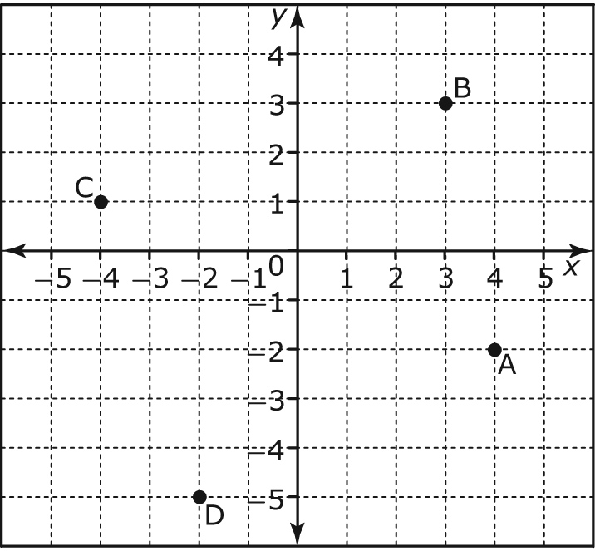

**2.** Quadrant II

**3.** ∠Q corresponds to ∠Y; ∠R corresponds to ∠Z; ∠P corresponds to ∠X;

side PQ corresponds to side XY; side PR corresponds to side XZ; side QR corresponds to side YZ

**4.** Yes. The scale factor is 1.5.

**5. a)** Yes. The corresponding angles are equal and the corresponding sides are proportional.

**b)** No. The corresponding angles are not equal and the corresponding sides are not proportional.

**6. a) b)**

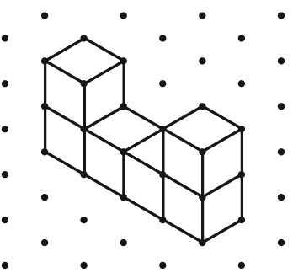 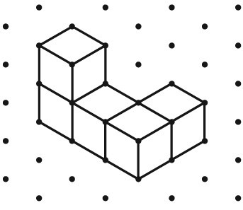

Section 6.2

**1.**

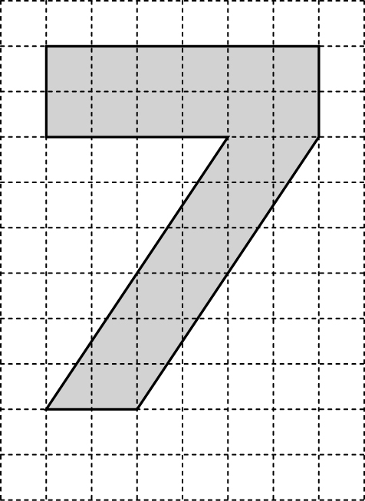

**2.**

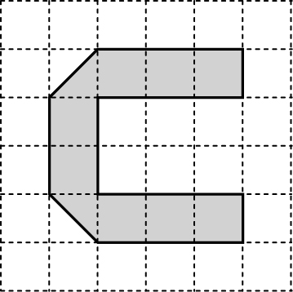

**3.** 1:15

**4.**

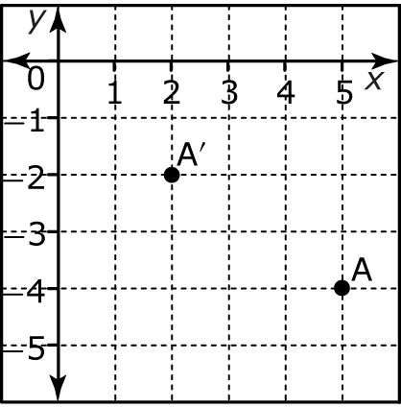

Section 6.3

**1.** **a)** 5 units right, 3 units up **b)** 5 units left, 5 units down

**2.**

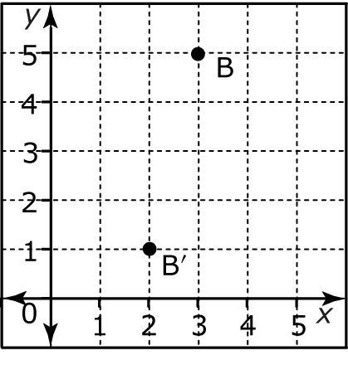

**3.**

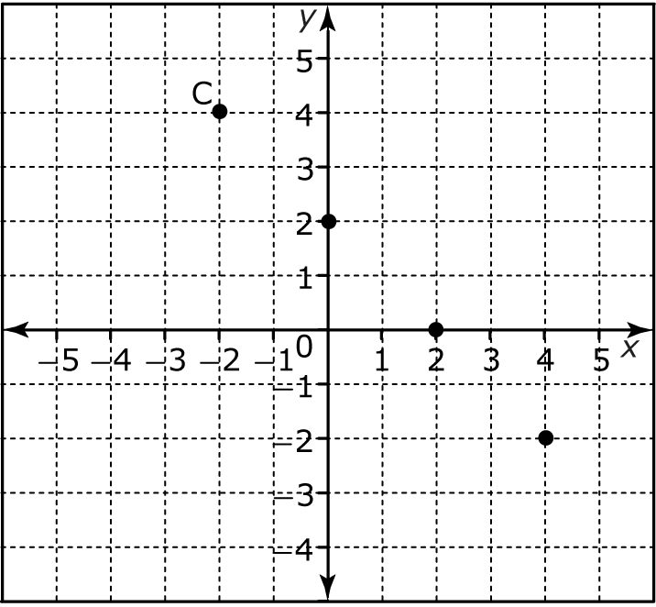

**4.** **a)** No. The triangles are not a mirror image of each other.

**b)** Yes. The triangles are a mirror image of each other, and corresponding points on the sides are equal distance from the line   
of reflection.

Section 6.4

**1.**

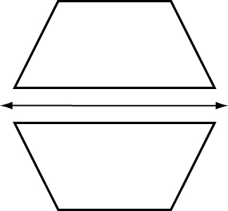

**2.**

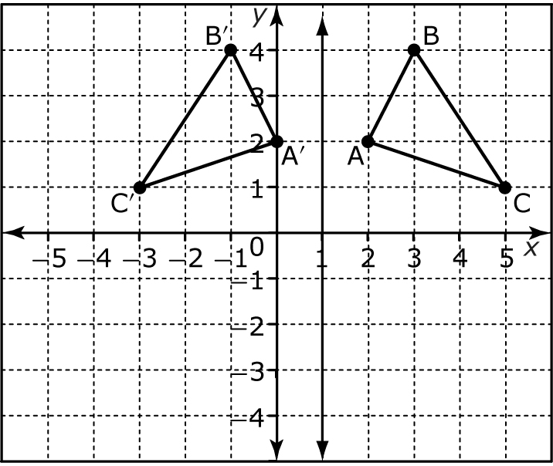

**3.**

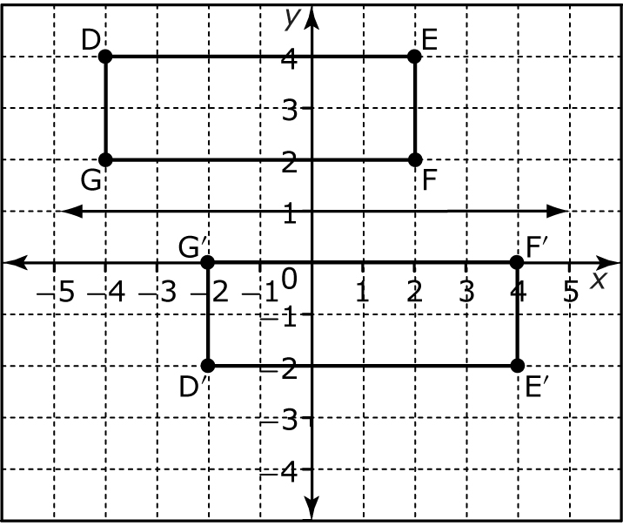

**4.**

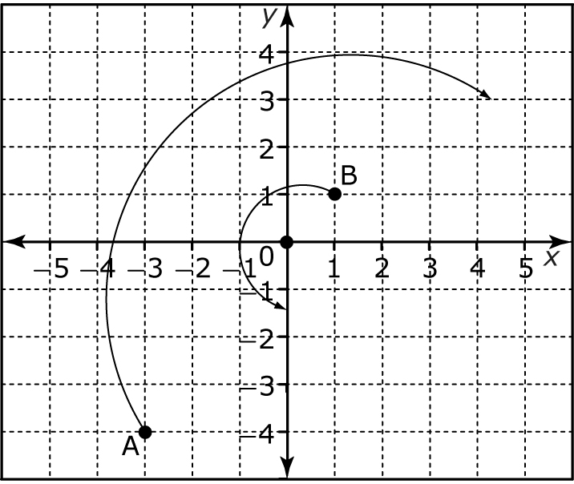

**5. a)** **b)**

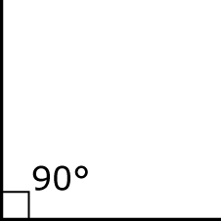 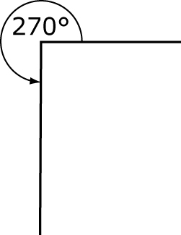

**c)** **d)**

