Chapter 1 Warm-Up

Section 1.1 Warm-Up

1. Write each fraction as a decimal.
a) b) c) d)
2. Write each decimal as a percent.
a) 0.5 b) 0.01
c) 0.7 d) 0.55
3. Write each percent as a decimal.
a) 50% b) 75%
c) 4% d) 100%
e) 32% f) 8%
4. a) Measure the following line
in inches.
b) State the length of the line
to the nearest centimetre.
5. Measure the following angle to the nearest degree.


Section 1.2 Warm-Up

1. Is the angle measure accurate?
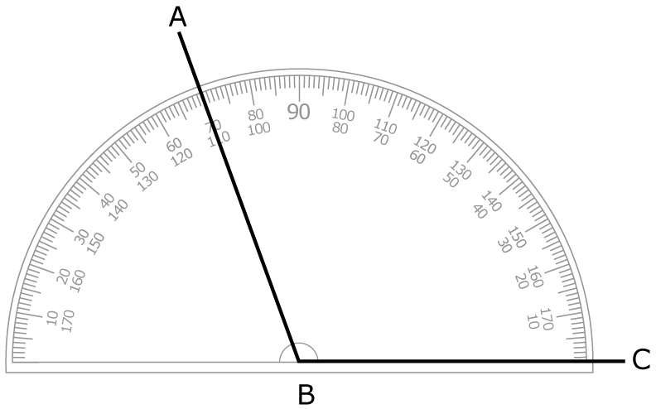
∠ABC = 80°
2. Is ″ the accurate location of the arrow?
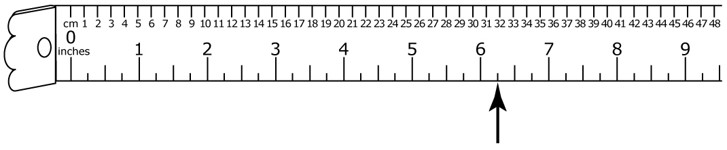
3. Measure the following lines.
State the length of each line to the nearest quarter inch.
a)
b)
4. What is the tolerance for each measurement?
a) 2 m ± 0.25 m
b) 15 kg ± 2 kg
5. For each part in #4, determine the maximum and minimum allowable measurements.

Section 1.3 Warm-Up

1. What is the probability of rolling a sum of 6 with two different dice? Express your answer as a fraction, a decimal to two decimal places, and a percent.
2. What is the probability of cutting a black king from a deck of
52 cards? Express your answer
as a fraction.
3. What is the probability of choosing a vowel from the letters
P-R-O-B-A-B-I-L-I-T-Y? Express your answer in words.
4. What are the odds of choosing the letter M from the letters
M-A-T-H-E-M-A-T-I-C-S?
5. A gym has a scratch-and-win promotion for members to receive a free personal training session. One third of the cards are winners. What are the odds of a member winning on each of two cards she chooses?

Section 1.4 Warm-Up

1. What is the probability of choosing a vowel from letters
G-R-A-D-U-A-T-E?
2. What are the odds against choosing a vowel from the letters
H-I-G-H-S-C-H-O-O-L?
3. What is the probability of choosing a vowel from the letters
S-E-N-I-O-R, twice in a row
(if you put the letter back
each time)?
4. A gas station has a scratch-and-win promotion. You scratch three cards and win once. What percent of the time did you win?
5. You find the odds of winning a game are 1 to 3. What is the probability of winning once, as
a percent?

