Chapter 3 Warm-Up

Section 3.1 Warm-Up

1. Write the coordinates of each point as an ordered pair.
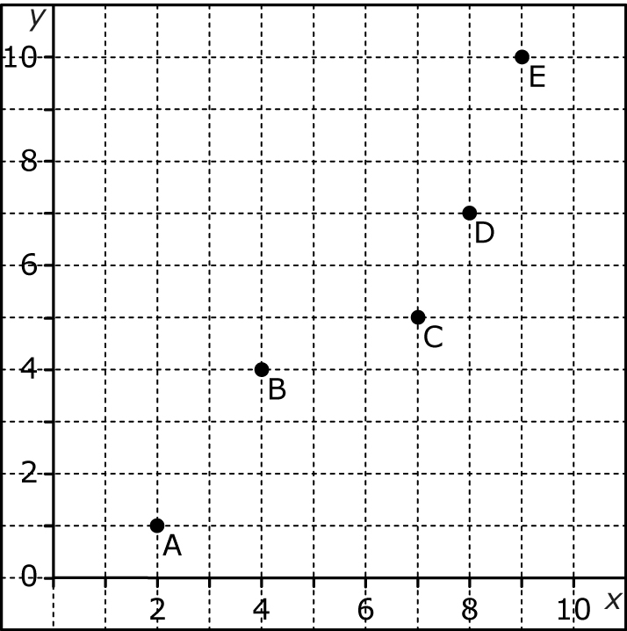
2. The graph shows the average mass of a human from conception to birth.
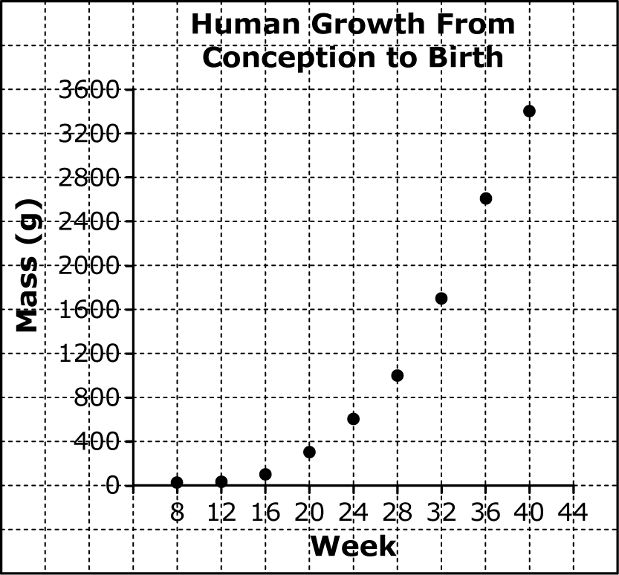
a) Extrapolate to predict the baby’s mass at 41 weeks.
b) Interpolate to estimate the baby’s mass at 30 weeks.
3. Calculate the slope of each line.
a)
b)
c)
d)
e)
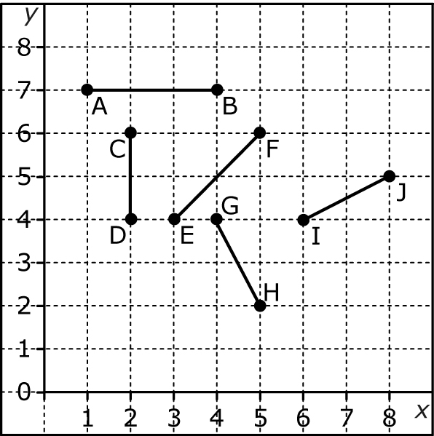
4. Describe each number pattern.
a) 3, 6, 9, 12, 15, …
b) 80, 40, 20, 10, …
c) 1, 4, 9, 25, …
5. Substitute the value of 2 for x into each equation to solve for the value of y.
a) y = 3x + 7
b) y = 18 – 5x
c) y = 100 + 50x

Section 3.2 Warm-Up

1. Does the scatter plot show
a linear trend between the variables? If so, is the trend positive or negative?
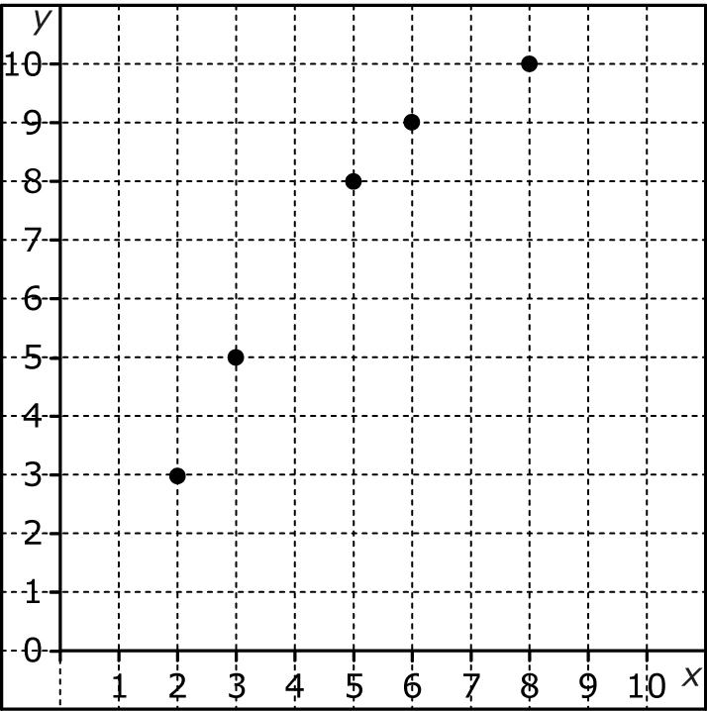
2. Create a scatter plot of the set
of data. Then, state whether the scatter plot shows a linear trend between the variables. If so, is the trend positive or negative?
x | 0 | 2 | 4 | 6 | 8 | 10
y | 13 | 11 | 9 | 7 | 5 | 3
3. State whether the relationship shown in the scatter plot is a linear relationship or a non-linear relationship. Explain your reasoning.
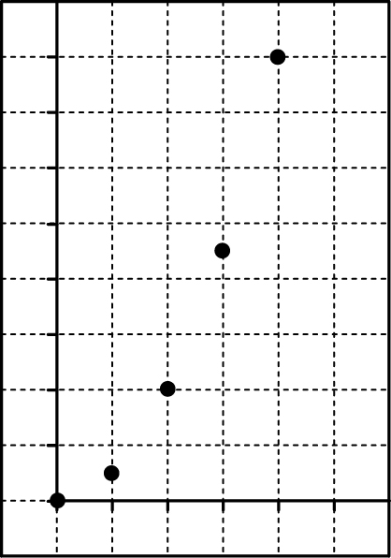
4. State whether the relationship shown in the scatter plot is a linear relationship or a non-linear relationship. Explain your reasoning.
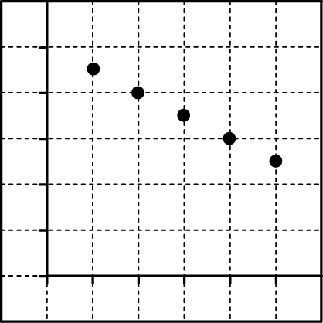
5. Calculate the difference between successive values in each
column of the table of values. State whether the table represents a linear relationship
or a non-linear relationship.
x | 0 | 1 | 2 | 3
y | 5 | 8 | 11 | 14

Section 3.3 Warm-Up

1. Does the table of values represent a direct variation relationship? How do you know?
x | y
0 | 2
1 | 5
2 | 8
3 | 11
4 | 14
2. The table of values represents
a linear relationship with direct variation. Determine the
missing values.
x | y
0
1 | 11
2
3 | 33
4
3. Does the graph represent a direct variation relationship? How do you know?
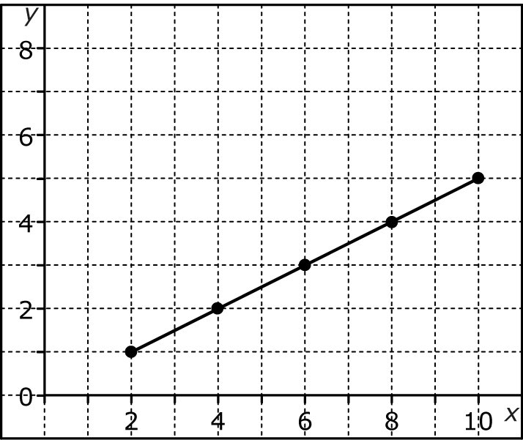
4. a) Substitute the values x = 0, 1, 2, and 3 into the equation y = 3x and solve for y.
b) Does the equation y = 3x model a relationship with direct variation? Explain why or why not.
5. Does the equation y = 4x + 3 represent a relation with direct variation? Explain how you know.

