Chapter 5 Warm-Up

Section 5.1 Warm-Up

1. Identify the polygon.

2. Draw a 70° angle.
3. Determine the sum using
mental math.
6.6 + 3.6
4. Substitute to solve the equation
A = bh.
b = 2.5, h = 5.0
5. Determine the area of the figure.
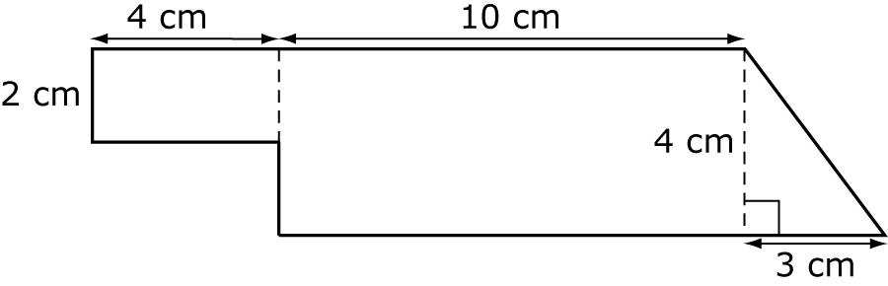

Section 5.2 Warm-Up

1. What is the measure of each interior angle in a regular hexagon?
2. What is the sum of the interior angles of a pentagon?
3. Does this triangle tessellate?
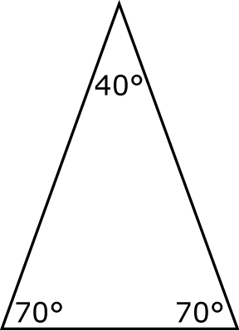
4. Does this polygon tessellate?
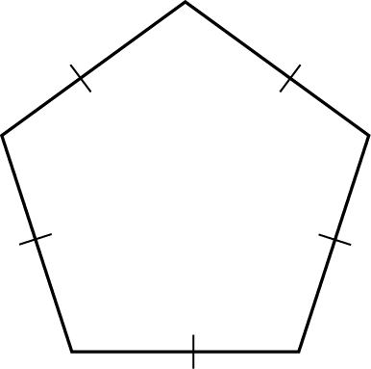
5. Does this polygon tessellate?
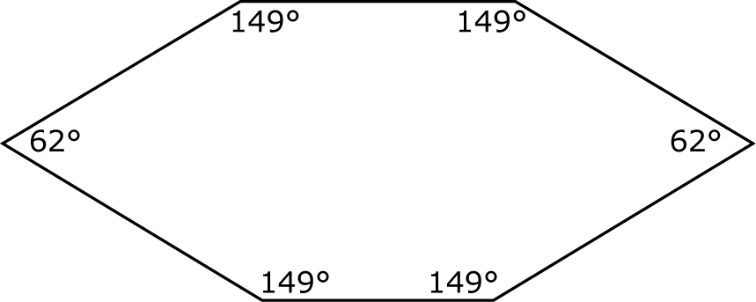

Section 5.3 Warm-Up

1. Given parallelogram ABCD, determine the length of the
sides below.
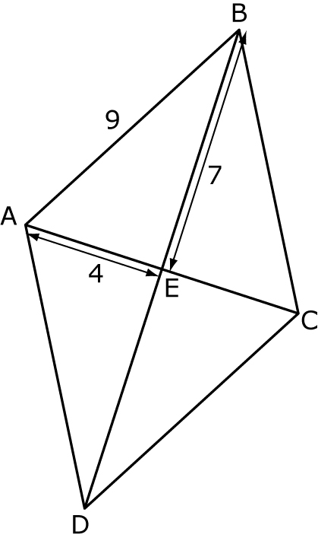
ED =
BD =
CD =
EC =
2. Given isosceles trapezoid EFGH, determine the measurements below.
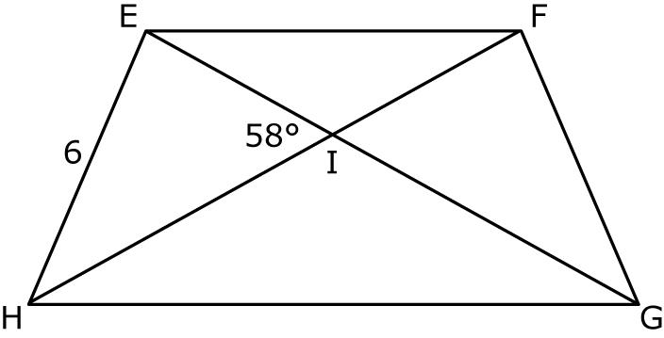
FG =
∠FIG =
∠EIF + ∠FIG + ∠GIH + ∠HIE =
3. True or false? A parallelogram has only one set of parallel sides.
4. True or False? An isosceles trapezoid has diagonals of
equal length.
5. Label the following triangle so that it is correct.
