Chapter 6 Warm-Up

Section 6.1 Warm-Up

1. Plot each point on a grid.
a) A(4, –2)
b) B(3, 3)
c) C(–4, 1)
d) D(–2, –5)
2. In which quadrant is (–3, 1) located?
3. List the corresponding angles and corresponding sides for PQR and XYZ.
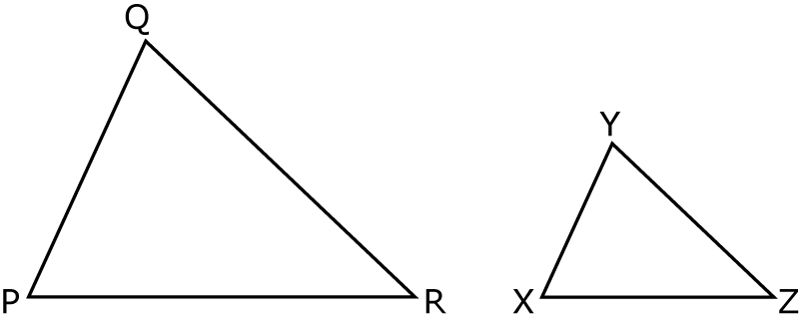
4. Does the pair of triangles have proportional corresponding sides?
Explain how you know.
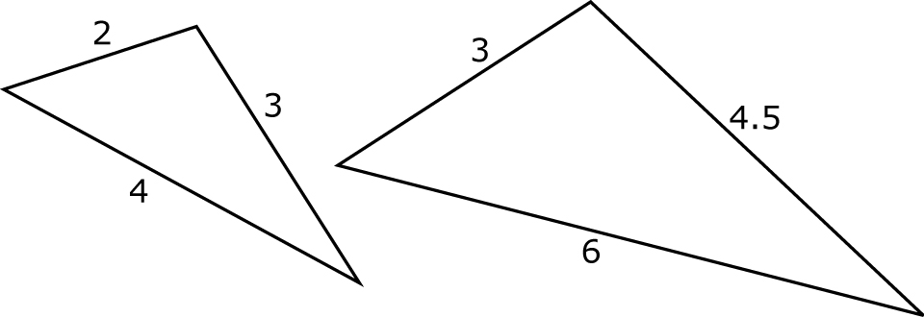
5. Are the figures similar? Use a ruler and a protractor to help you. Explain how you know.
a)
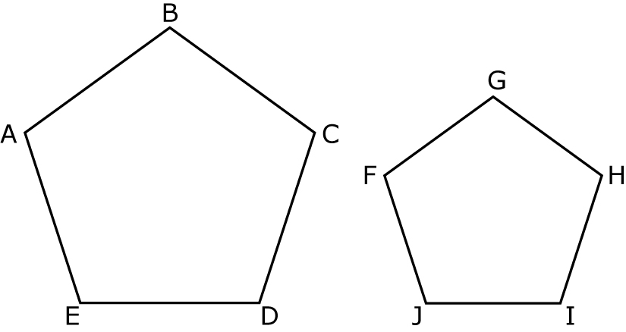
b)
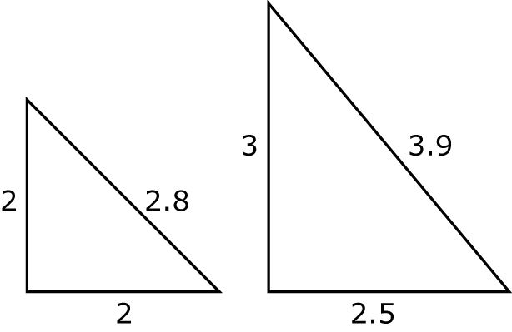
6. Draw each figure on isometric
dot paper.
a)
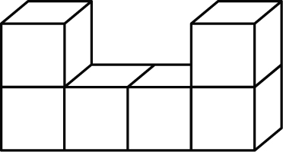
b)
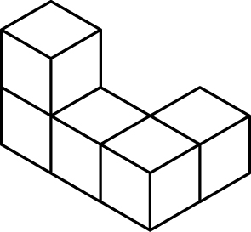

Section 6.2 Warm-Up

1. Enlarge the figure using a
scale factor of 2.
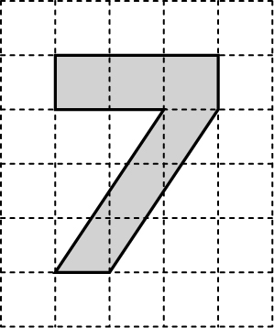
2. Reduce the figure using a
scale factor of .
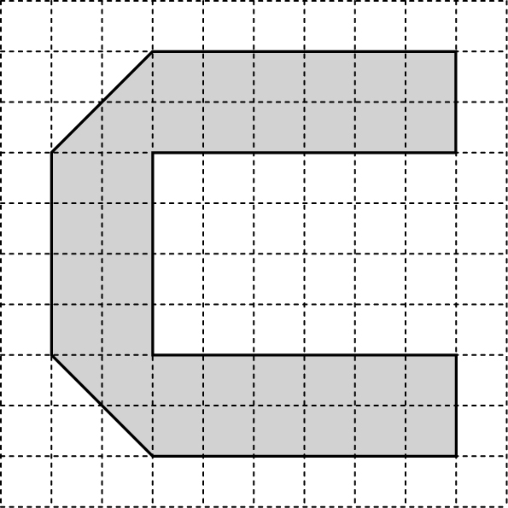
3. A kitchen plan has a 30″ wide stove measuring 2″ on the plan. What scale factor is used?
4. Translate point A 3 spaces left and 2 spaces up. Label the new point A′.
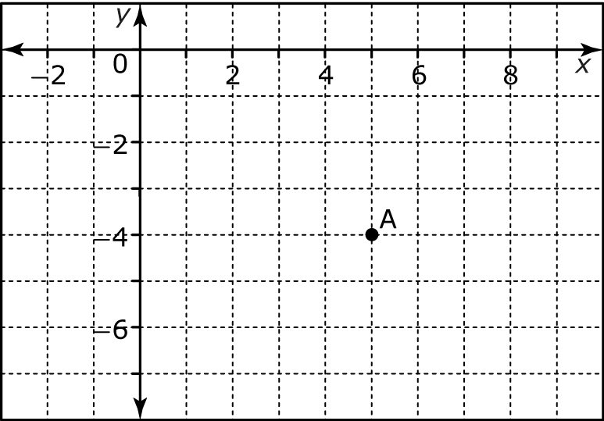

Section 6.3 Warm-Up

1. Describe the translation shown in each diagram.
a)
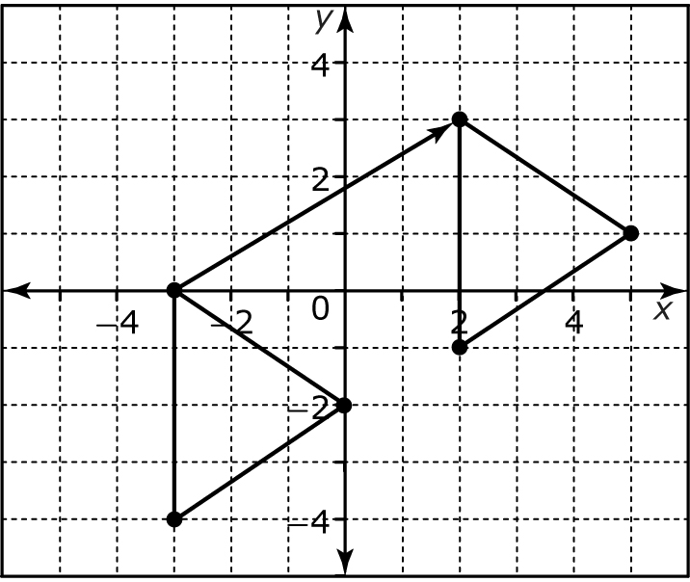
b)
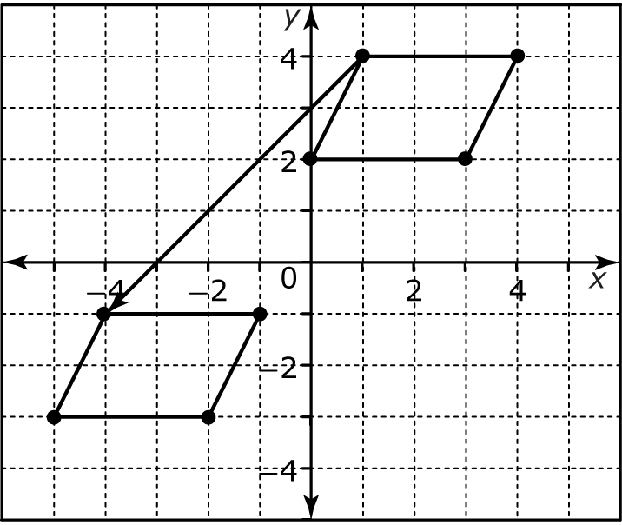
2. Plot point B(3, 5) on a coordinate grid. Then, translate it 1 unit left and 4 units down. Label it B′.
3. Plot point C(–2, 4) on a coordinate grid. Then, translate it 2 units right and 2 units down. Perform the translation
three times.
4. Does each transformation represent a reflection? How do you know?
a)
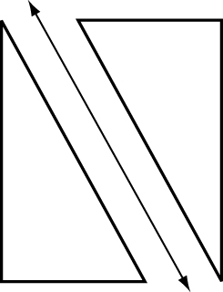
b)
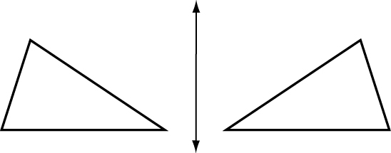

Section 6.4 Warm-Up

1. Reflect the shape over the line
of reflection.
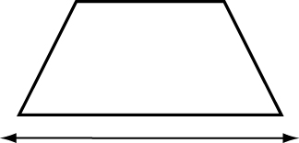
2. Reflect the shape over line of reflection x = 1.
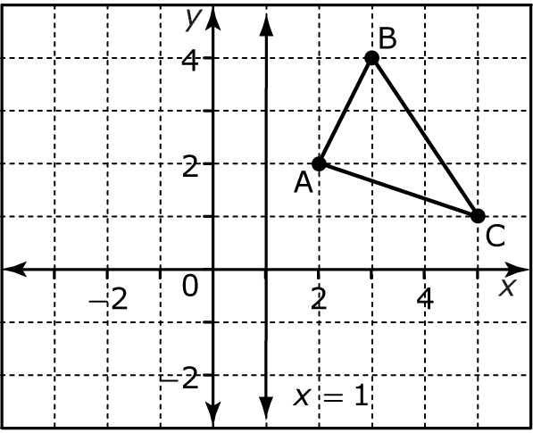
3. Reflect the rectangle over y = 1. Then, translate the reflected image 2 units right.
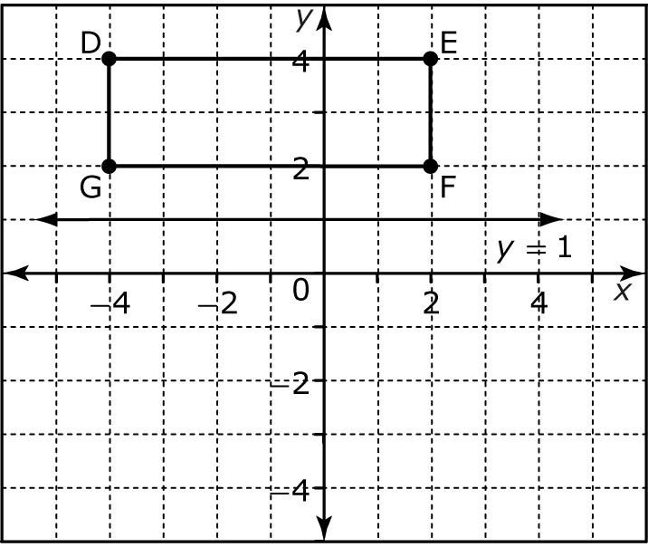
4. Placing the metal tip of a compass on the origin, draw
an arc from each point in the direction indicated.
Point A: clockwise
Point B: counterclockwise
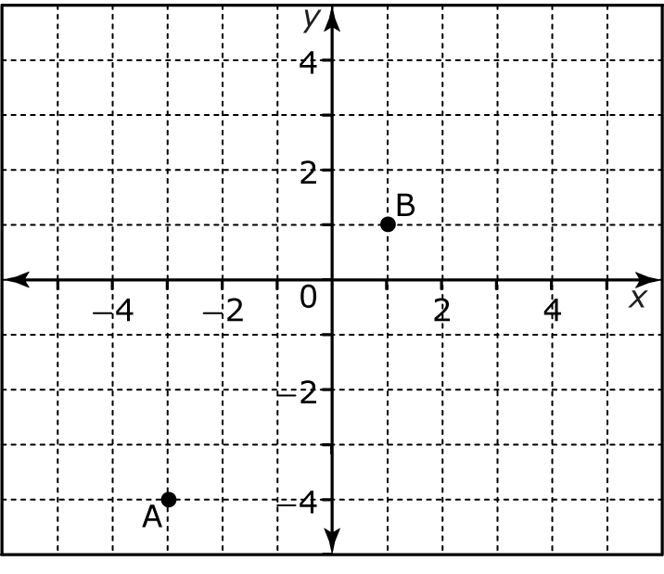
5. Use a protractor to draw
each angle.
a) 90°
b) 270°
c) 45°
d) 180°

