Chapter 7 Warm-Up

Section 7.1 Warm-Up

1. Evaluate sin 42° to three
decimal places.
2. Determine the measure of ∠A,
to the nearest degree, when
cos A = 0.515.
3. Determine the measure of the unknown angle.
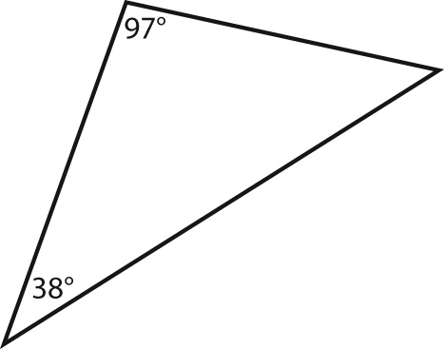
4. Determine the measure of ∠A,
to the nearest degree.
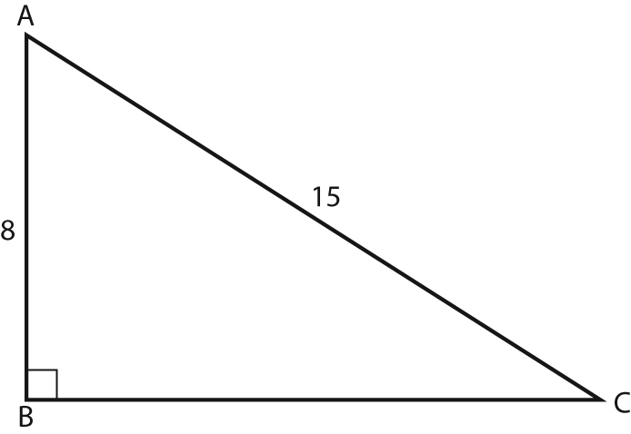
5. Determine the length of side x,
to the nearest tenth of a unit.
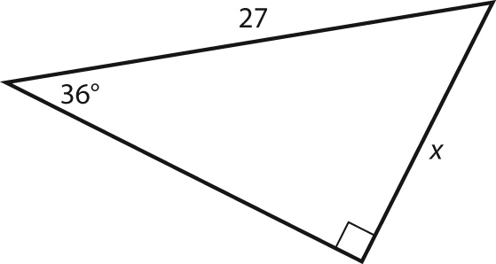

Section 7.2 Warm-Up

1. Write two ratios that are equivalent to in MNO.
2. Solve for the unknown side, to the nearest tenth of a metre.
3. Solve for the unknown angle, to the nearest degree.
4. Determine the length of side a,
to the nearest tenth of a unit.
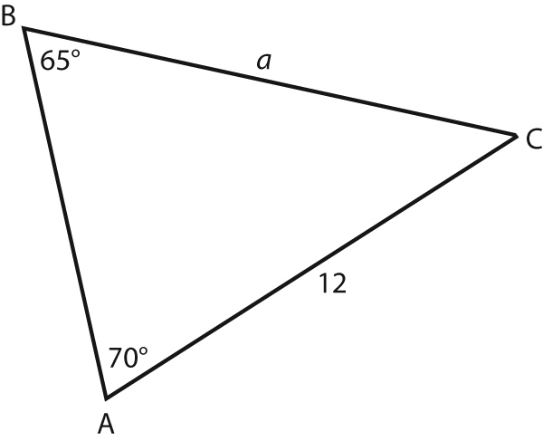
5. Determine the measure of ∠A,
to the nearest degree.
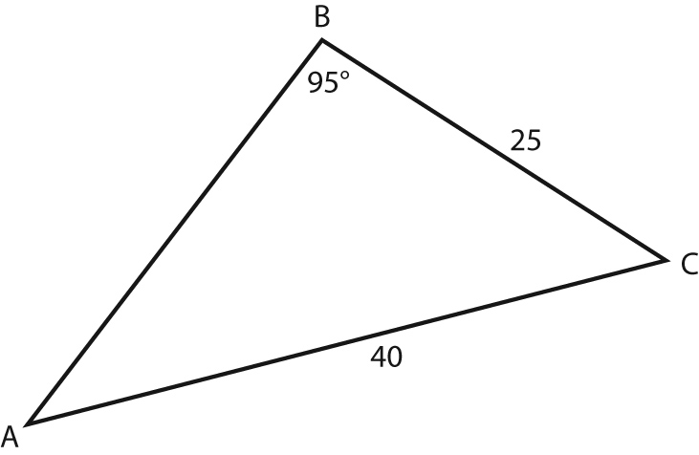

Section 7.3 Warm-Up

1. Write the cosine law to determine the length of side y in XYZ.
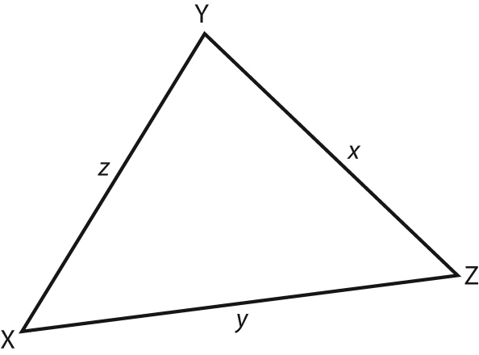
2. Write the cosine law to determine the measure of ∠Z in XYZ.
3. Determine the measure of ∠C, to the nearest degree.
4. Determine the length of side a,
to the nearest tenth of a metre.
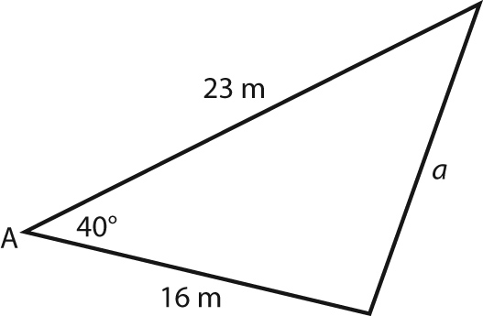
5. Determine the measure of ∠A,
to the nearest degree.
